Galway City Council Arts Newsletter Early April
Welcome to the Arts Office Newsletter for Early April.
Below you will find Opportunities, News, Listings and Events for creative practitioners and people interested and involved in Arts and Culture in Galway City.
Happy reading, from the Galway City Arts Office team.
_____________________________________________________________
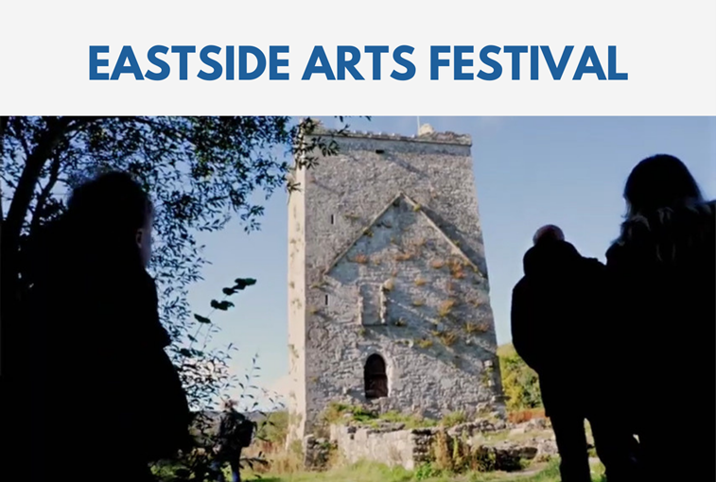
Eastside Arts Festival Open Call
Following on from 2024’s successful inaugural Festival, the Eastside Arts Festival is returning in 2025. This year's Festival will take place on Friday 3rd October, and Saturday 4th October.

Artists and community groups are invited to submit an application for the festival.

The closing date for receipt of applications is Thursday 24th April.

More information and application forms here.

_____________________________________________________________
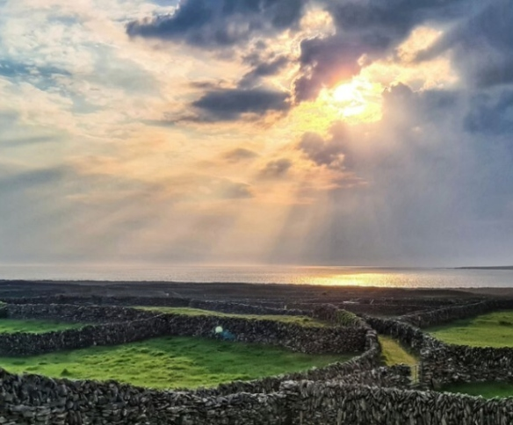
Áras Éanna Artist Residency call out 2025
Áras Éanna and Baboró invite one performing artist for a residency from 2–16 December, 2025 which includes €2,000 stipend, travel, accommodation, and studio access. Irish-language artists prioritised. Open time for creative work.

Receipt of applications by Thursday, 15th May, 2025.

More information here.

_____________________________________________________________

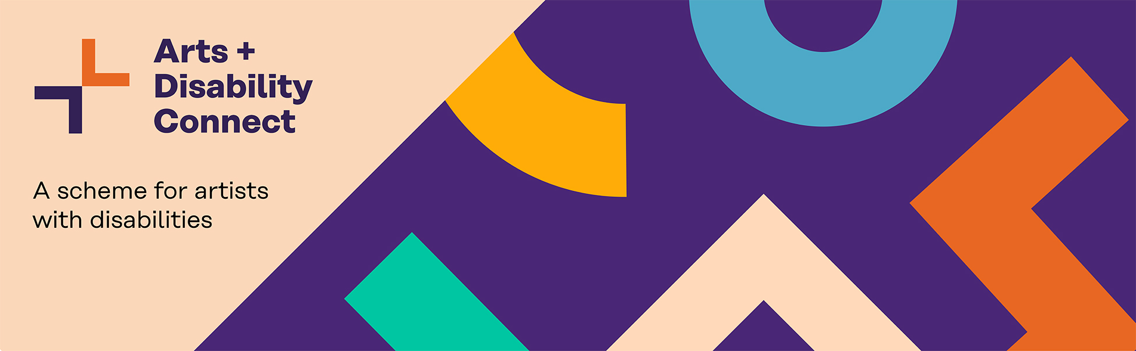
Arts and Disability Connect Scheme, Round 1 launched via Arts & Disability Ireland

The Arts and Disability Connect Scheme is designed to support artists with disabilities to be ambitious, to develop their practice and to connect with arts organisations and arts professionals in the Republic of Ireland.

Arts and Disability Connect includes Mentoring, Training, New Work, and Research and Reflection awards for individual artists with disabilities.

The deadline for applications is Wednesday 7th May, with information sessions available between 10th April and 2nd May.

More information at adiarts.ie/artists/funding/connect/

_____________________________________________________________
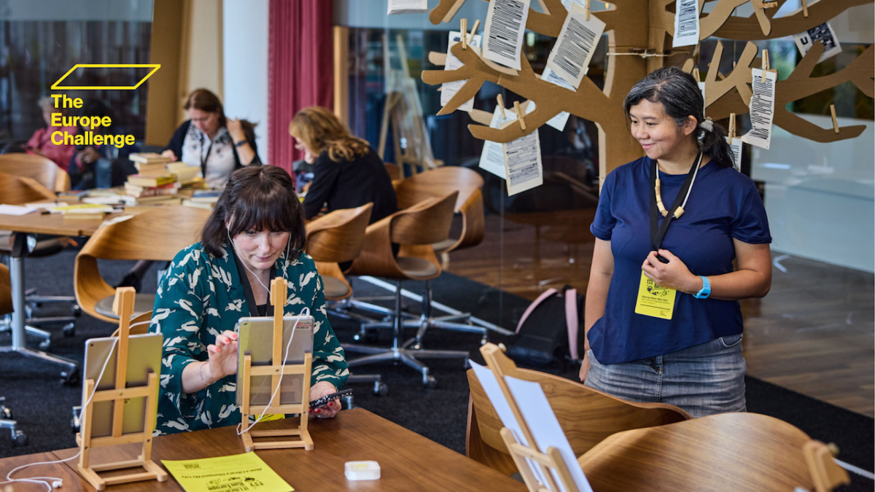
The Europe Challenge 2025/26 Call for Applications Now Open!
The Europe Challenge supports libraries and communities in tackling social, digital, and climate challenges through citizen-led projects. Participants receive up to €10,000 funding, mentorship, and networking opportunities. Since 2020, 96 libraries across 26 countries have taken part. Join this growing European network!
More information here.
_____________________________________________________________

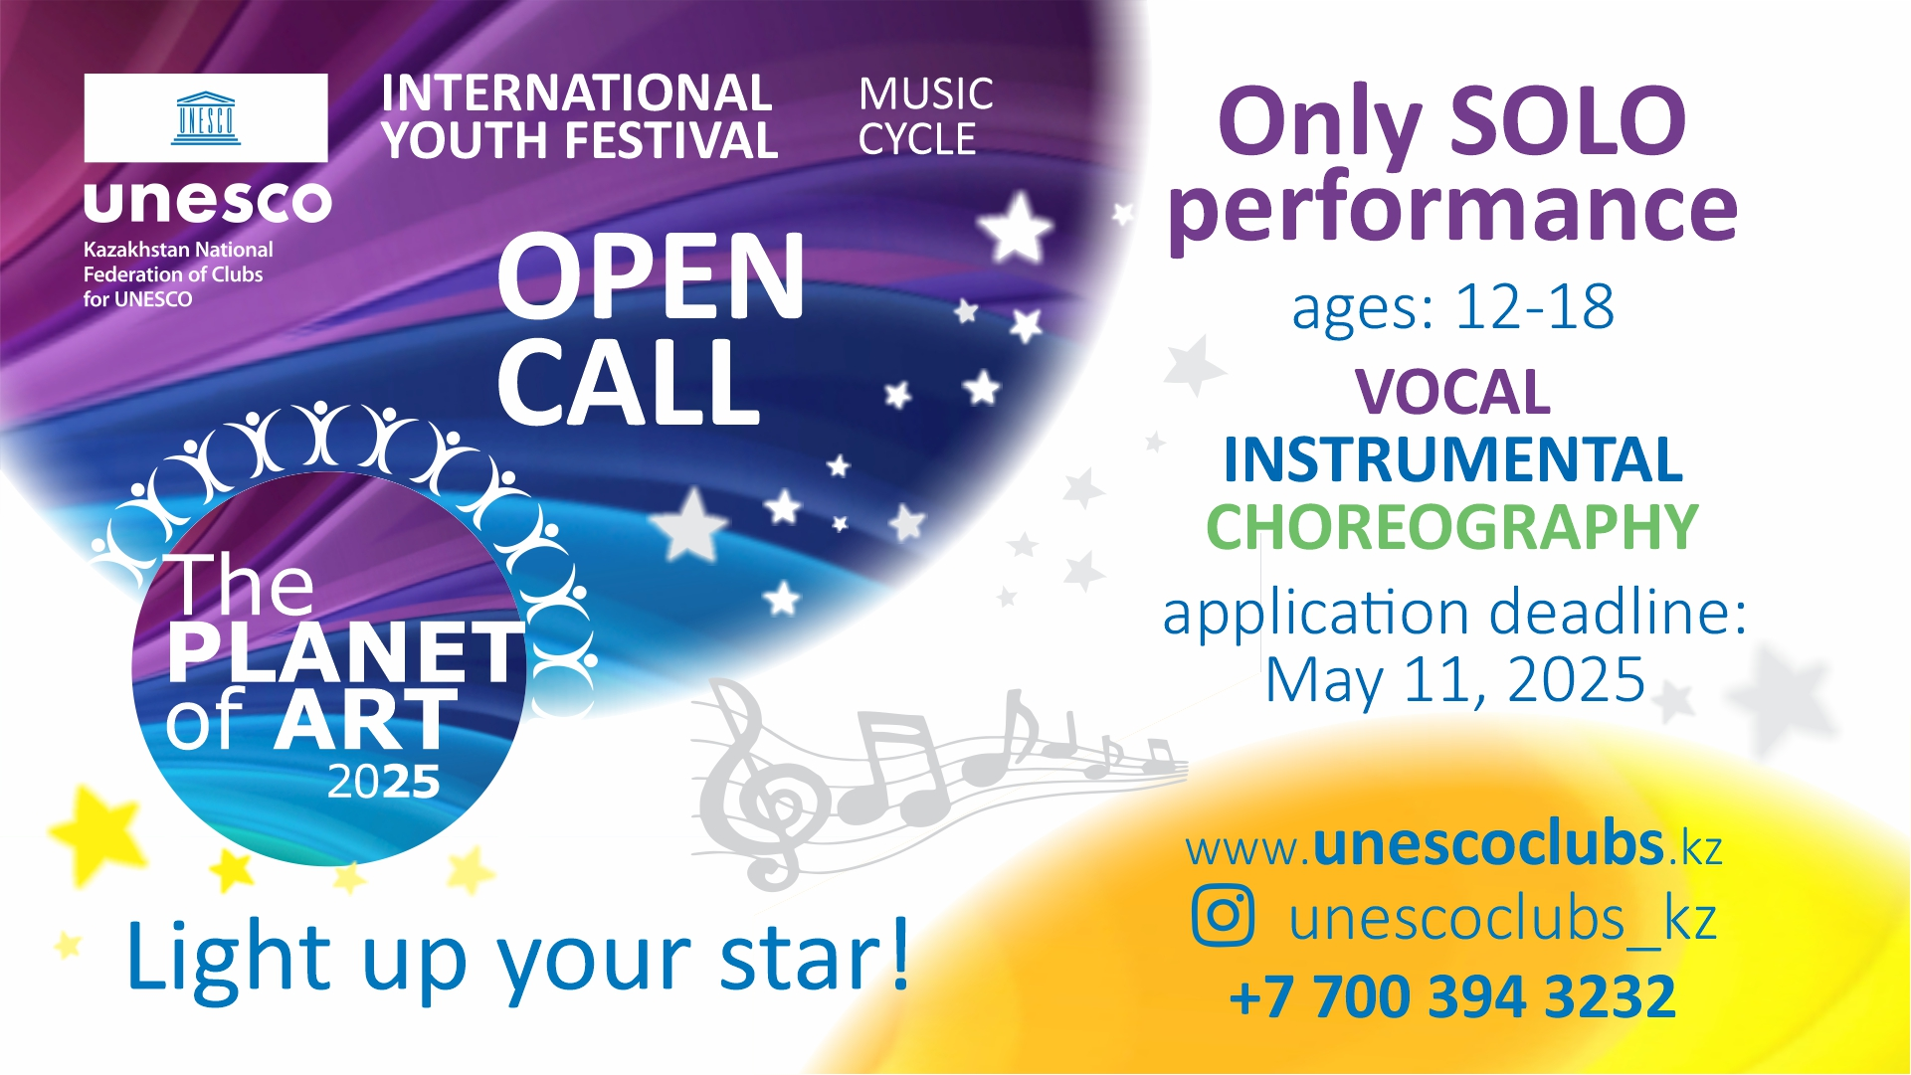
The Music Cycle of the International Youth Festival THE PLANET OF ART – 2025
Kazakhstan National Federation of Clubs for UNESCO has announced the launch of the music cycle of the International Youth Festival THE PLANET OF ART – 2025.

The Festival provides young talents with the opportunity to showcase their skills in vocal, instrumental and choreographic categories. The project is aimed at participants aged 12 to 18 from UNESCO member-states, where Associations and Clubs for UNESCO exist, who aspire to develop their artistic abilities and promote the ideals of peace and harmony through creativity.

To apply, read the guidelines, and information here.

_____________________________________________________________
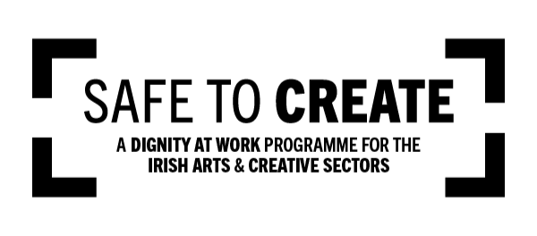
Safe to Create – April Updates
Safe to Create’s Spring training is in full swing, with upcoming workshops on LGBTQIA+ Inclusion, Staged Intimacy, and Autism Accessibility. They have also welcomed Ann-Marie Ahearne as their new Projects Manager. Don’t miss the chance to join their sessions and support safer, more inclusive arts spaces.

More info here.

_____________________________________________________________
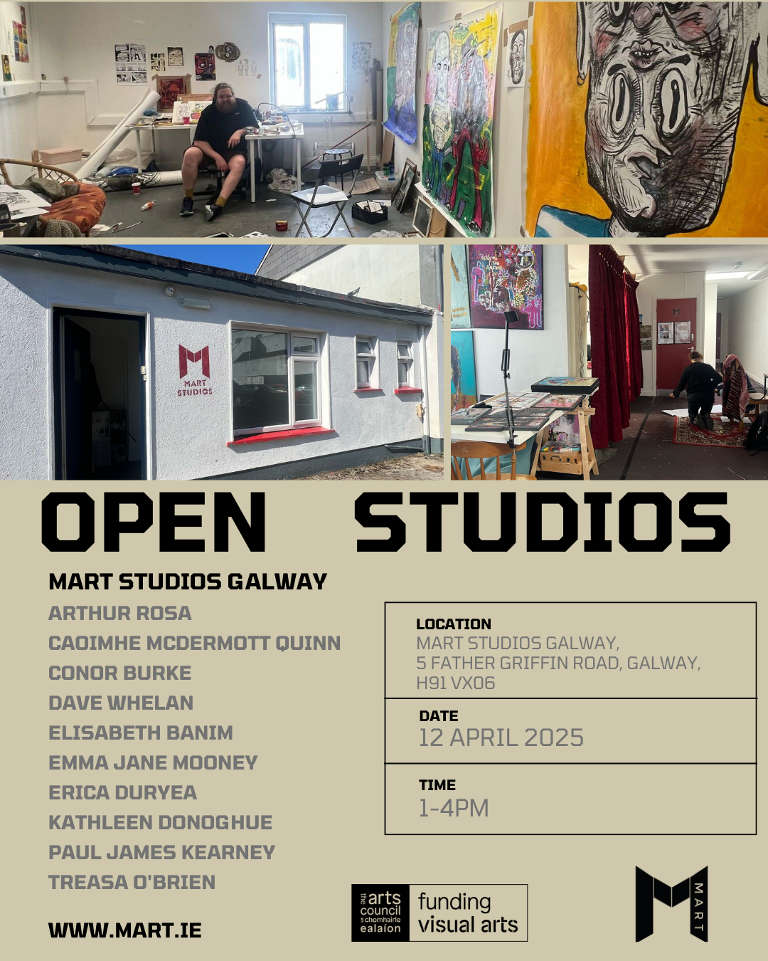
MART Galway Open Studios 2025
Explore the studios of MART Galway artists on Saturday, April 12th (1–4 PM) at MART Studios, Galway. Meet the artists, see works-in-progress, and experience their creative process. Free admission, all welcome! Supported by the Arts Council of Ireland.

More info here.

_____________________________________________________________
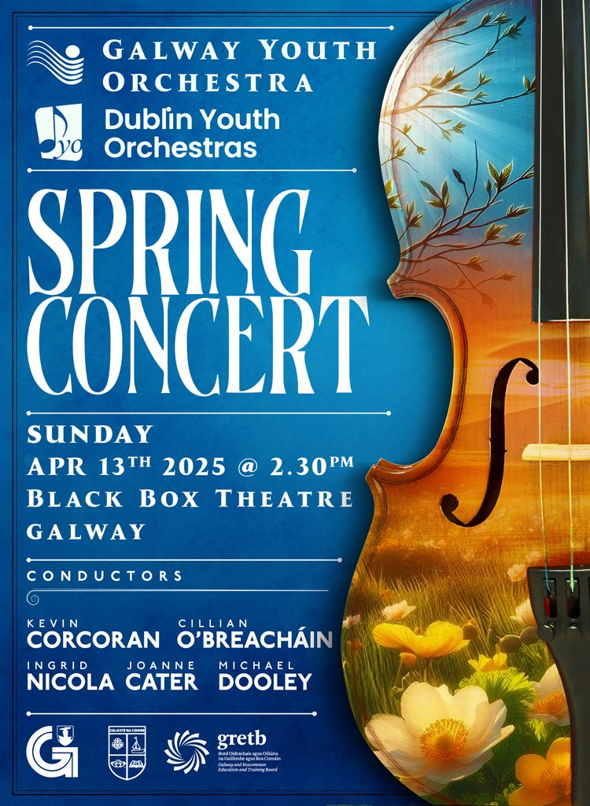
Galway Youth Orchestra presents its Spring Concert
Galway Youth Orchestra presents its Spring Concert with guests the Dublin Youth Orchestra in the Black Box Theatre on Sunday April 13th at 2.30pm.

Tickets available from the Town Hall Theatre ticket office are €12.50 and €5 concession. Tickets will also be available at the door which opens at 2pm.

More information and details here.
_____________________________________________________________
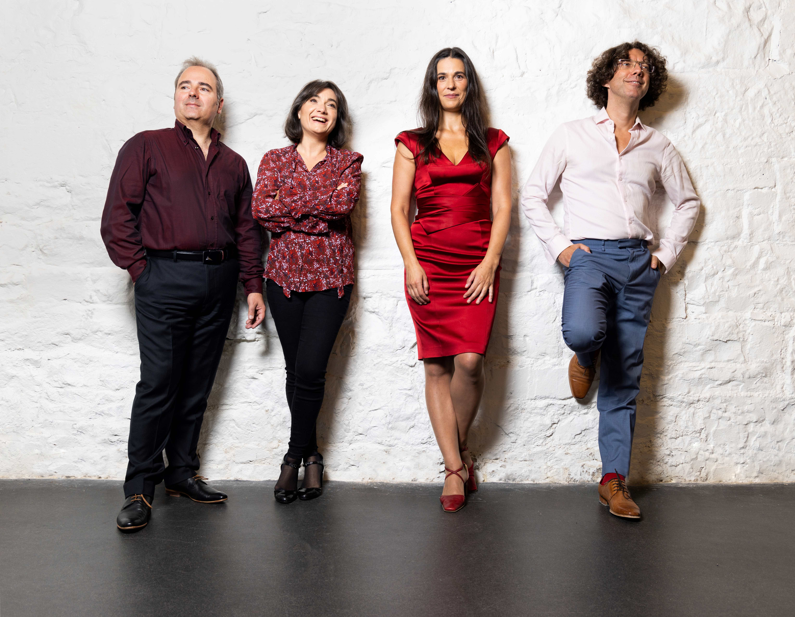
Galway Music Residency – April Events
Galway music residency have two exciting events this April:
Experience ConTempo Countywide at Claregalway Castle on April 27th, 7 PM, featuring ConTempo Quartet and Cois Cladaigh—no booking required!
Join Music Unveiled at Westside Library on April 29th, 11:30 AM, for an insightful look into upcoming performances. Free, booking via westside@galwaylibrary.ie / 091-509091.
More information and details here.
_____________________________________________________________

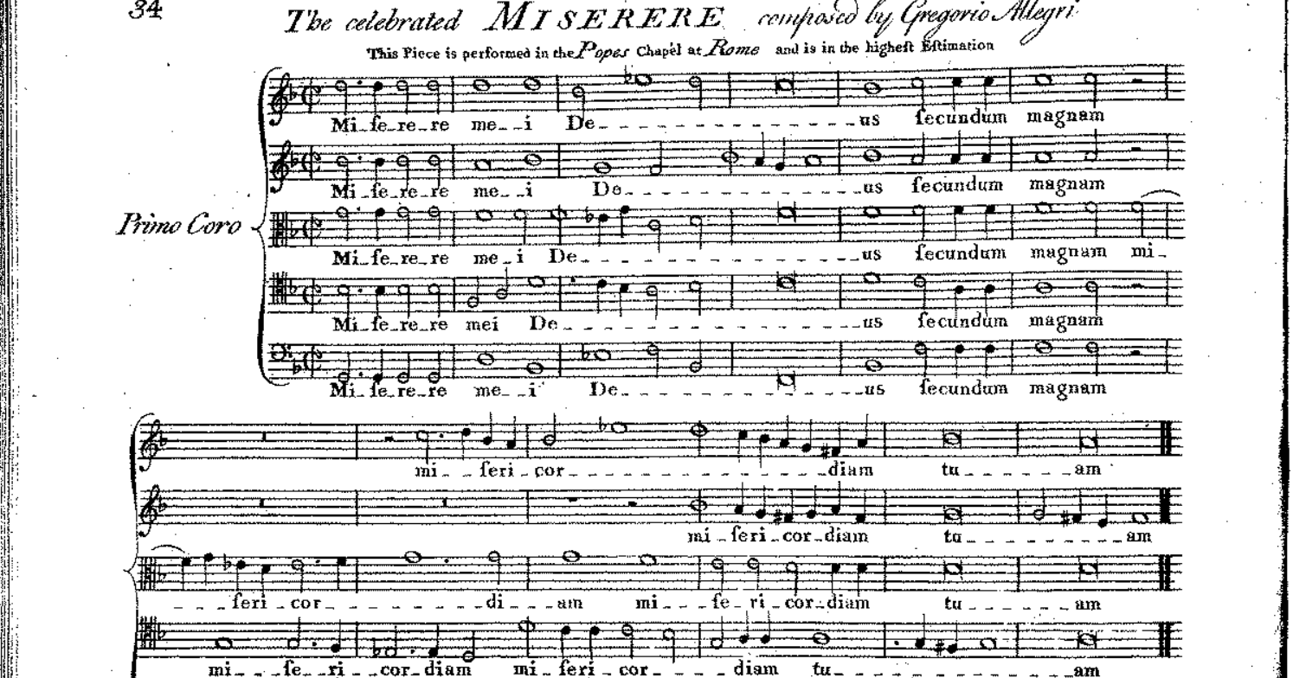
Miserere - Music for Good Friday
This Good Friday, April 18th at 5.00pm, St. Nicholas’ Collegiate Church will once again become a sanctuary to those who would like to take an hour away from the hustle and bustle of life as Galway’s finest chamber choir Collegium under the direction of Mark Duley presents a programme of reflective music.

More information here.

_____________________________________________________________
Send us your Listings & News
We can share your posts! Email up to 50 words to arts@galwaycity.ie with a high-resolution landscape image. Images and text may be edited to fit.
___________________________________________________________________
GCC Arts Office Social Media
Facebook: www.facebook.com/ArtsOfficeGalwayCity
Instagram: @artsofficegalwaycity
X: @cityartsgalway
___________________________________________________________________
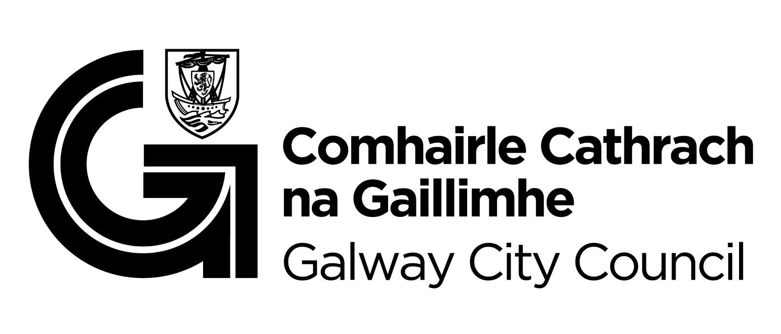
You are getting this email because you are on the Galway City Council Arts Office mailing list. Unsubscribe by emailing arts@galwaycity.ie and ask to be removed.

