Galway City Council Arts Newsletter Late March
Welcome to the Arts Office Newsletter for the end of March.
Below you will find funding opportunities and some exciting events in Galway in the coming weeks.
Happy reading, from the Galway City Arts Office team.
_____________________________________________________________
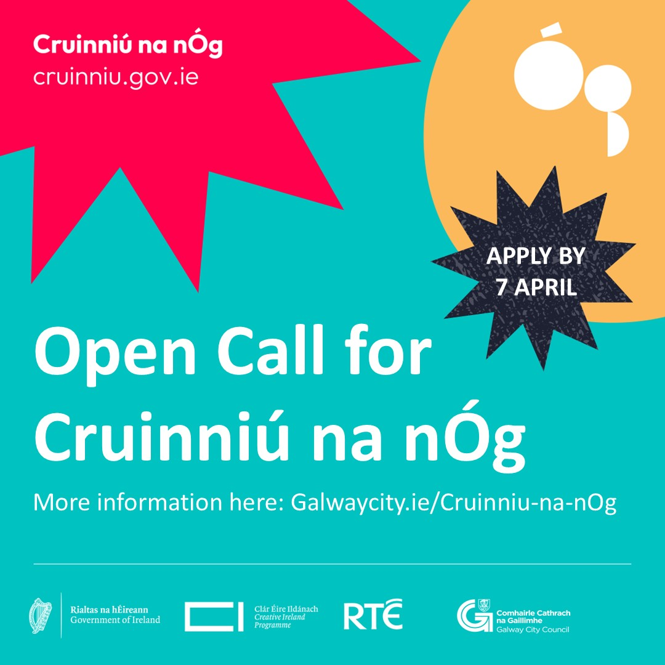
Cruinniú na nÓg Open Call
Galway City Council invites artists, creatives, and youth groups to submit projects for Cruinniú na nÓg in Fr. Burke Park on 7 June 2025. Grants of €500 to €3,000 are available.

Information and Q&A sessions will be held on Wednesday 2 April, in-person at Galway City Museum’s Education Room at 1.30 pm and online at 7 pm. To register your attendance online or in person, please contact candc@galwaycity.ie.

Closing date for applications: 7 April, 12 pm.

More information here.

_____________________________________________________________
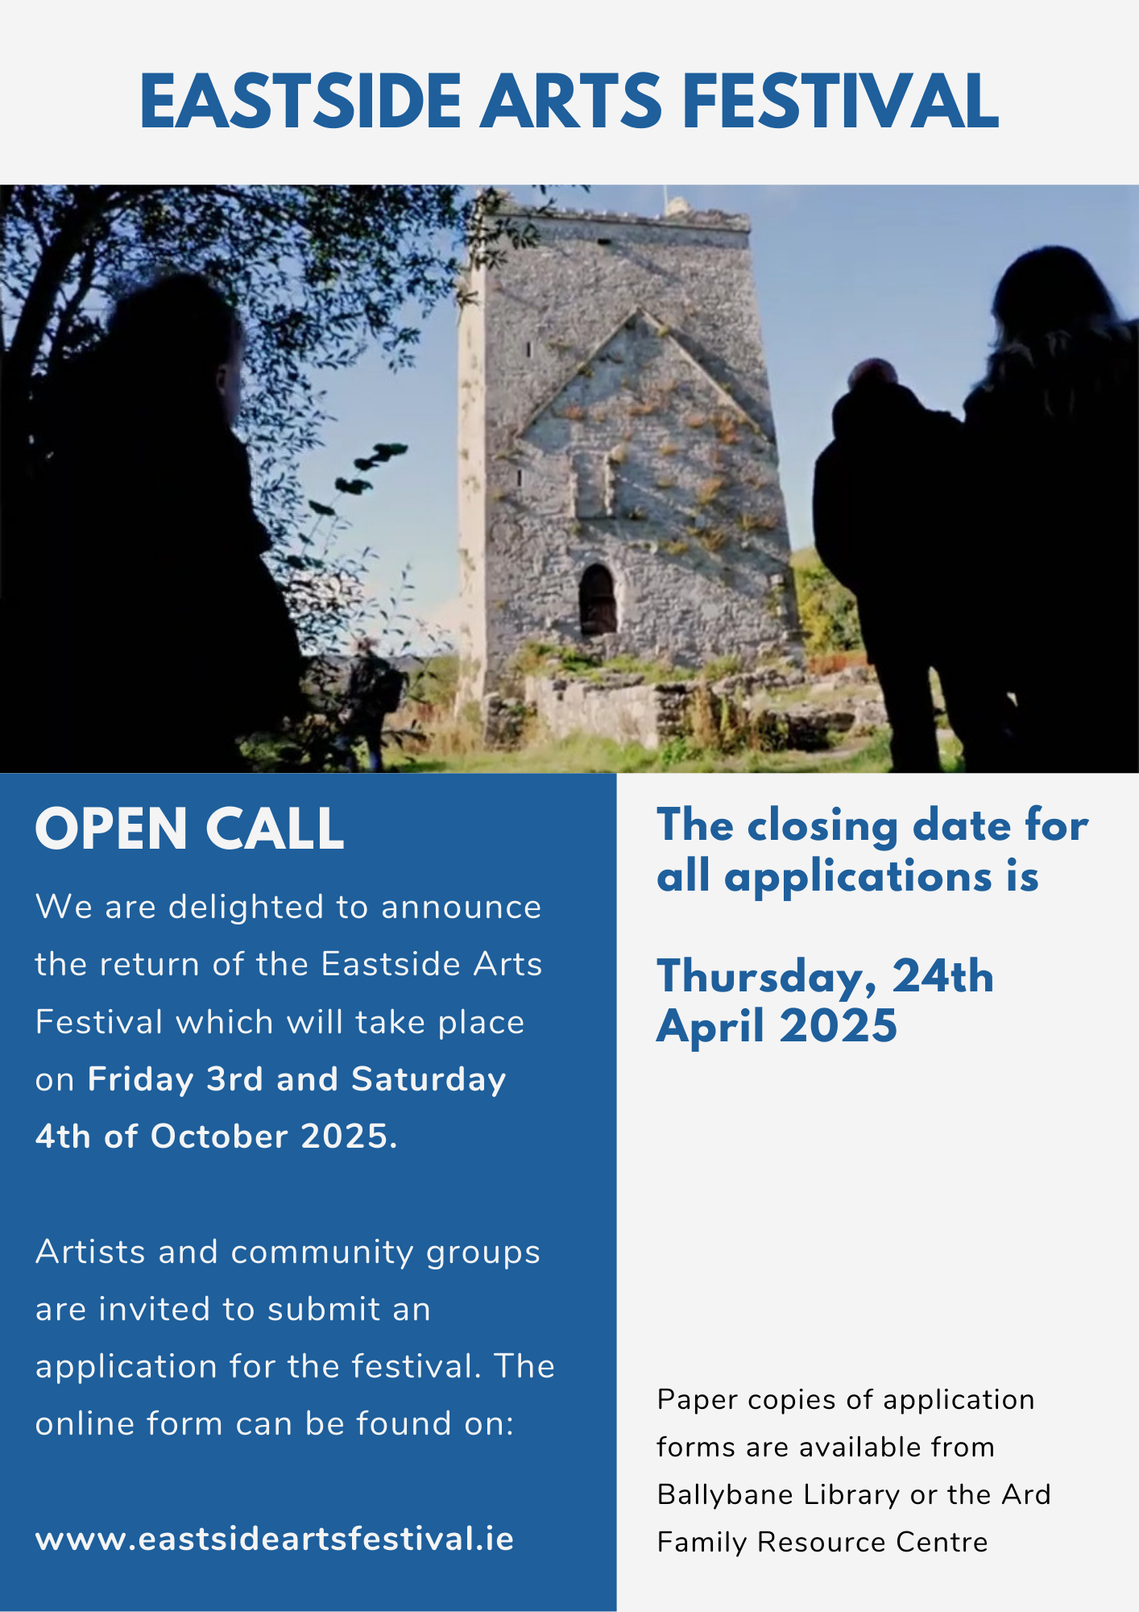
Eastside Arts Festival Open Call
The Eastside Arts Festival returns in 2025, building on the success of its inaugural celebration in 2024. This year’s festival will take place on Friday, October 3, and Saturday, October 4.

Artists and community groups are invited to submit an application for this creative and cultural showcase.

The closing date for applications is Thursday 24 April.

More information and application forms are here.

_____________________________________________________________
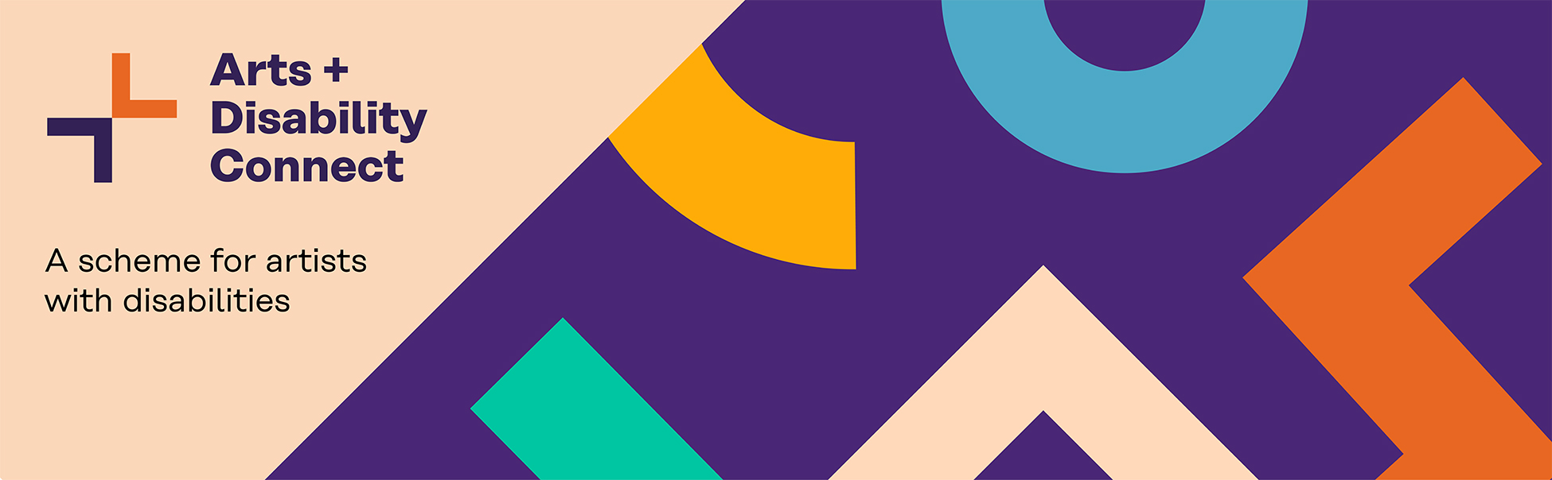
Arts and Disability Connect Scheme Round One Launch
The Arts and Disability Connect scheme launches this week via Arts & Disability Ireland, the scheme is designed to support artists with disabilities to be ambitious, to develop their practice and to connect with arts organisations and arts professionals in the Republic of Ireland.

Arts and Disability Connect includes Mentoring, Training, New Work, and Research and Reflection awards for individual artists with disabilities.

The deadline for applications is Wednesday 7 May, with information sessions available between 10 April and 2 May.

More information here.
_____________________________________________________________
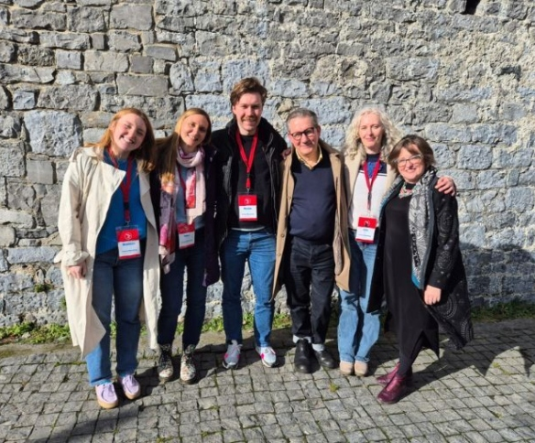
Baboró Festival Mentoring 2025 Now Open for Applications
Baboró invites you to apply to their three-day paid mentorship programme during the festival in Galway, from 16 to 18 October.

This initiative aims to encourage both emerging and established artists who are interested in making work for children to experience the Baboró International Arts Festival for Children in an immersive and rewarding way.

More information here.

_____________________________________________________________
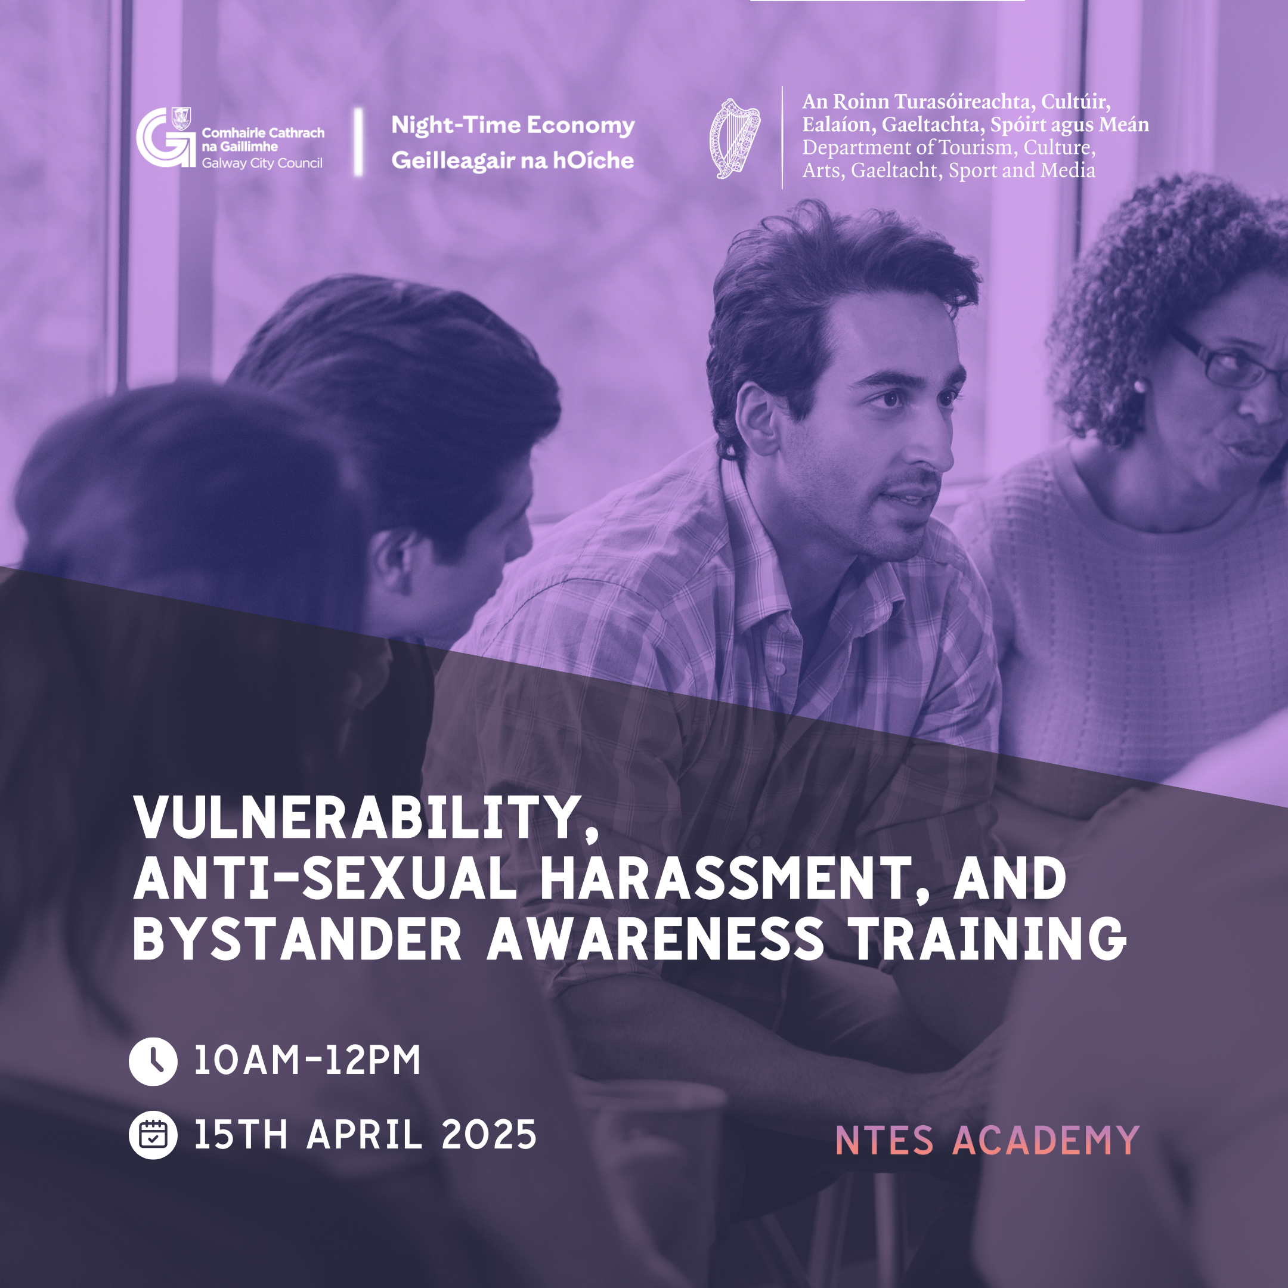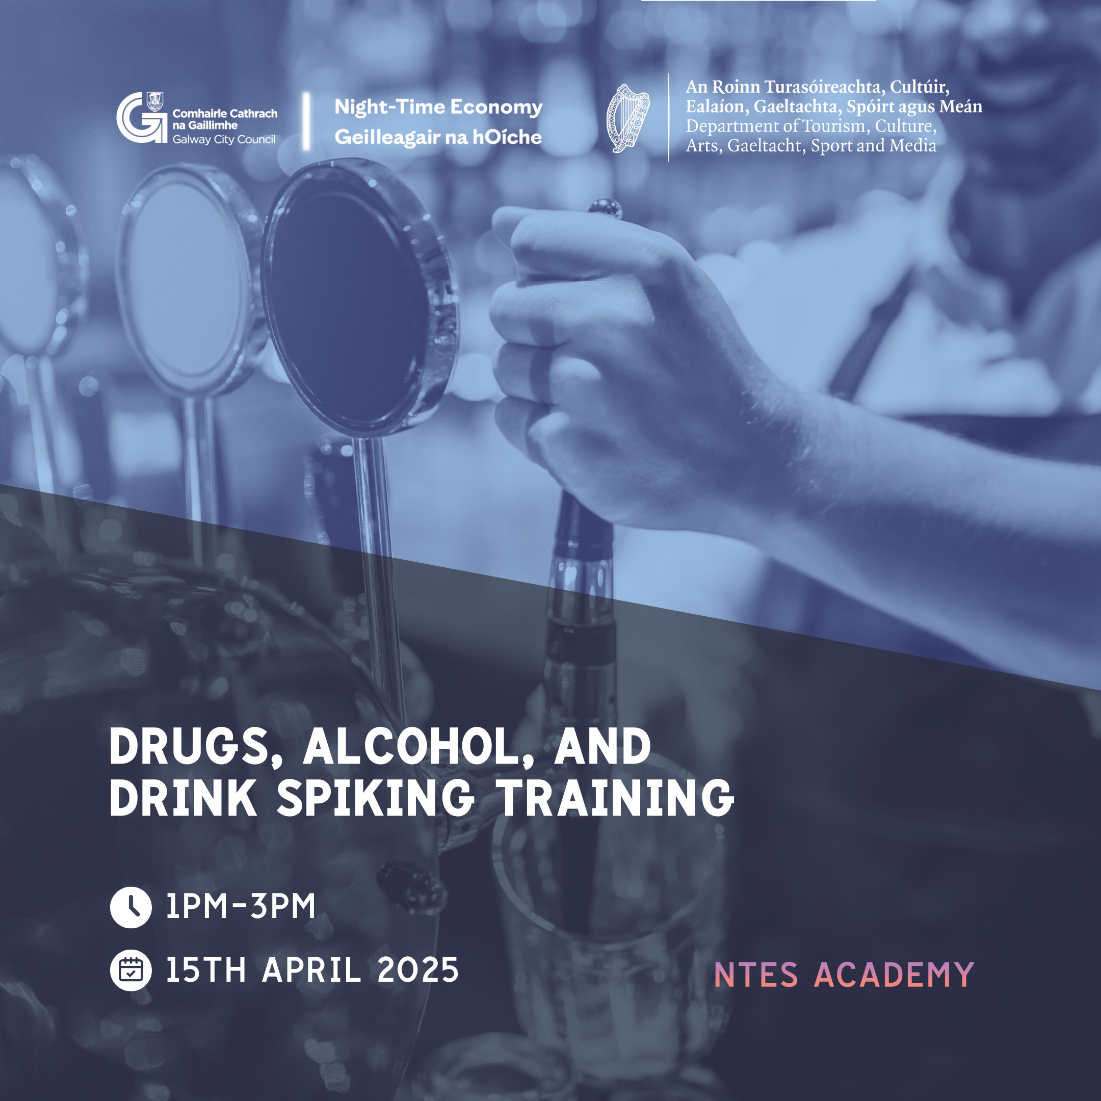
Enhancing Safety in Galway’s Night-Time Economy
Galway City Council is offering free training to improve safety in the evening and night-time economy. Two expert-led sessions on April 15th cover anti-harassment, bystander awareness, and drink spiking. Open to businesses and individuals, this initiative supports a safer nightlife. Register now—spaces are limited! Both sessions will be led by Jo Cox-Brown, Night-Time Economy Solutions - a seasoned expert with over 20 years of experience in night-time economy management.
More information and registry for the Vulnerability, Anti-Sexual Harassment, and Bystander Awareness Training here.
More information and registry for the Drugs, Alcohol, and Drink Spiking Training here.
_____________________________________________________________
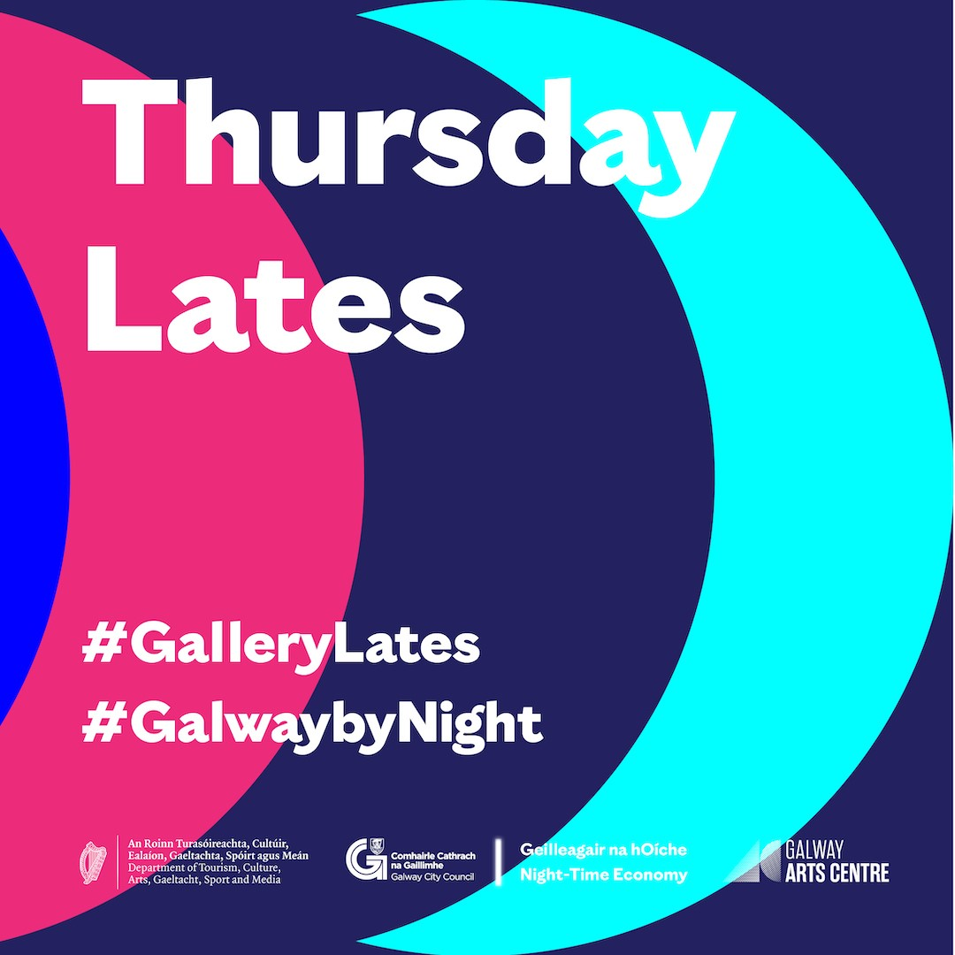
Thursday Lates at Galway Arts Centre
Galway City Council Night-Time Economy and Galway Arts Centre are excited to announce the launch of Thursday Lates, a six-month pilot program extending its opening hours to provide greater access to arts and culture in Galway City. Starting on 3 April, the Centre will remain open every Thursday evening from 10 am to 9 pm, for a six-month period.
More information here.
_____________________________________________________________
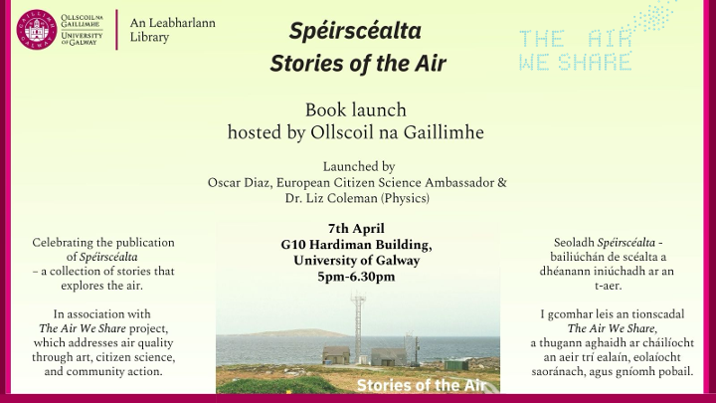
Citizen Science Book Launch: Spéirscéalta/Stories of the Air
The University of Galway Library is delighted to invite you to celebrate the publication of Spéirscéalta – a collection of stories that explores the air.
Join them on 8 April for the launch of Spéirscéalta, a collection of stories exploring the air, part of the Stories of the Air project. The event features speakers Oscar Diaz, Dr. Liz Coleman, artists Paula McCloskey and Sam Vardy, and Dr. Mairéad Hurley, with live music.
This free event, open to the public, requires registration. Copies of the book will be available.
More information and registration here.
_____________________________________________________________
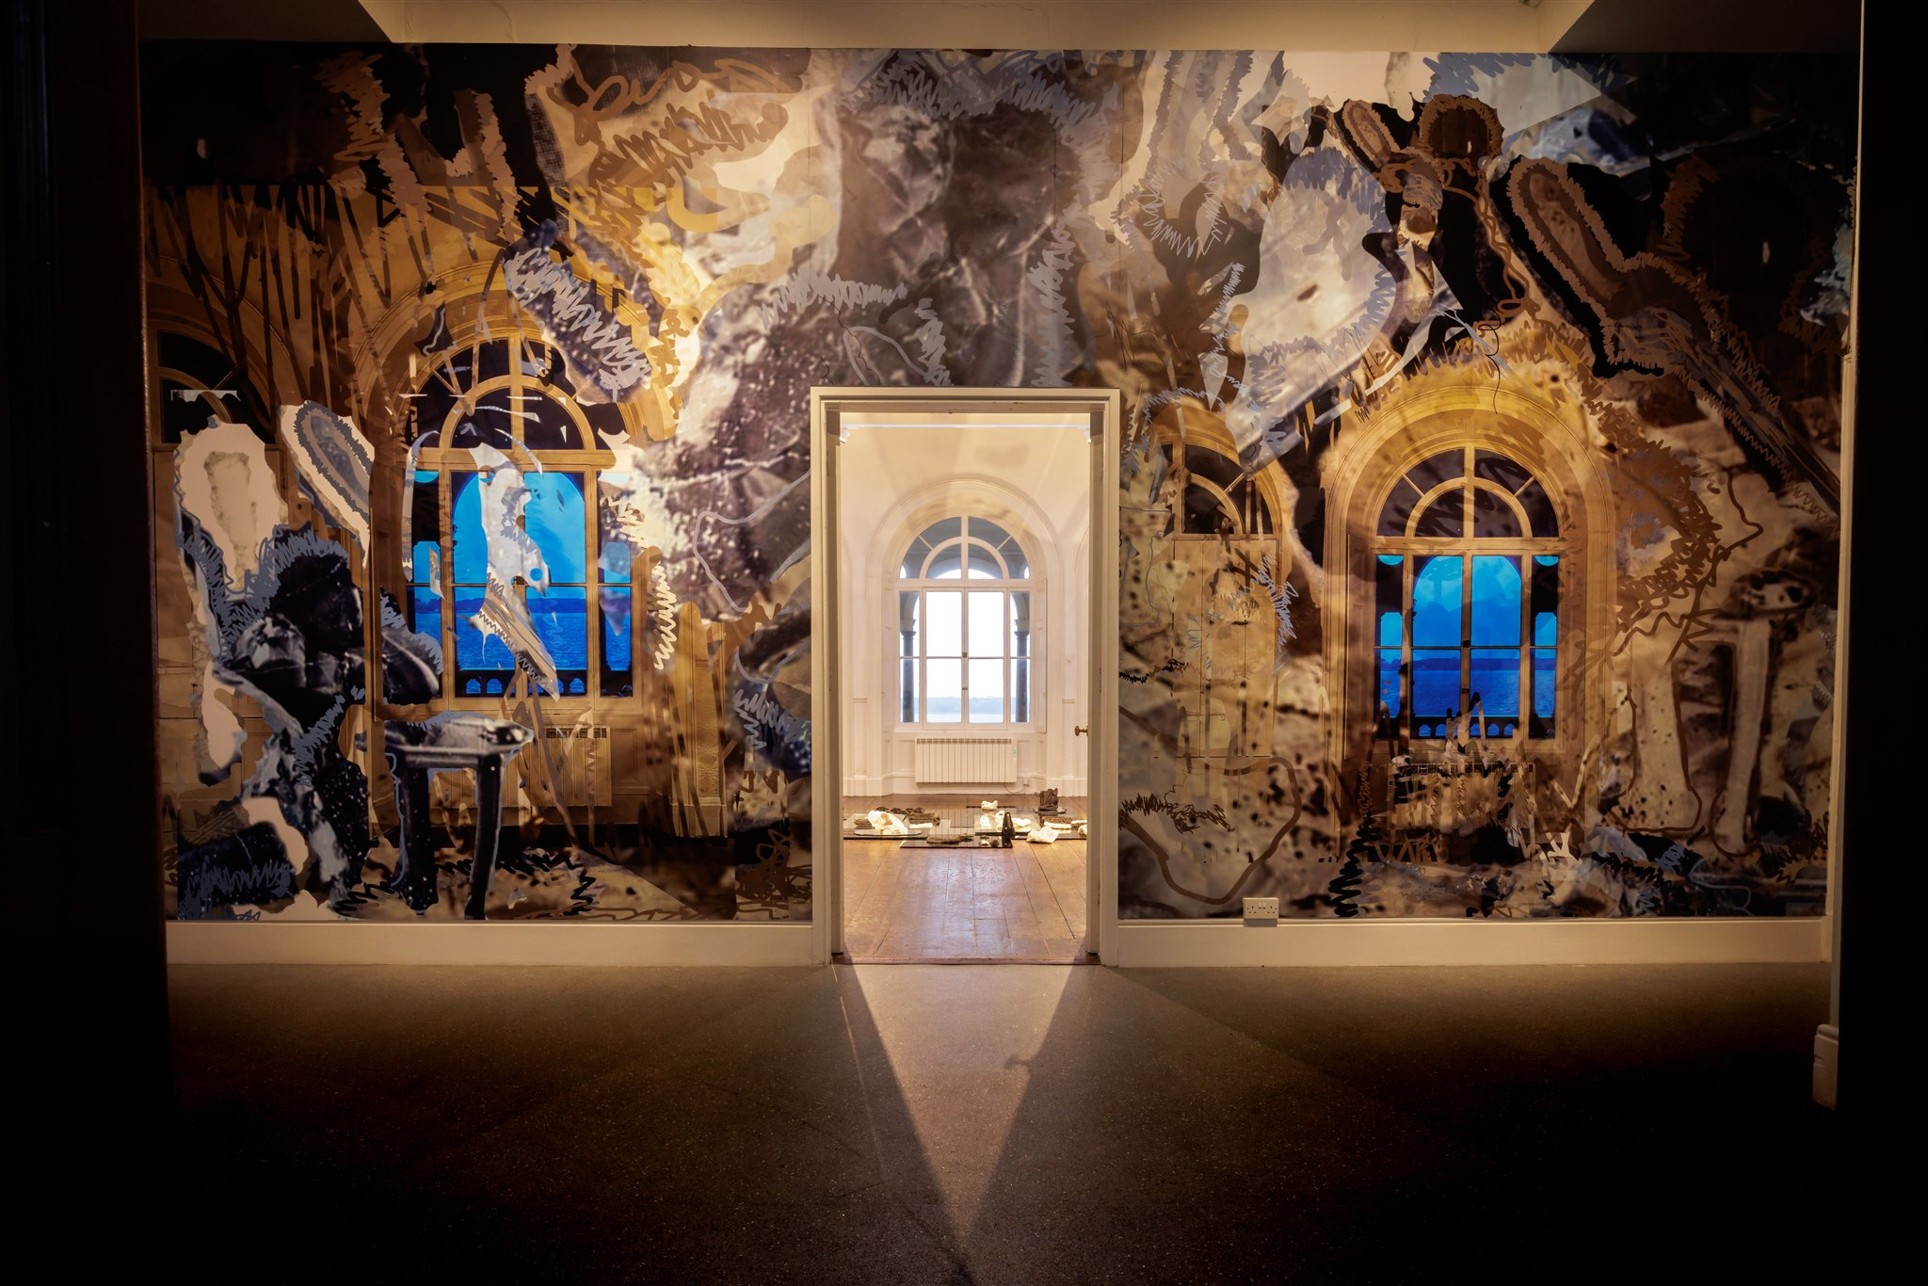
Clann Miotlantach / Mythlantics, a solo exhibition by Alice Rekab
Alice Rekab: Clann Miotlantach / Mythlantics explores identity, diaspora, and belonging through sculpture, digital collage, and performance. Rekab reimagines archival materials and personal narratives, challenging perceptions of Irishness and race.

Where: Galway Arts Centre
When: 28/03 – 10/05 | Free
Artist Talk: 5 pm, 28 March | Opening Reception: 6 pm

More information here.
_____________________________________________________________
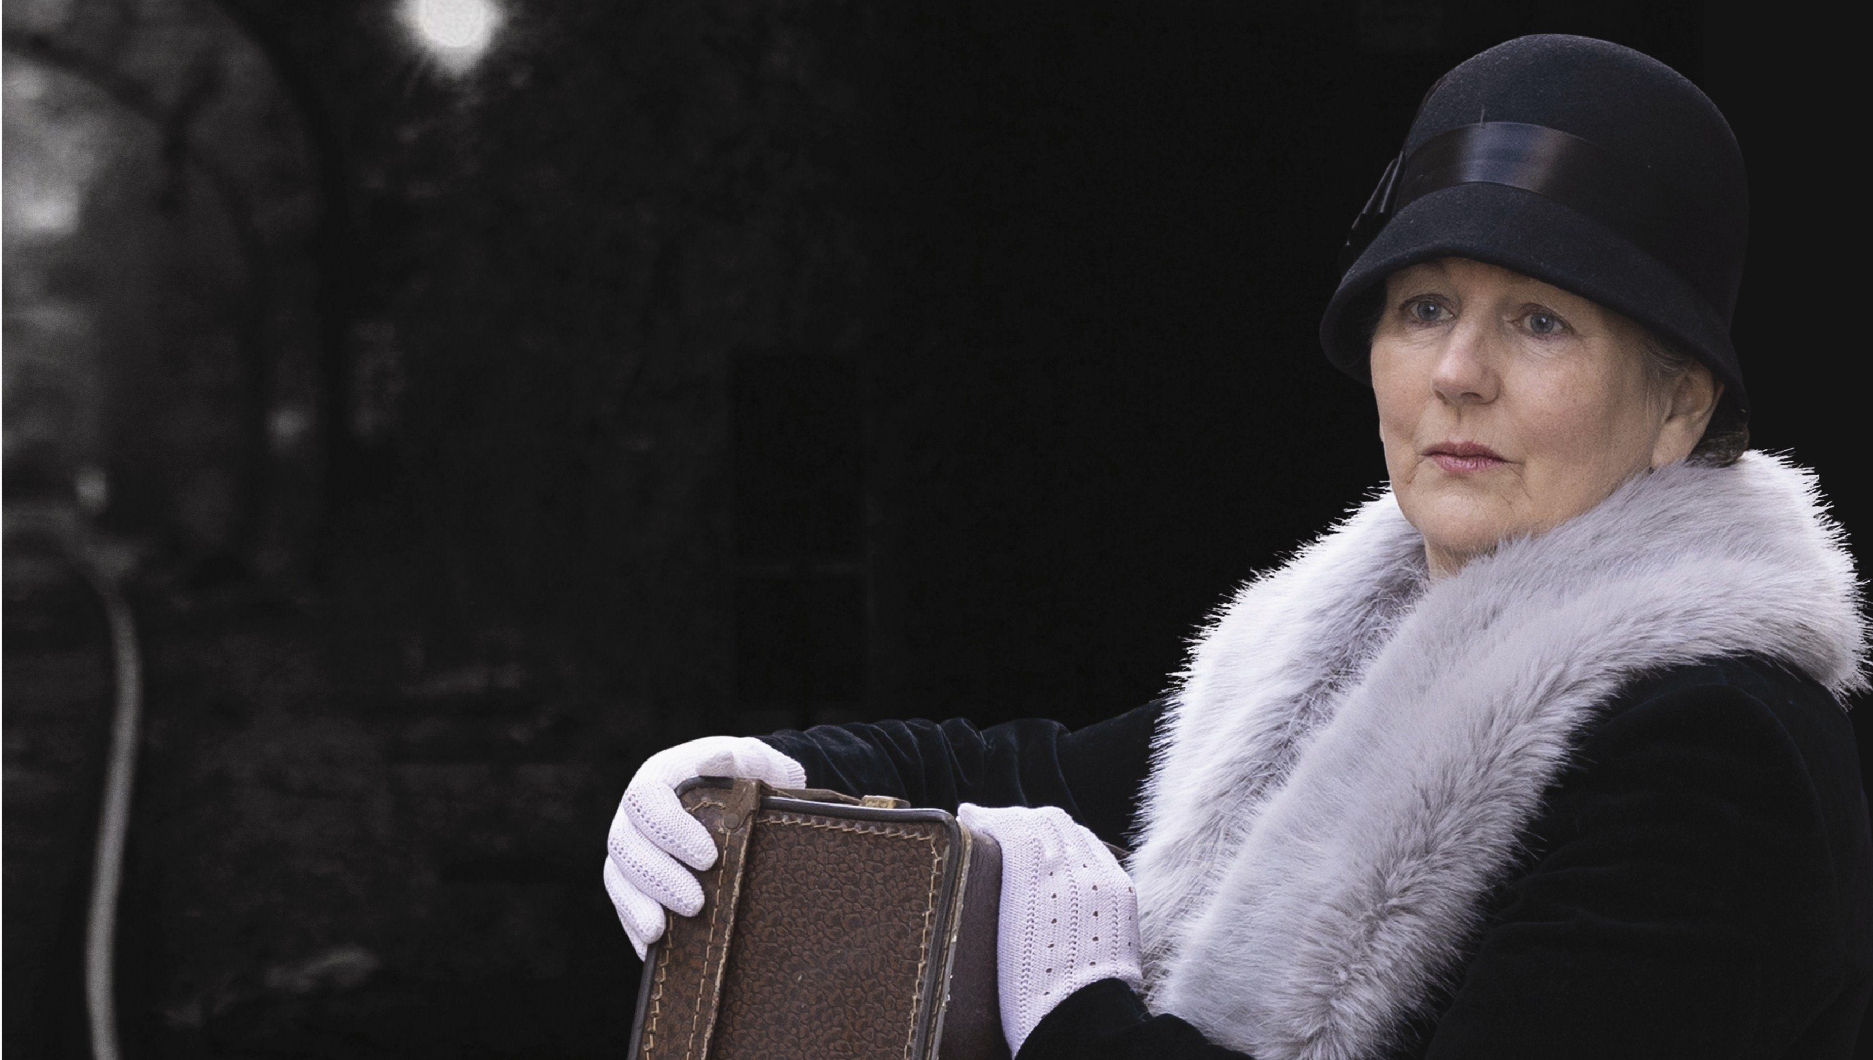
A Rare Journey at the Town Hall Theatre
A Rare Journey, Nora Joyce’s Odyssey celebrates the life of a truly remarkable Galway woman Nora Barnacle, in a highly entertaining roller-coaster 75-minute play, filled with music and song.

Written and performed by Paula Greevy-Lee, and directed by Gerard Lee, this one-woman show separates the funny, wise, sharp-witted, complex, and compassionate Nora from the half-truths that have dogged her since her death in 1951.

Duration: 75 min, no interval
Age: 14+
No re-admittance.
Post-show Q&A
Town Hall Theatre / 13 May
More information and tickets here.
_____________________________________________________________
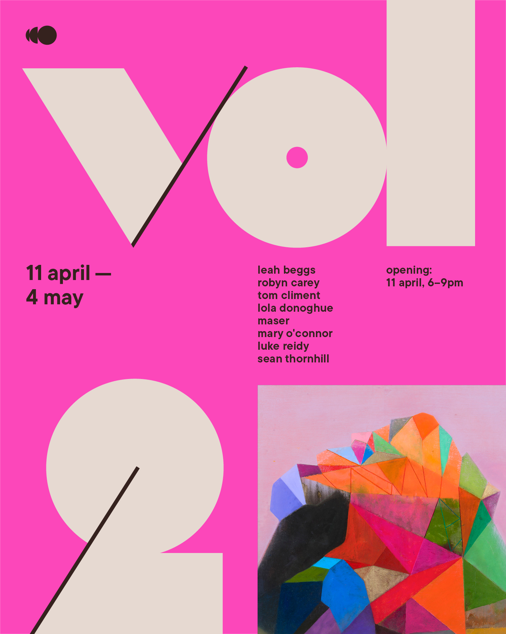
Volume 2: New Exhibition at Outset Gallery
Outset Gallery proudly presents Volume 2, showcasing abstract and mixed media paintings by leading Irish and UK artists. Join them for the opening on Friday, 11 April (18:00-21:00) with music by DJ Mitch Presents and refreshments. The exhibition runs until 4 May 2025.

More information and register here.

______________________________________________________________
Send us your Listings & News
We can share your posts! Email up to 50 words to arts@galwaycity.ie with a high-resolution landscape image. Images and text may be edited to fit.
___________________________________________________________________
GCC Arts Office Social Media
Facebook: www.facebook.com/ArtsOfficeGalwayCity
Instagram: @artsofficegalwaycity
X: @cityartsgalway
___________________________________________________________________
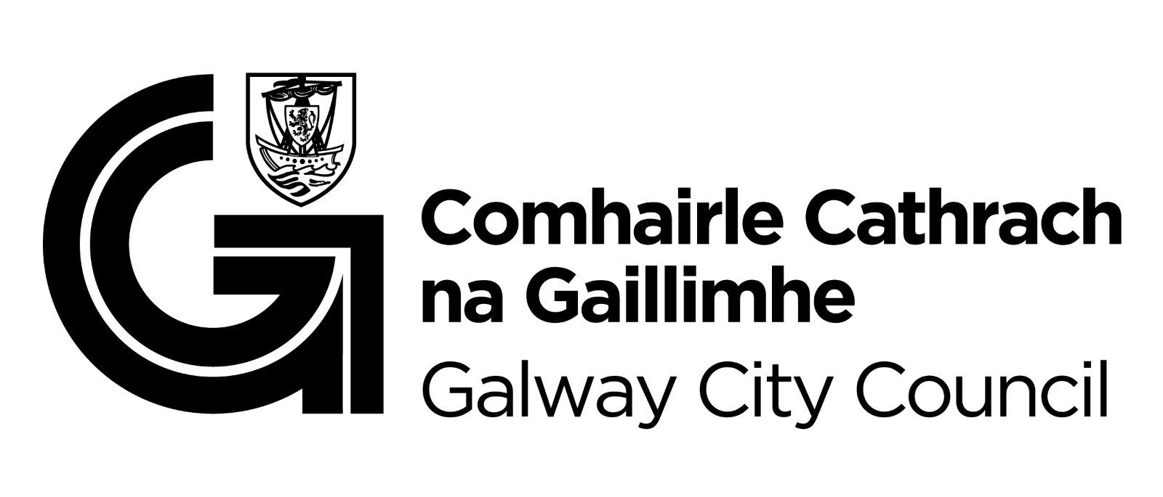
You are getting this email because you are on the Galway City Council Arts Office mailing list. Unsubscribe by emailing arts@galwaycity.ie and ask to be removed.

