Galway City Council Arts Newsletter Early March
Welcome to the Arts Office Newsletter for early March.
Galway’s creative spirit shines this March with a dynamic lineup of events, residencies, and celebrations. From textile art to marching bands, contemporary music to coastal movement, this edition is packed with opportunities to engage, create, and be inspired.
Happy reading, from the Galway City Arts Office team.
_____________________________________________________________
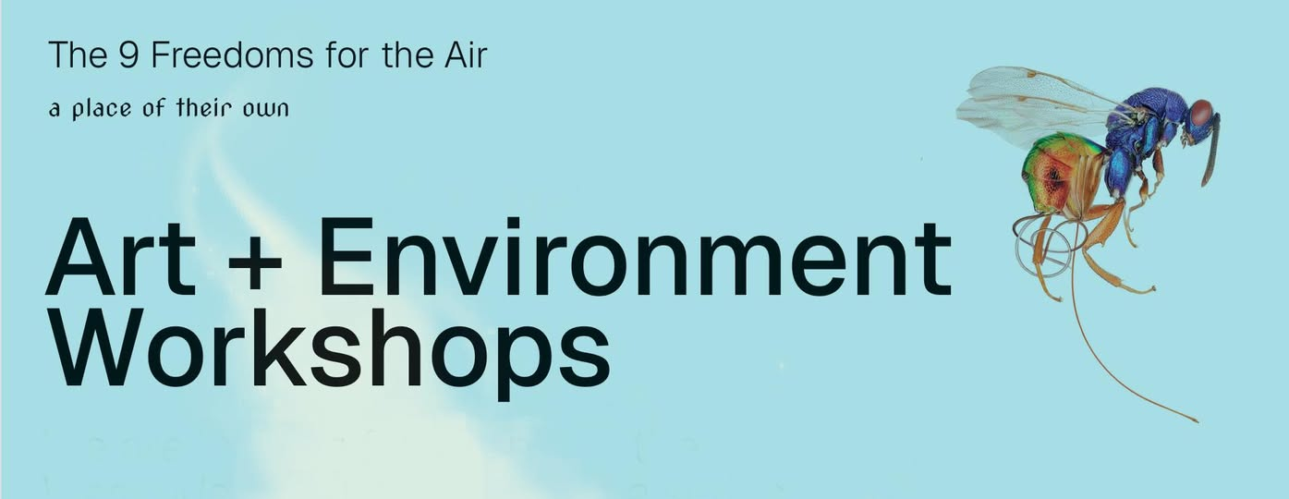
Take part in Art + Environment Workshops in Westside
Artist duo A Place of their Own are looking for people in the Westside community to join a series of art workshops about the air. These workshops will explore the air we breathe using folklore, scientific and legal knowledge.

Participants will work with the artists who created the project, Paula McCloskey and Sam Vardy, and local textile artist Karena Ryan to collectively embroider a textile which will be shown at exhibitions in Westside and beyond as part of The Air We Share project.

The workshops are open to all, no previous experience necessary.
Lunch and refreshments will be provided.

To register your interest please call Westside Resource Centre on 091 528 325.

These workshops are part of The Air We Share, a Creative Climate Action Project funded by Creative Ireland. More info about the project here: airweshare.ie

_____________________________________________________________
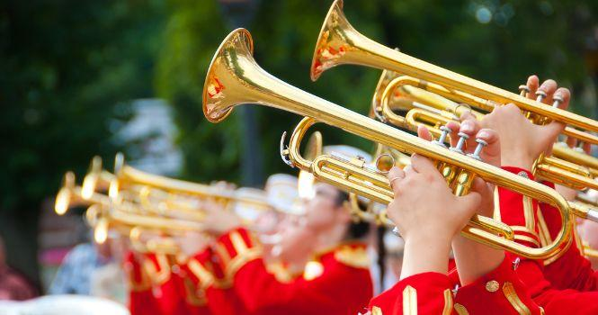

Galway to Host 2027 WAMSB World Championships

Galway City Council is proud to announce that Galway has been selected as the host city for the 2027 World Association of Marching Show Bands (WAMSB) World Championships, a global event that will bring thousands of musicians and performers to the city from the 13 to 15 August 2027. Across this large-scale, 3-day event, Galway City will welcome marching bands, drum corps, concert bands, and music ensembles and their families from around the globe.
A regional qualifier in 2026 will preview the event ahead of the main competition.

Mayor of Galway City, Peter Keane, said:
"It is a great honour for Galway City to host the 2027 WAMSB World Championships. This event will celebrate the best of international music and culture, bringing our community together and welcoming thousands of visitors to experience the unique hospitality of our city.'’

The hosting bid was a collaborative effort between Galway City Council, IMBA, Celtic Horizon Tours, and University of Galway.

See the full article here.
_____________________________________________________________
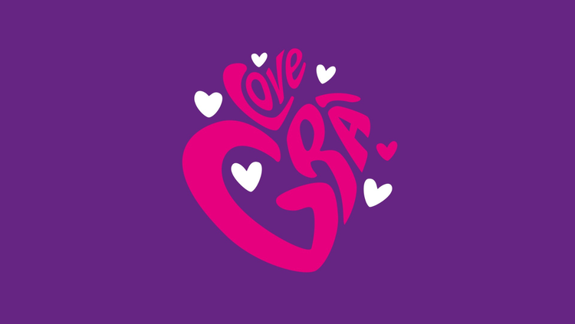

Grá Festival taking place this March

A festival dedicated to love in all its forms—romantic, platonic, familial, self-love, and love for community, humanity, and the environment. Inspired by the legendary Nora Barnacle, this year’s festival explores her story, her love, and her impact on Galway, Grá Fest takes place from Thursday 20 March to Sunday 23 March.

More information here.
_____________________________________________________________
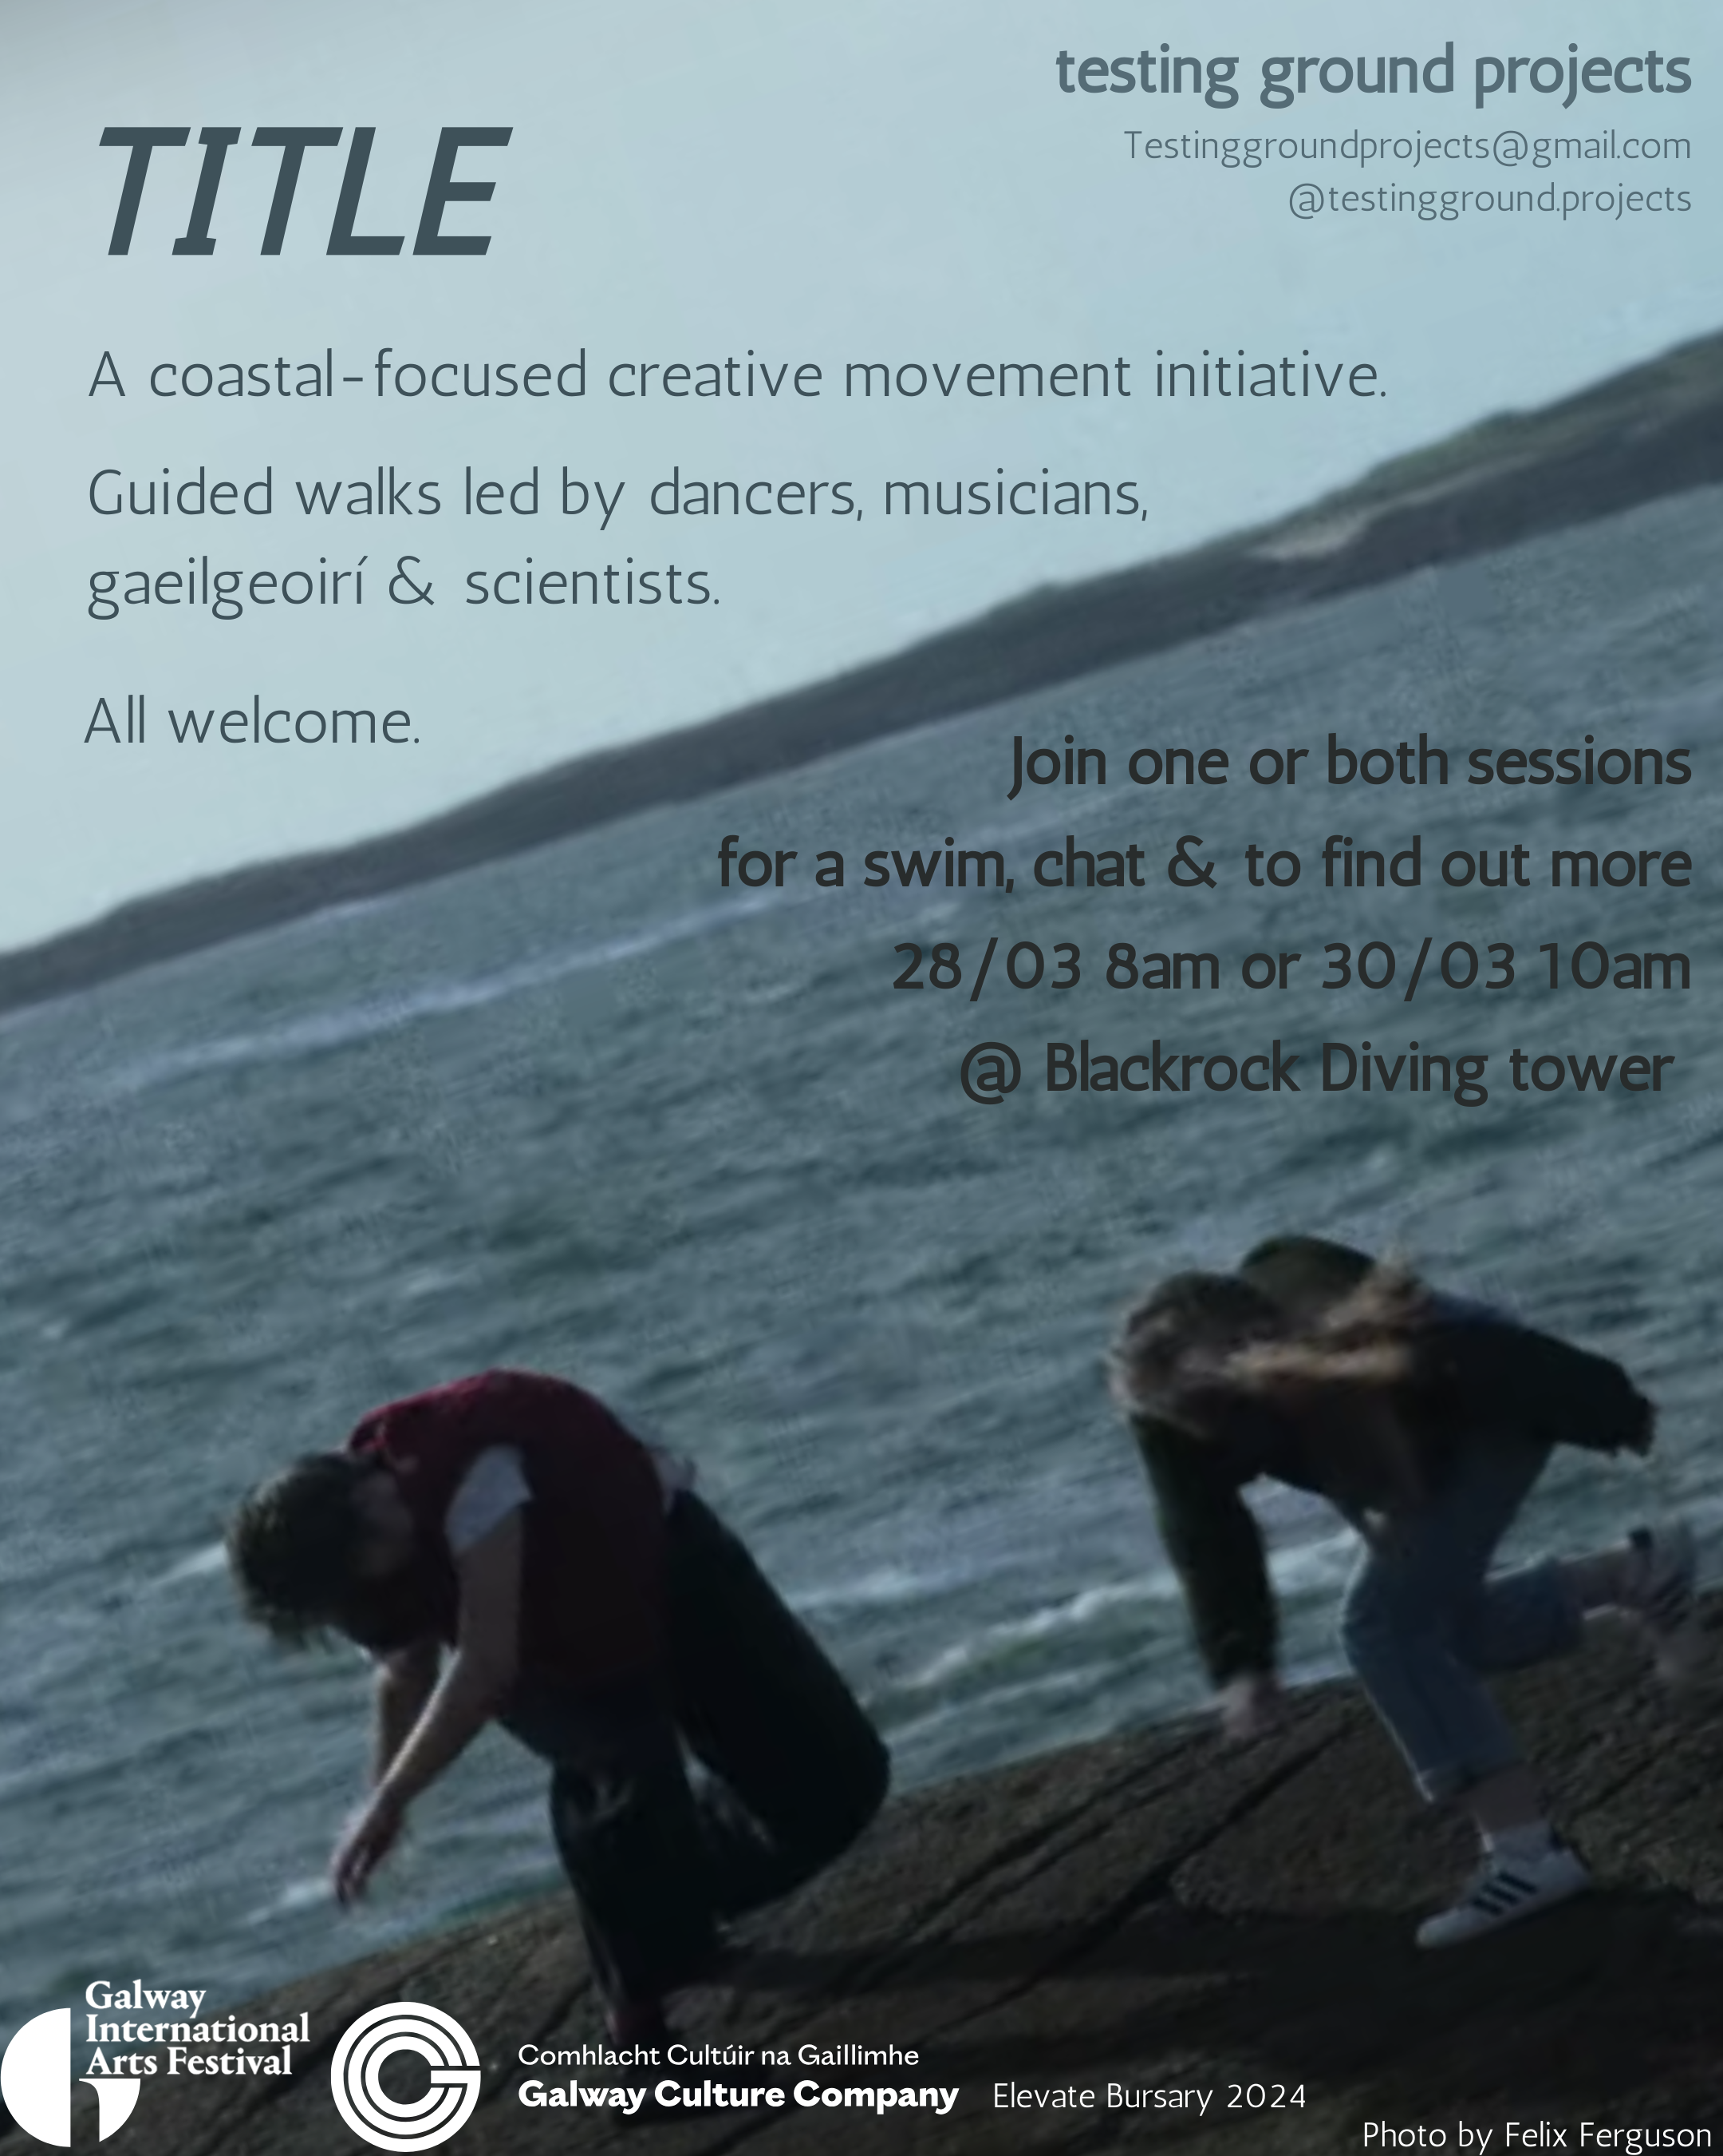
Title: A Coastal-focused Creative Movement Initiative
Join Galway city dance artists Roberta Ceginskaite & Fionnuala Doyle Wade for an information session on their upcoming coastal-focused creative movement initiative on 28 or 30 March
For questions & more information contact Testinggroundprojects@gmail.com
_____________________________________________________________


Neil Ó Lochlainn: Immram

Is sraith dánta atá in Immram le Nuala Ní Dhomhnaill a chuir Neil Ó Lochlainn ceol leo. Tá an ceol measctha le tionchair ó cheol traidisiúnta na hÉireann agus traidisiún amhránaíochta an tsean-nóis, chomh maith leis an snagcheol/ceol saor-chumtha agus ceol clasaiceach comhaimseartha chun stíl nuálach, iar-seánraithe a dhéanamh de cheol aireagail comhaimseartha na hÉireann.

Eolas ón Taibhdhearc anseo.
_____________________________________________________________
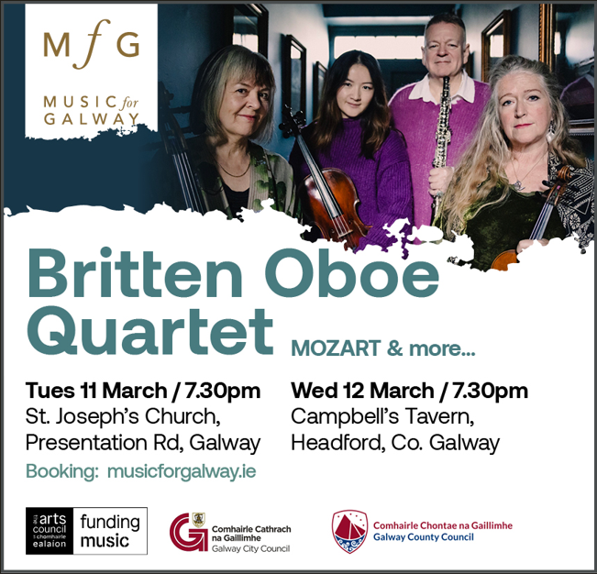

Music for Galway presents: The Oboe Soars Over the Strings

While perhaps not as well-known as the string quartet, the combination of oboe, violin, viola and cello can create the most beautiful soundscapes. The Britten Oboe Quartet will amply demonstrate this as they perform a wonderful programme that takes in a strong, nearly abstract piece by Irish composer Elizabeth Maconchy, folk influenced work by Ernest Moeran, a Danish traditional piece, and all of it bookended by two splendid Mozart masterpieces.

Performances take place Tuesday 11 March @ 7.30pm in St.Joseph’s Church and Wednesday 12 March @ 7.30pm in Campbells Tavern.

More information here.

_____________________________________________________________
Galway Camera Club Presents: "This is Galway" Photography Exhibition
Galway Camera Club has announced its first public photography exhibition in years, showcasing the stunning work of its talented members. Featuring images inspired by the theme "This is Galway," the exhibition captures the beauty and spirit of the city and its surroundings.
Join Galway Camera Club on Sunday 30 March from 12-7pm in Galway Rowing Club for a day of creativity, connection, and conversation. Refreshments provided. All are welcome!
More information about Galway Camera Club here.
_____________________________________________________________
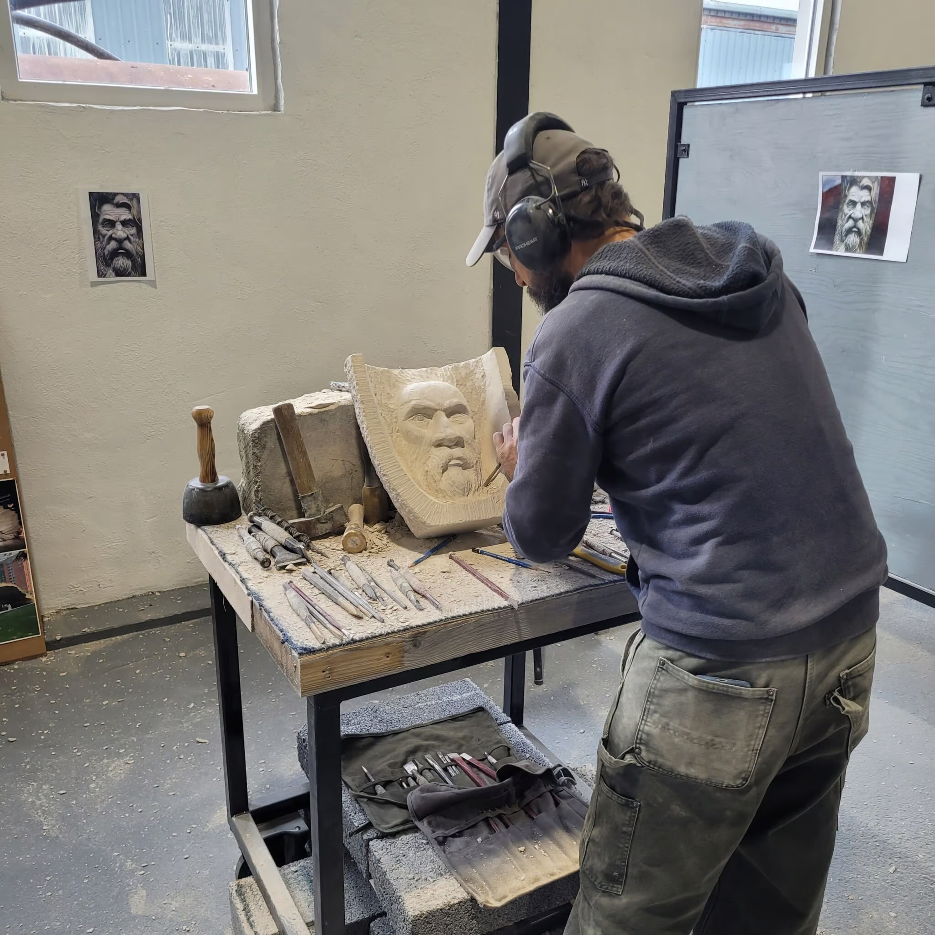
INStone's Fundamentals: Three-Day Stone Carving Course in the Burren
Learn the art of stone carving in this hands-on three-day course led by renowned sculptor Colin Grehan. Participants will use traditional techniques to create their own Portland Limestone sculpture, guided step-by-step by one of Ireland’s leading stone artists.
Courses are currently available in March and April
More information and booking here.
_____________________________________________________________
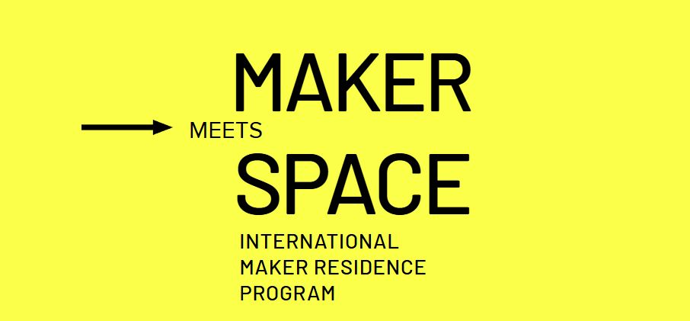

International Maker Residence Programme | Maker meets Space

Applications are now open for the Maker Residence Program 2025, Maker Meets Space, part of European Capital of Culture Chemnitz 2025.

Makers e.V. invites EU-based makers to apply for one-week or one-month residencies taking place in June 2025. These residencies, hosted by nine Chemnitz2025 Maker Hubs, culminate in the Makers United Festival.

Welcoming makers into makerspaces across Saxony, and the Chemnitz Cultural capital of Europe 2025 region, the goal is to foster and expand the vibrant maker culture. Nine Chemnitz2025 Maker Hubs are taking part in the program.

To apply: Submitting a formal application to makers-united.de.

The focus areas for proposals are sustainability, circular economy, STEAM projects (Science, Technology, Engineering, Arts, Math), interdisciplinary collaboration and innovation.

Deadline for applications: March 12, 2025.

The entire Open Call is available online at makers-united.de

_____________________________________________________________
Tour de Loop: Experience the Textile History and Future of Chemnitz
Chemnitz, the European Capital of Culture 2025, invites experts from the world of textile design and textile art to a unique tour. Discover the traditional and at the same time innovative textile industry of this city, which was once known as the "Saxon Manchester" and today inspires with new concepts in sustainable production, digital textile design and artistic design. Get to know the Esche Lab, the workshop for creative textile work with a focus on knitting, embroidery and clothing in Limbach-Oberfrohna. Discover the possibilities for textile art projects in the renowned Sächsisches Textilforschungsinstitut e.V. (STFI).

Target group: Textile designers, textile artists, university employees from the fields of fashion, textiles and art

Deadline for applications: April 11, 2025

More information and application forms are available here.

_____________________________________________________________
Failte Ireland Invites Creative Events Listings

Do you have a great event happening in Ireland this year? Promote it with Fáilte Ireland!
Advertise your upcoming events to irelandwestinfo@failteireland.ie and
Register & add your events through the events portal linked to Discover Ireland.
www.FailteIrelandEvents.ie/
_________________________________________________________
Galway City Council Night-Time Economy & This is Galway Invites Events Listings
Do you have a great event happening from 6pm? Promote it with This is Galway!
Simply email Kate.Howard@galwaycity.ie with a brief summary of your event and receive a special code to access the events page, where you can add all the necessary details and promote your offering. Free.
More information.
_________________________________________________________
Send us your Listings & News
We can share your posts! Email up to 50 words to arts@galwaycity.ie with a high-resolution landscape image. Images and text may be edited to fit.
___________________________________________________________________
GCC Arts Office Social Media
Facebook: www.facebook.com/ArtsOfficeGalwayCity
Instagram: @artsofficegalwaycity
X: @cityartsgalway
___________________________________________________________________
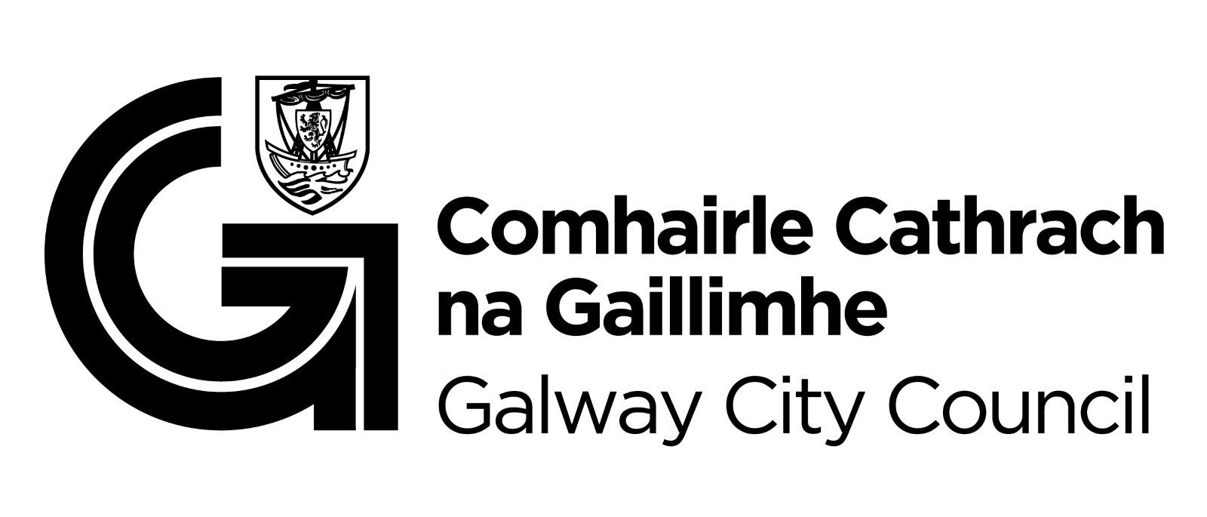
You are getting this email because you are on the Galway City Council Arts Office mailing list. Unsubscribe by emailing arts@galwaycity.ie and ask to be removed.

