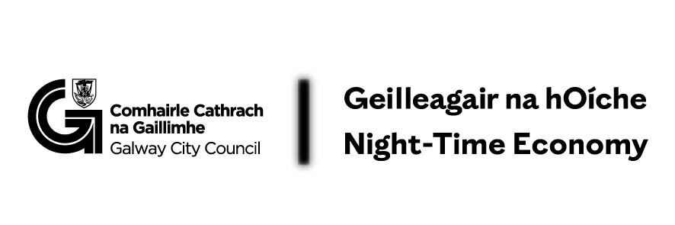

Please complete the following form to express your interest:

1. Contact Information:
- Name: _________________________________________
- Phone Number: _________________________________________
- Email Address: _________________________________________
2. Business Information:
- Business Name: _________________________________________
- Business Address and Eircode: _________________________________________

3. Proposed Cultural Activity:
Description of the cultural activity you propose to present as part of Café Lates. This could include (but not limited to) music performances, bring your vinyl night, acoustic music sessions, game nights, crafty café evenings, spoken word events, coffee/wine/food tastings, coffee + paint, coffee + draw, talks, workshops, or other similar activities. The activity must be suitable for your premises capacity and must take place from 6 pm onwards. Indicate the proposed number of events and the proposed schedule (e.g., weekly, bi-weekly, monthly).

For each proposed event, please include:

- Proposed Date: _________________________________________
- Proposed Time: _________________________________________
- Description of Cultural Activity: ______________________________________________________________________________________________________________________________________________________
- Ticketed /non-ticketed:

4.Proposed Cost/Expenditure:
Please provide a detailed breakdown of costs.
Please note: The pilot scheme will provide up to 80% of funding for the event(s) The minimum award is €250 and the maximum award is €2,000 (maximum award is for a series of events, over a period of time)

Element of Work/Programme/Item | Cost (€):
TOTAL

I confirm I have read and understand the terms and conditions: Yes/No

Completed applications must be submitted by email to Eimear Coleman, Eimear.Coleman@galwaycity.ie at Galway City Council.

