Galway City Council Arts Newsletter February
Welcome to the Arts Office Newsletter- Second February Edition.
Below, you will find arts news, listings, and inspiring events for creative practitioners and those interested in arts and culture in Galway City.
We have two grant applications closing soon! We are calling writers to apply for the Emerging Writer in Residence opportunity with Áras Éanna, and Bernadette Divilly is leading dance labs to get you moving, among other exciting opportunities.
Happy reading, from the Galway City Arts Office team.
_____________________________________________________________
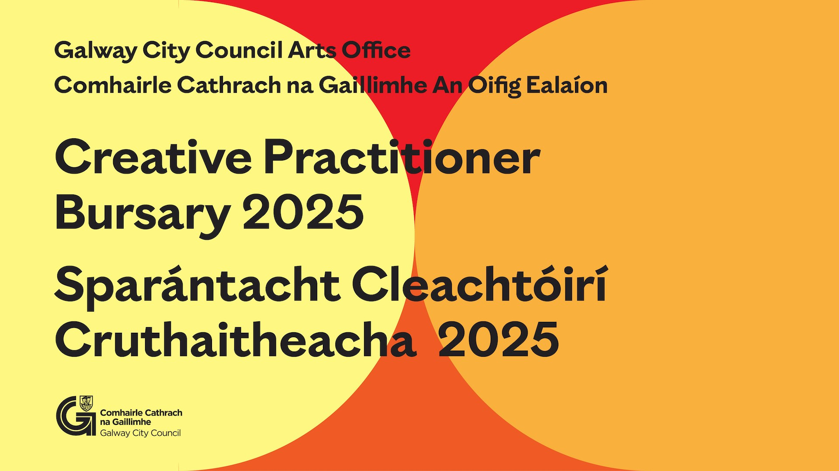
Two Galway City Grant Applications Closing Soon:
Creative Practitioners Bursary 2025

Galway City Council invites applications to the Creative Practitioner Bursary 2025.
The bursary is for Galway City-based creative practitioners to develop new work and to support creative and professional practices.
This is an online application process.

Application Deadline: Tuesday, 25 February 2025

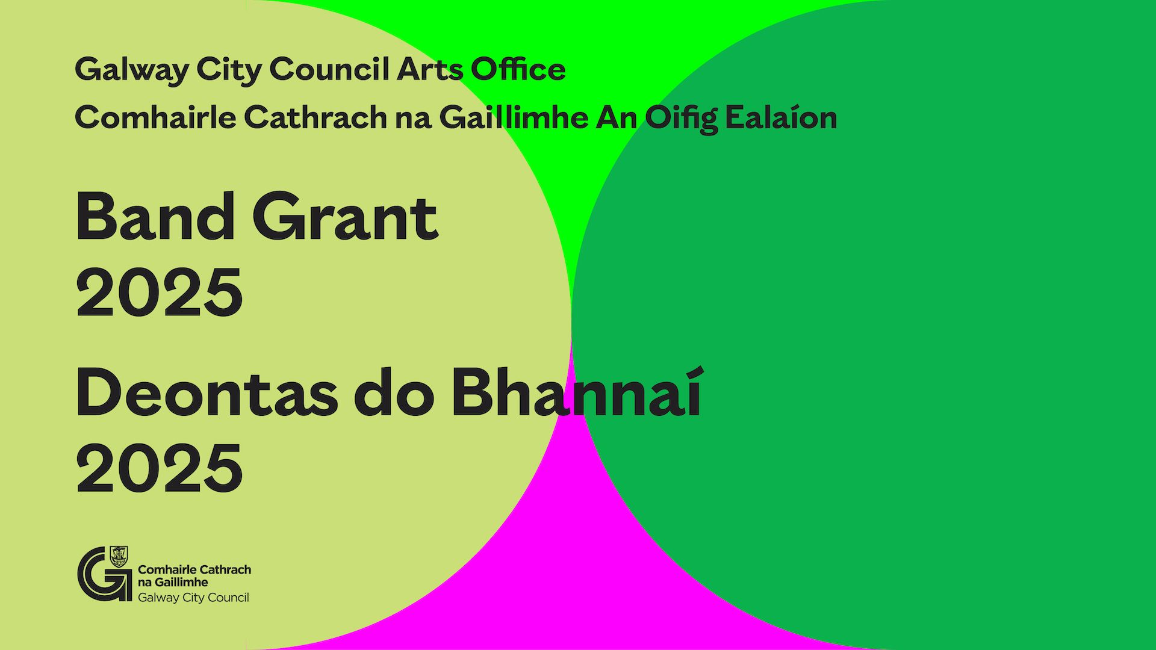

Galway City Council Band Grant 2025
Galway City Council invites applications to the Band Grant 2025.

School bands and community bands from all musical genres can apply. Support is for band development, work towards performance, and performances in Galway City.
Application Deadline: Monday, 6 March 2025

More information here.

_____________________________________________________________
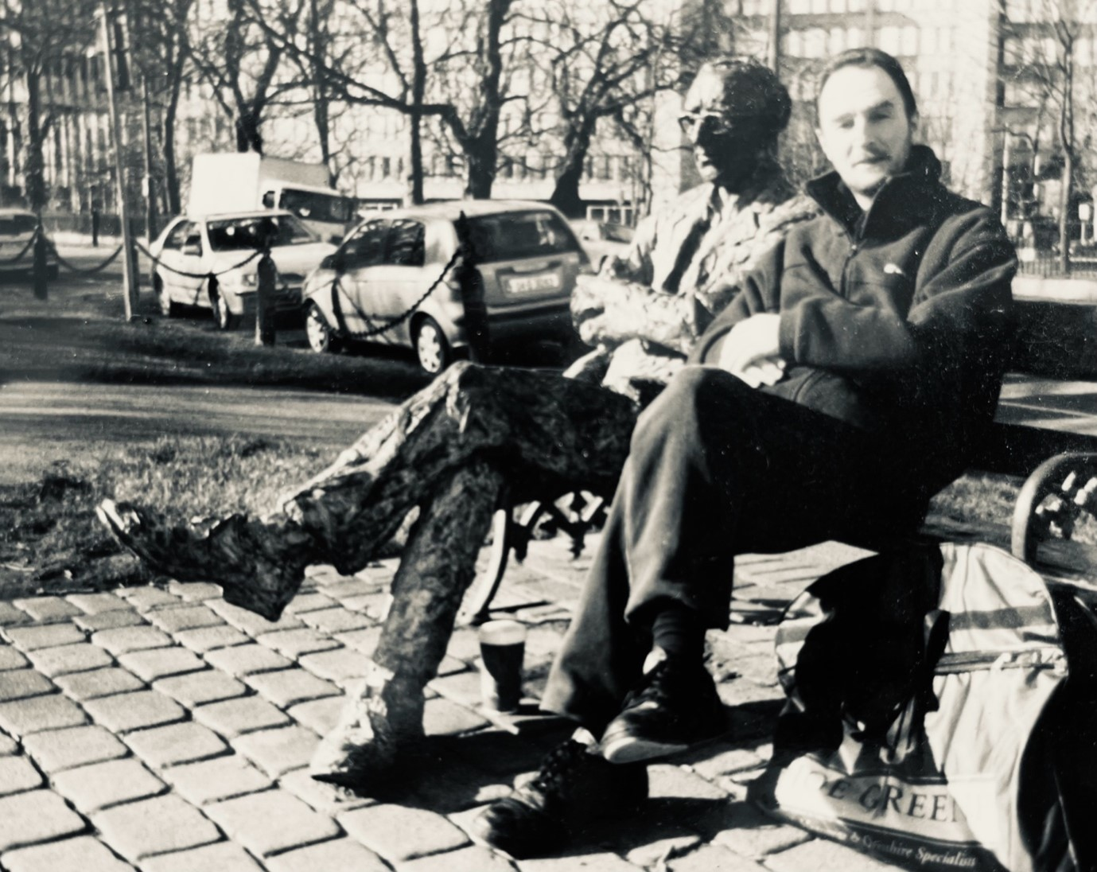
Pat Coleman Emerging Writer in Residence Opportunity
Áras Éanna Arts Centre, Inis Oírr and the Galway City Council Arts Office are delighted to announce the first Pat Coleman Emerging Writer in Residence, honouring Pat—a beloved Galway character with a deep love for sport, music, and Irish literature.

This three-week residency on Inis Oírr in May 2025 supports an emerging Galway City-based writer. It includes travel from Galway City, accommodation, stipend, dedicated studio space at Áras Éanna, and mentoring workshops.

To apply:
- Artists must be a resident of Galway City
- Be available for the full residency in May 2025
To apply, email arts@galwaycity.ie by 14 March 2025 with:
- A cover letter & proposal for the residency
- A C.V. & work samples
More Information Here
Application deadline: 14 March 2025
The selected writer will be announced on 20 March 2025.

_____________________________________________________________
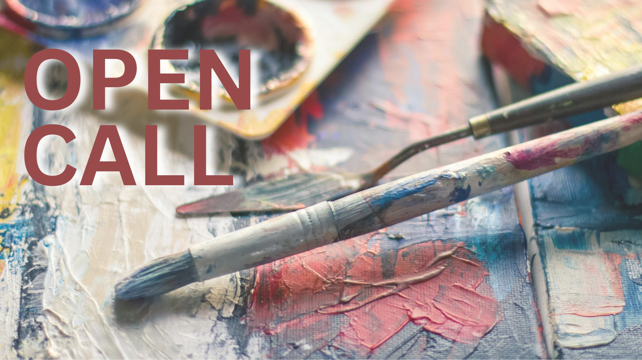
Open Call: Opportunities for Visual Artists with Saolta Arts
Saolta Arts invites expressions of interest from professional practicing visual artists to join a Participatory Artist Panel for workshop facilitation and public engagement opportunities at the hospitals.
Saolta Arts presents this opportunity in partnership with our colleagues at University Hospital Galway (UHG), Merlin Park University Hospital (MPUH), Portiuncula University Hospital (PUH) Ballinasloe, Mayo University Hospital (MUH) and Roscommon University Hospital (RUH),
More information here.
_____________________________________________________________
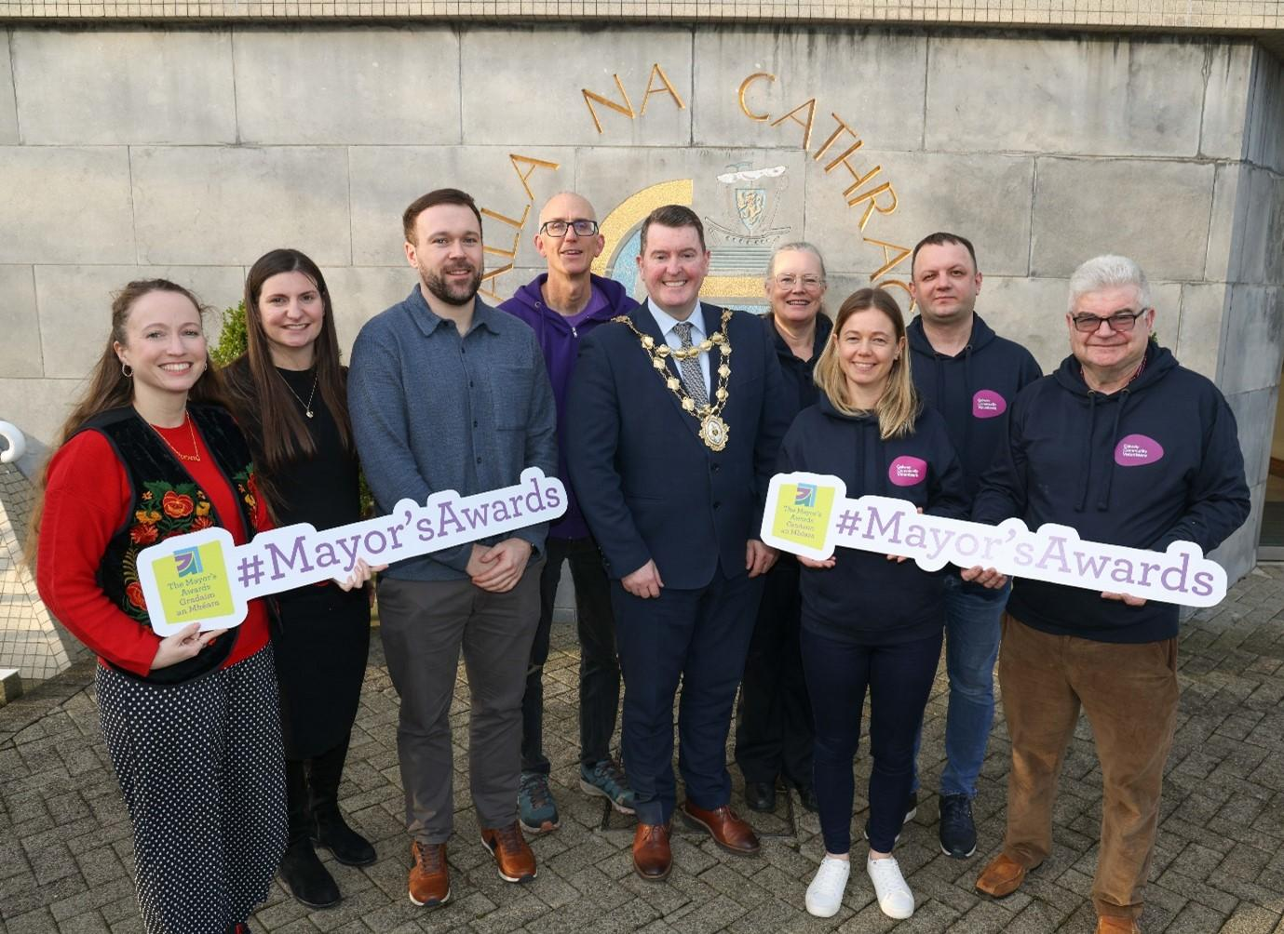
Galway City Mayor’s Awards Open for Nominations
The annual Galway City Council Mayor’s Awards launched on Thursday, 30 January 2025 and is now open for nominations.

The Mayors Awards are the most prestigious annual awards recognising those who make a significant contribution to Galway City. These awards are an annual opportunity to celebrate inspirational local people and groups who go above and beyond to support our community.

Amongst the many categories are Arts, Culture, Heritage and the Cúrsaí Gaeilge Award, which may interest our subscribers.

More information here.

_____________________________________________________________
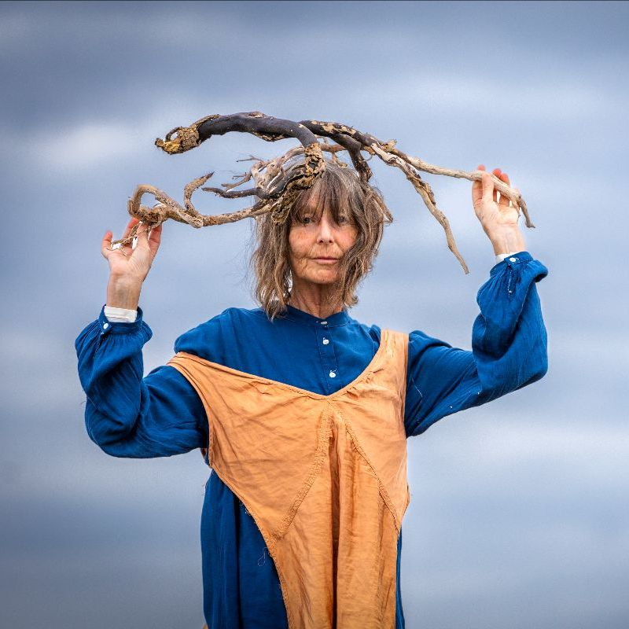
'Síreacht agus Sult' Dance Labs with Bernadette Divilly at Galway Dance studio
Galway City based dance artist, Bernadette Divilly will be refining her dance work Bígí ag Damhsa at Galway Dance Studio between 24 February and 21 March. She is inviting the dance community to join her dance labs in the studio. The focus and intent of these labs is 'Síreacht agus Sult' (our longings and satisfactions), which is the title of a recent exhibition Bernadette held on Inis Oírr.
More information here.
_____________________________________________________________
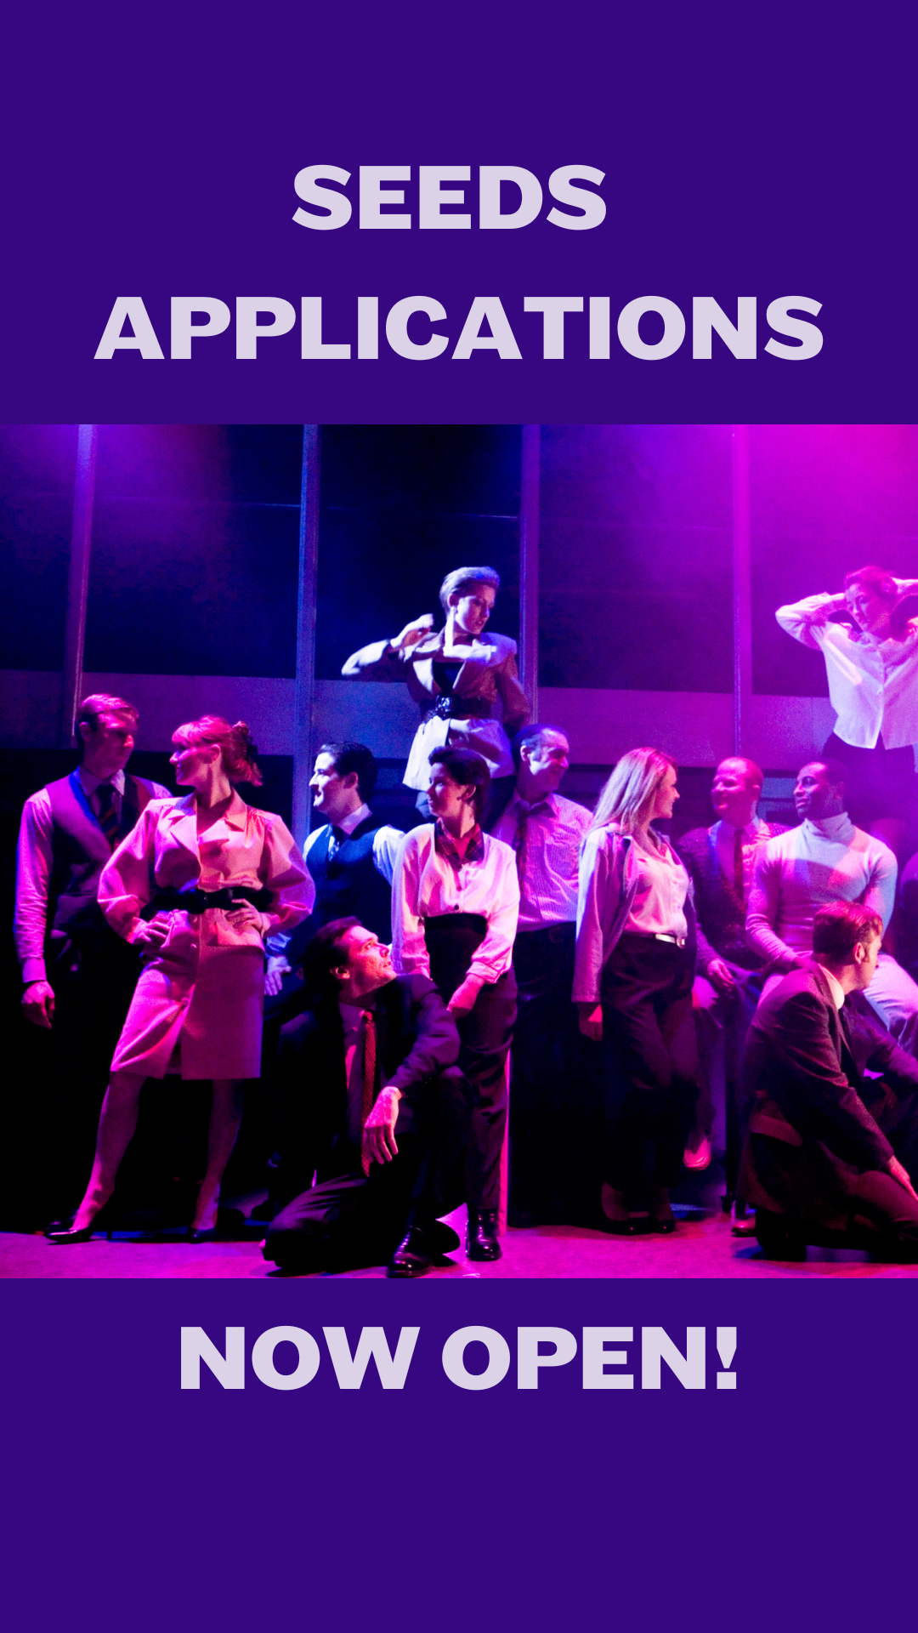
Announcing New Round of the SEEDS Artist Development Programme 2025-26
In 2001, Rough Magic launched SEEDS as a pioneering artist development initiative. To date it has supported 58 emerging theatre artists, with the vast majority of these going on to establish themselves as theatre professionals, many in leading roles.
The programme has evolved over time in response to the needs of the sector. Having previously focused on supporting individual artists, this year Rough Magic will be evolving SEEDS to support emerging theatre collectives.
More information here.
_____________________________________________________________
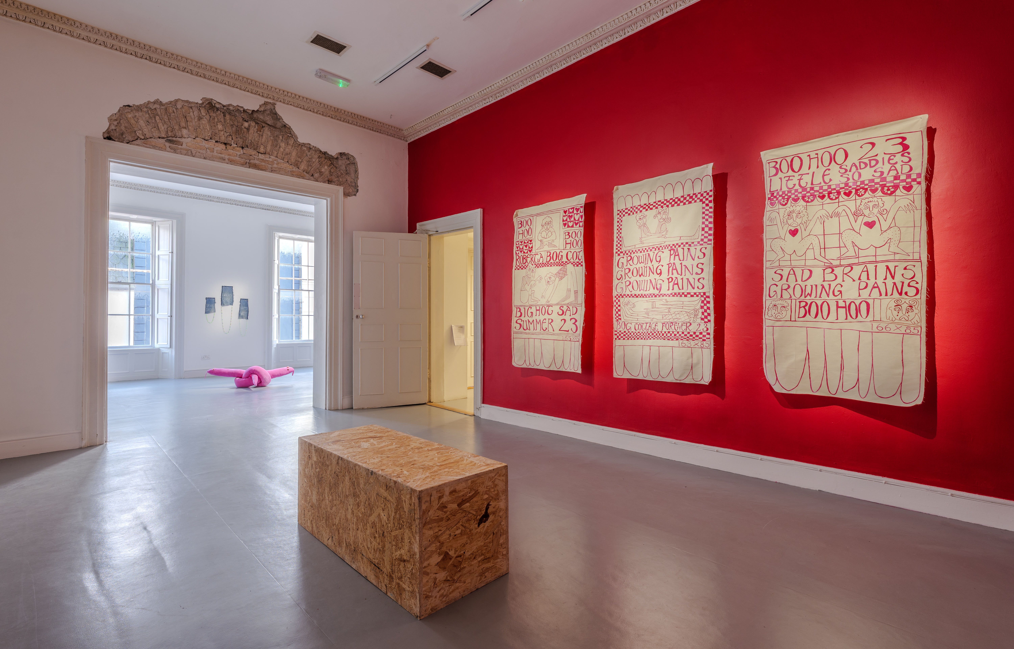
Galway Arts Centre - Exhibition
A Year in Review: Moving, Growing, Fighting, an exhibition of new work by Bog Cottage runs until March 15th in Galway Arts Centre.

More information here.

_____________________________________________________________
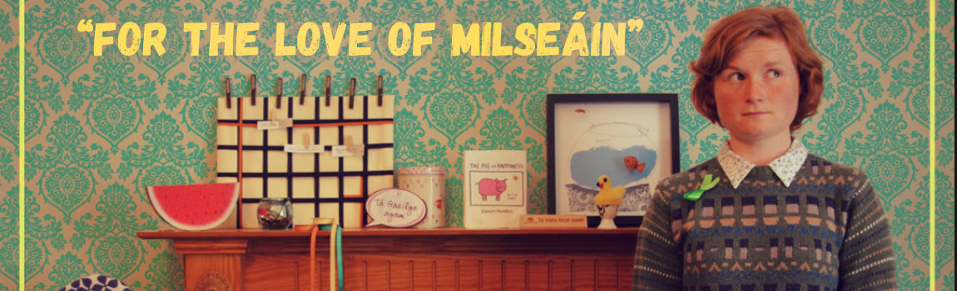
Áine Gallagher Presents: For the Love of Milseáin
Award-winning comedian and Ireland’s "queen of the offbeat" Áine Gallagher, is on a mission to prove that speaking Irish can be both accessible and hilarious.
With her deadpan, offbeat and wholly unique style, there is no doubt Áine will ignite your passion for Irish, even if you don’t know a word.

Duration: 60 mins no interval
Age Guidance: 14+
Town Hall Studio / 14th – 15th Mar

More information here.

_____________________________________________________________

Failte Ireland Invites Creative Events Listings
Do you have a great event happening in Ireland this year? Promote it with Fáilte Ireland!
Advertise your upcoming events to irelandwestinfo@failteireland.ie and
Register & add your events through the events portal linked to Discover Ireland.
www.FailteIrelandEvents.ie/
_________________________________________________________
Galway City Council Night-Time Economy & This is Galway Invites Events Listings
Do you have a great event happening from 6pm? Promote it with This is Galway!
Simply email Kate.Howard@galwaycity.ie with a brief summary of your event and receive a special code to access the events page, where you can add all the necessary details and promote your offering. Free.
More information.
_________________________________________________________
Send us your Listings & News
We can share your posts! Email up to 50 words to arts@galwaycity.ie with a high-resolution landscape image. Images and text may be edited to fit.
___________________________________________________________________
GCC Arts Office Social Media
Facebook: www.facebook.com/ArtsOfficeGalwayCity
Instagram: @artsofficegalwaycity
X: @cityartsgalway
___________________________________________________________________
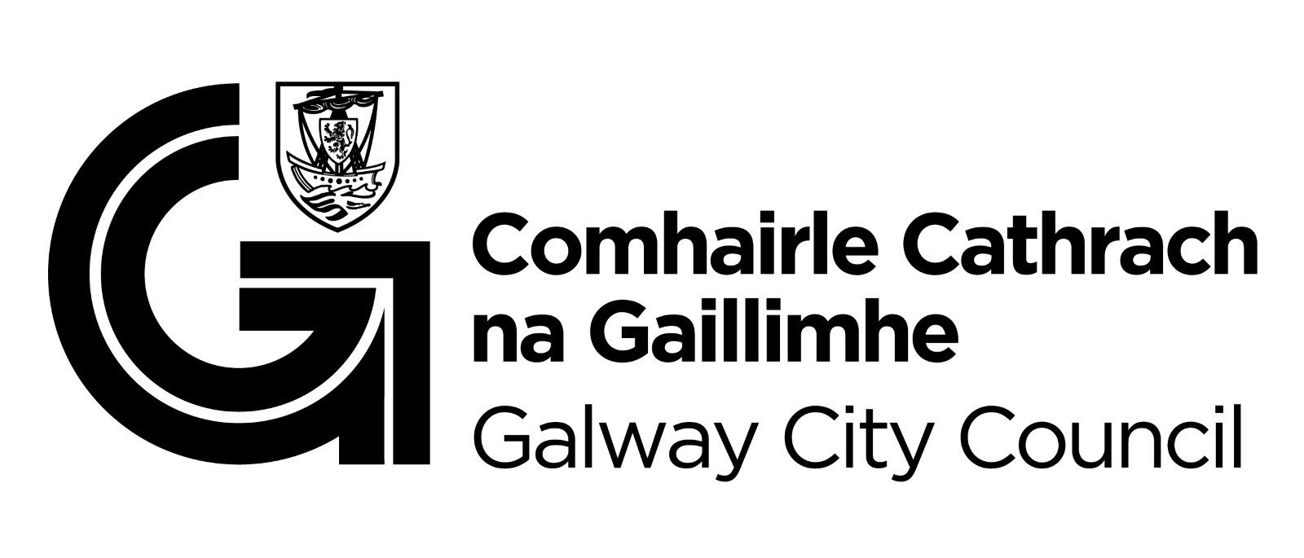
You are getting this email because you are on the Galway City Council Arts Office mailing list. Unsubscribe by emailing arts@galwaycity.ie and ask to be removed.

