Galway City Council Arts Newsletter February 2025
Welcome to the Arts Office newsletter for early February.
Below, you will find opportunities, news, listings and events for Creative Practitioners and people interested in and involved in the arts and culture in Galway City.
Happy reading, from the Galway City Arts Office team.
_____________________________________________________________
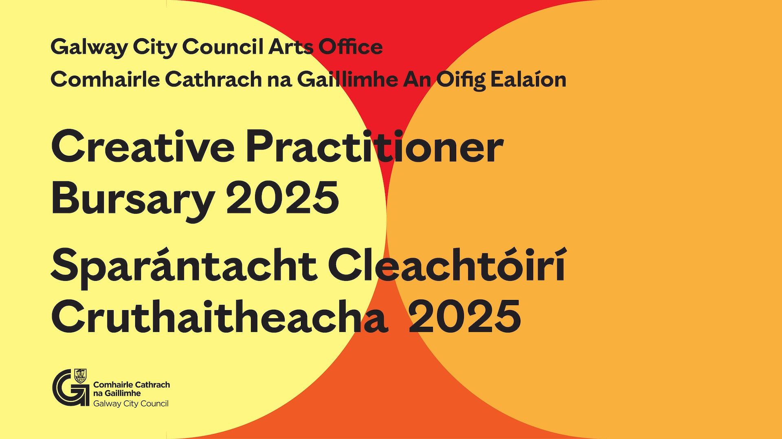
Galway City Council Launch Creative Practitioners Bursary 2025
Galway City Council invites applications for the Creative Practitioner Bursary 2025.
The bursary is for Galway City-based Creative Practitioners to develop new work and to support creative and professional practices.

Application Deadline: Tuesday, 25 February 2025

More information here.

_____________________________________________________________
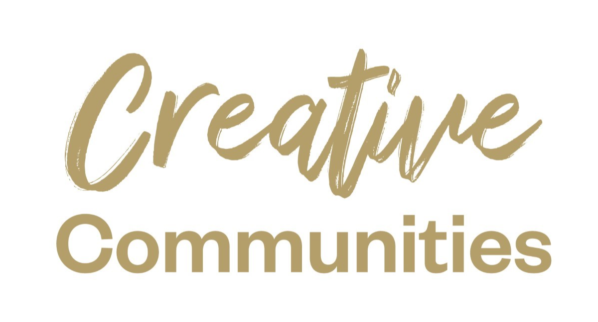
Deadline Extended for Creative Communities Grant 2025
Due to the disruptions caused by Storm Éowyn, the deadline for the Creative Communities Grant has now been extended to Friday, 7 February 2025 at 4 pm.

This open call invites creative practitioners, organisations and community groups to propose community-focused creative projects and activities that will take place in Galway City in 2025.

More information here.

_____________________________________________________________
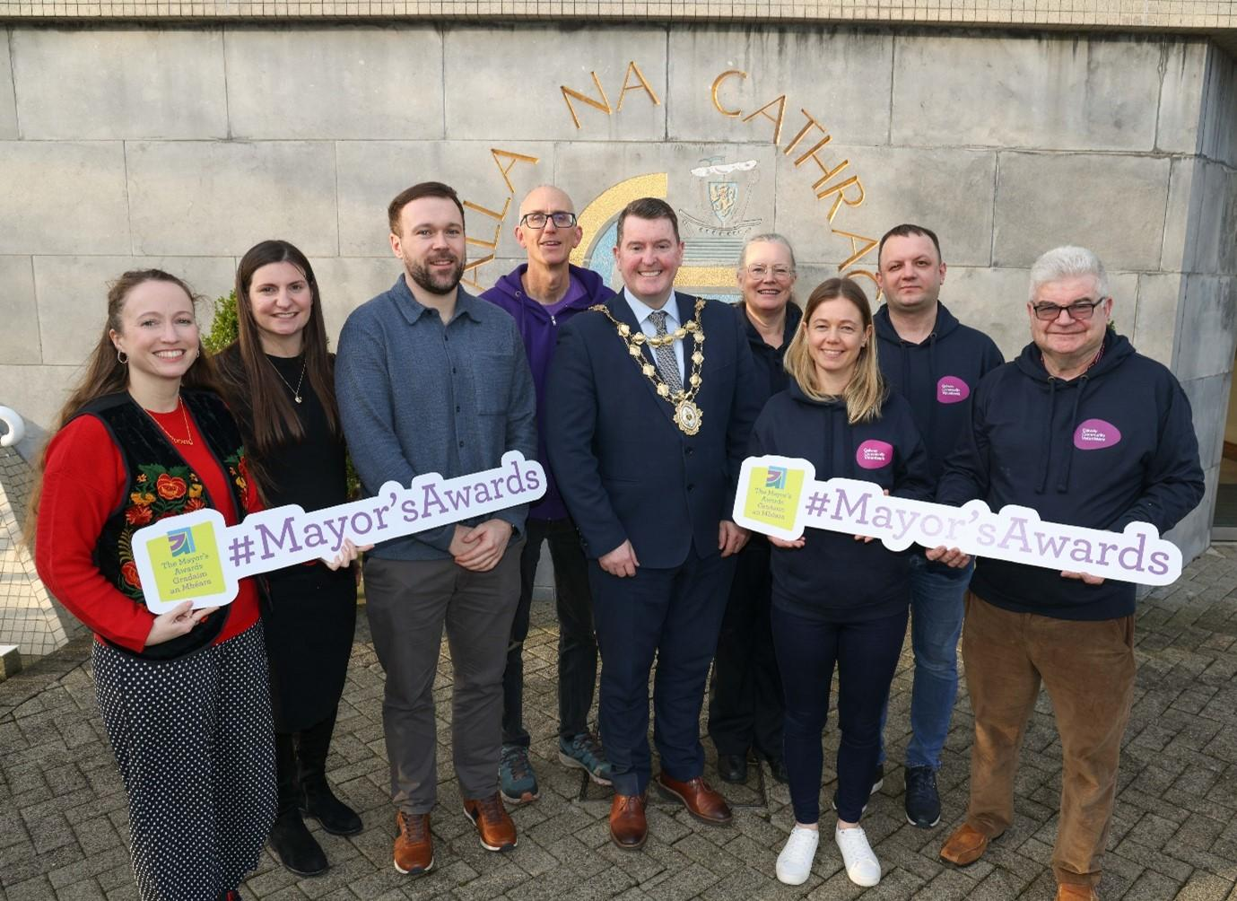
Galway City Mayor’s Awards Open for Nominations
The annual Galway City Council Mayor’s Awards launched on Thursday, 30 January 2025 and is now open for nominations.

The Mayors Awards are the most prestigious annual awards recognising those who make a significant contribution to Galway City. These awards are an annual opportunity to celebrate inspirational local people and groups who go above and beyond to support our community.

Amongst the many categories are Arts, Culture, Heritage and the Cúrsaí Gaeilge Award, which may interest our subscribers.

More information here.

_____________________________________________________________

Open Call for Visual Artists
Saolta Arts invite professional visual artists to apply for opportunities in hospitals across the HSE West North-West region in 2025–2026, including the Mending HeArts Project.

This initiative supports participatory arts in healthcare, enhancing well-being through creative engagement.

Deadline: 21 February 2025

More information here.

_____________________________________________________________

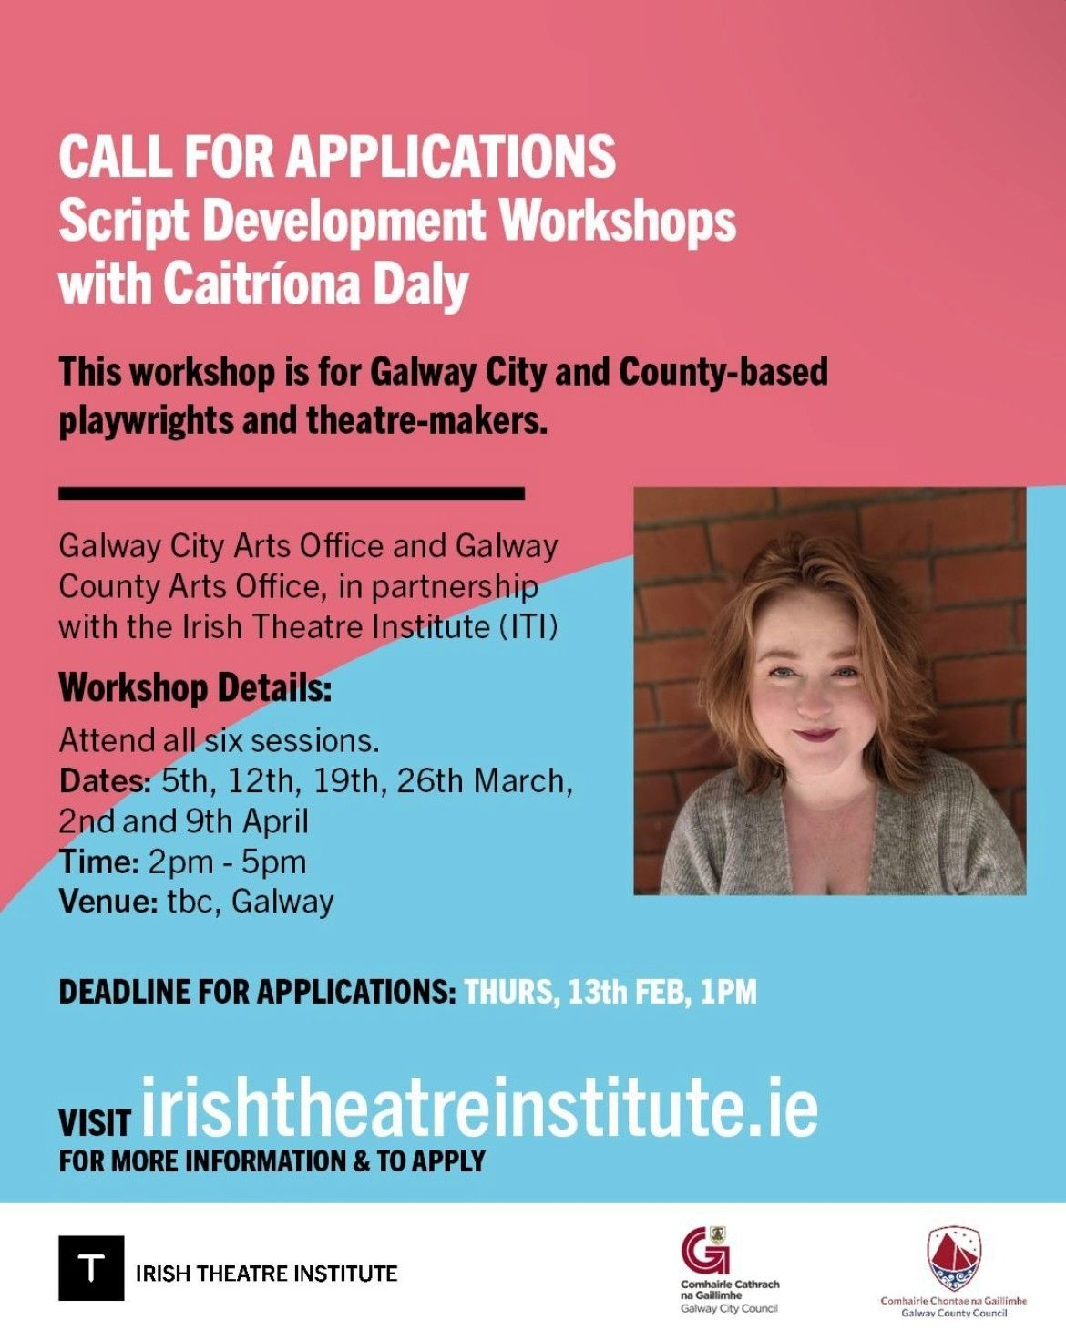
Irish Theatre Institute Script Development Workshop Series –Apply Now
Galway City Council Arts Office are delighted to announce the upcoming Irish Theatre Institute Script Development Workshops taking place in Galway.
Deadline for applications is 1 pm Thursday, 13 February 2025.
More information here.
_____________________________________________________________

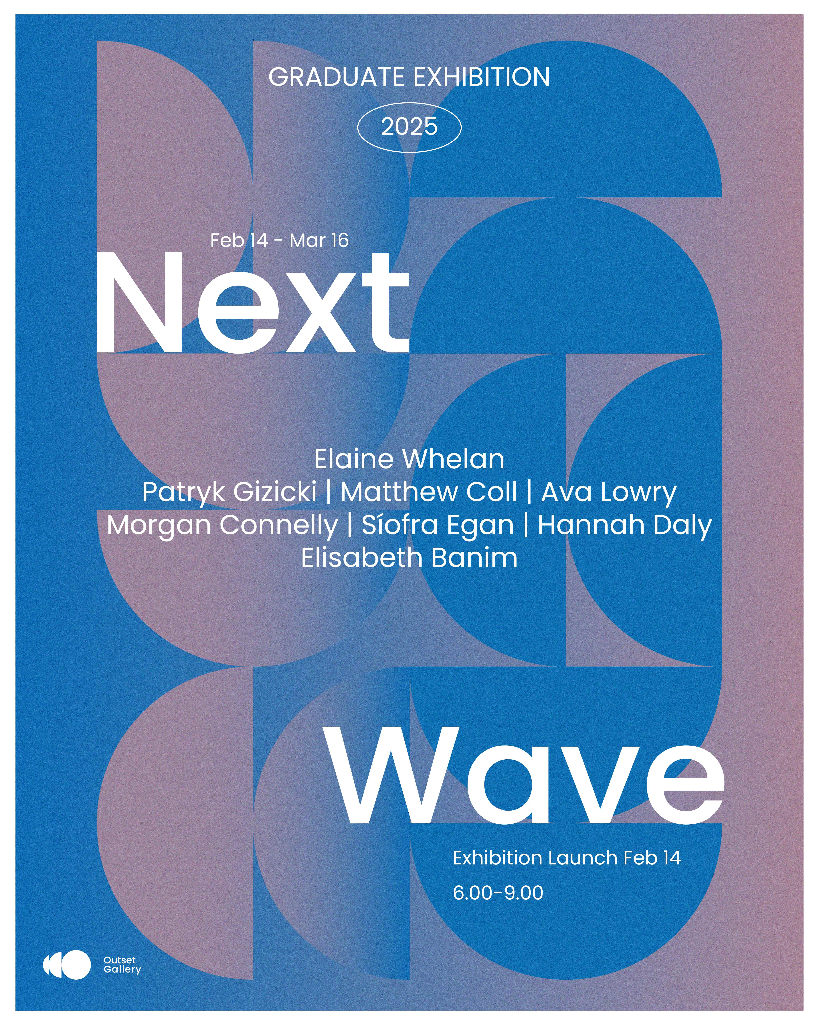
Next Wave: Graduate Show 2025
Outset Gallery proudly presents Next Wave: A Graduate Showcase, featuring eight emerging artists from Ireland’s leading art colleges. Opening on February 14 and running until the 16 of March, the exhibition explores identity, memory and environment through painting, sculpture, printmaking, and photography.

Join Outset for the opening event on Feb 14, 6-9 pm with music and refreshments.

Register here.

_____________________________________________________________
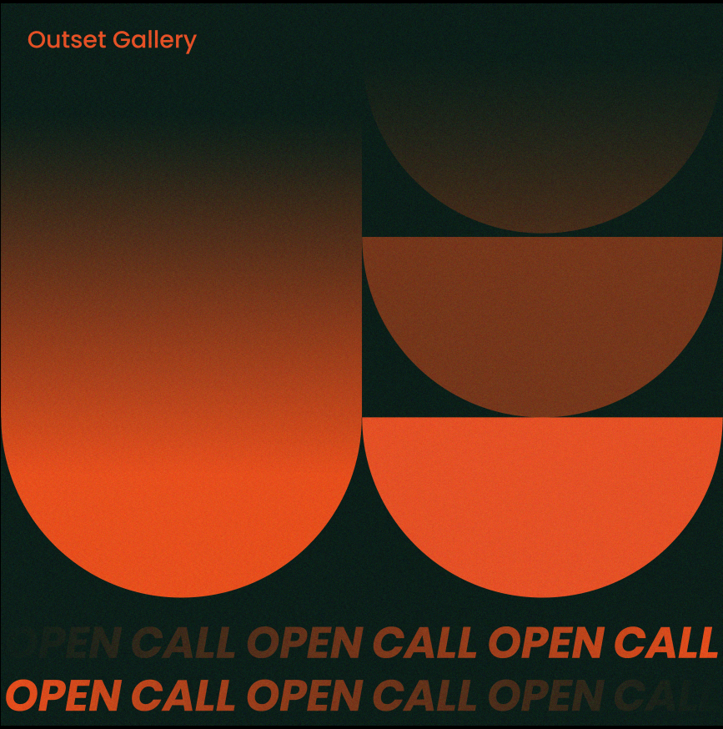
Outset Gallery: Expressions of Interest 2026 Open Call
Outset Gallery is thrilled to announce its Expressions of Interest 2026 Open Call. The primary aim of this open call is to provide artists, groups, organisations, curators, and producers an opportunity to propose new work in the form of exhibitions, events, and collaborations for inclusion in Outset’s 2026 program.
This streamlined process ensures a fair review of all proposals through two strands:
- Visual Art / Exhibitions (Solo, Duo, Group, Other)
- Arts Programming (including but not limited to street art, performance, literature, spoken word, film, music, and events)
Applications close on 16 February 2025.
More information here.

_____________________________________________________________
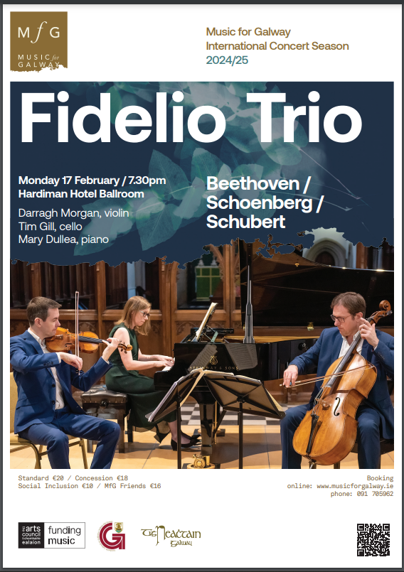
Music for Galway presents the Fidelio Trio
The Fidelio Trio returns to Galway on Monday, February 17 to perform a programme of pillars of the piano trio repertoire. Masterpieces by Beethoven and Schubert frame Edward Steuermann’s transcription for piano trio of Schoenberg’s sensuous ‘late Romantic string sextet “Transfigured Night”, inspired by a poem by Richard Dehmel.

More information here.

_____________________________________________________________
Failte Ireland Invites Creative Events Listings

Do you have a great event happening in Ireland this year? Promote it with Fáilte Ireland!
Advertise your upcoming events to irelandwestinfo@failteireland.ie and
Register and add your events through the events portal linked to Discover Ireland.
www.FailteIrelandEvents.ie/
_________________________________________________________
Send us your Listings & News
We can share your posts! Email up to 50 words to arts@galwaycity.ie with a high-resolution landscape image. Images and text may be edited to fit.
___________________________________________________________________
GCC Arts Office Social Media
Facebook: www.facebook.com/ArtsOfficeGalwayCity
Instagram: @artsofficegalwaycity
X: @cityartsgalway
___________________________________________________________________
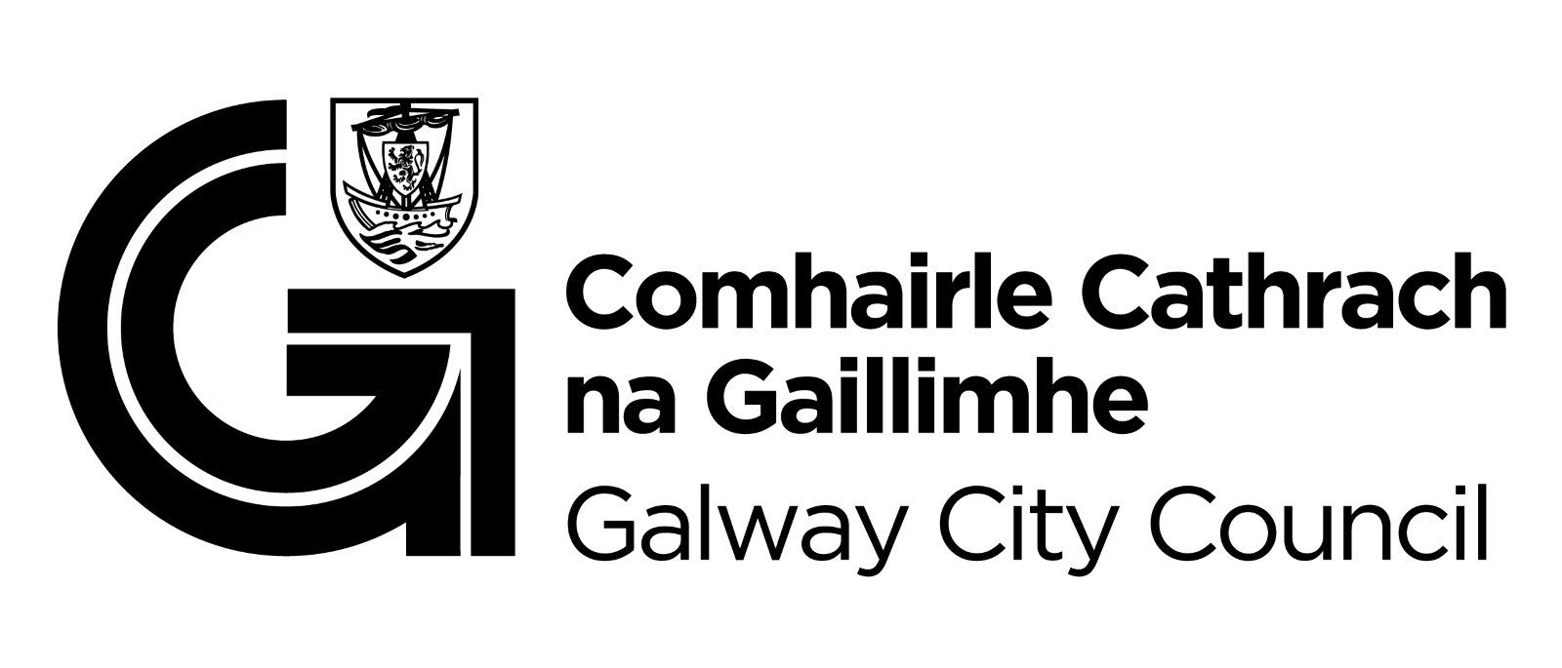
You are getting this email because you are on the Galway City Council Arts Office mailing list. Unsubscribe by emailing arts@galwaycity.ie and ask to be removed.

