Galway City Council Arts Newsletter December
Welcome to the final Arts Office Newsletter for 2025. Below you will find Galway City Council Arts Office Content, External Content, News, Opportunities, and Listings/Events.
Happy reading, from the Galway City Arts Office team, and Merry Christmas to all.
_____________________________________________________________
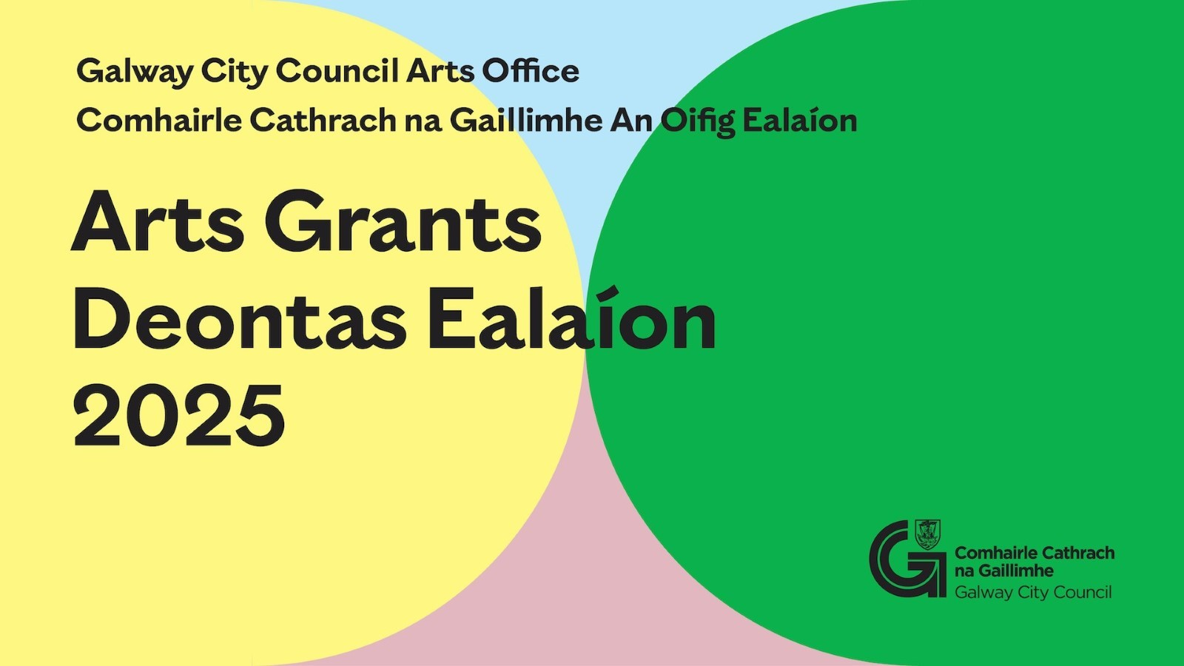
Galway City Council: Arts Organisation Grants
Galway City Council now invites applications for the Arts Organisation Grants 2025.
Arts Grants for Organisations are in two strands:

1) Arts Grant Professional Strand
2) Arts Grant Community, Voluntary and Amateur Strand

For the Arts Grants 2025 online application and guideline go to
www.GalwayCity.ie/ArtsGrants

_____________________________________________________________

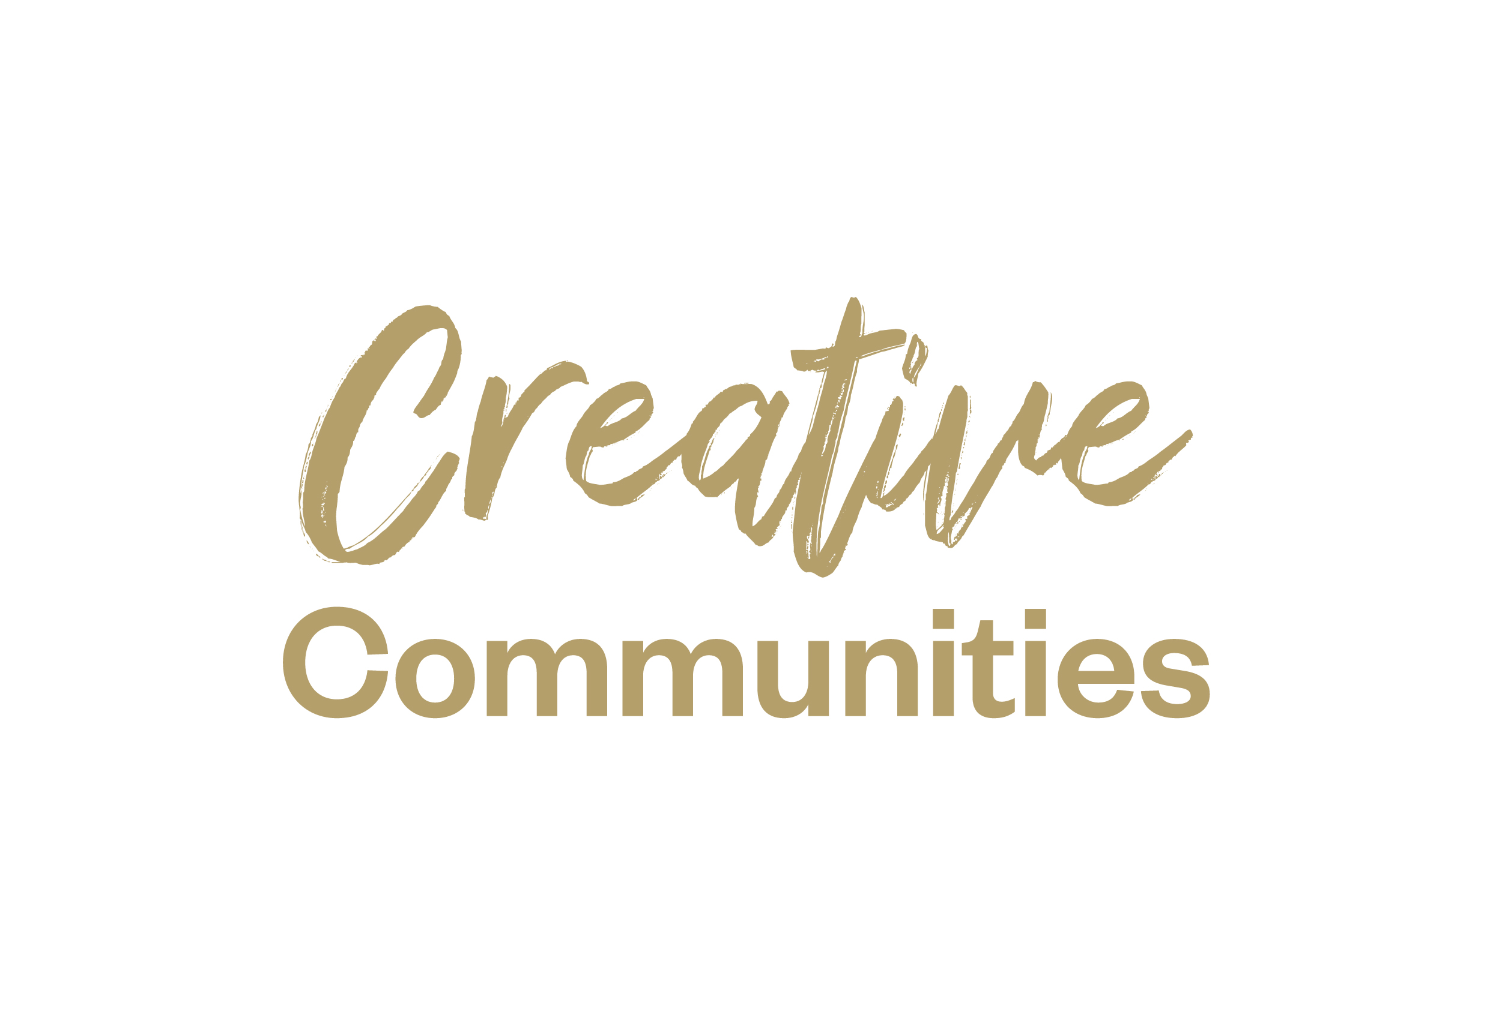
Creative Communities Grant Open Call
Galway City Council Culture and Creativity Team are pleased to announce an Open Call for the 2025 Creative Communities Grant. This open call invites creative practitioners, organisations, and community groups to propose community focused creative projects and activities that will take place in Galway City in 2025.

Closing date for applications: Friday 31 January 2025, 4pm

More information here.

_____________________________________________________________

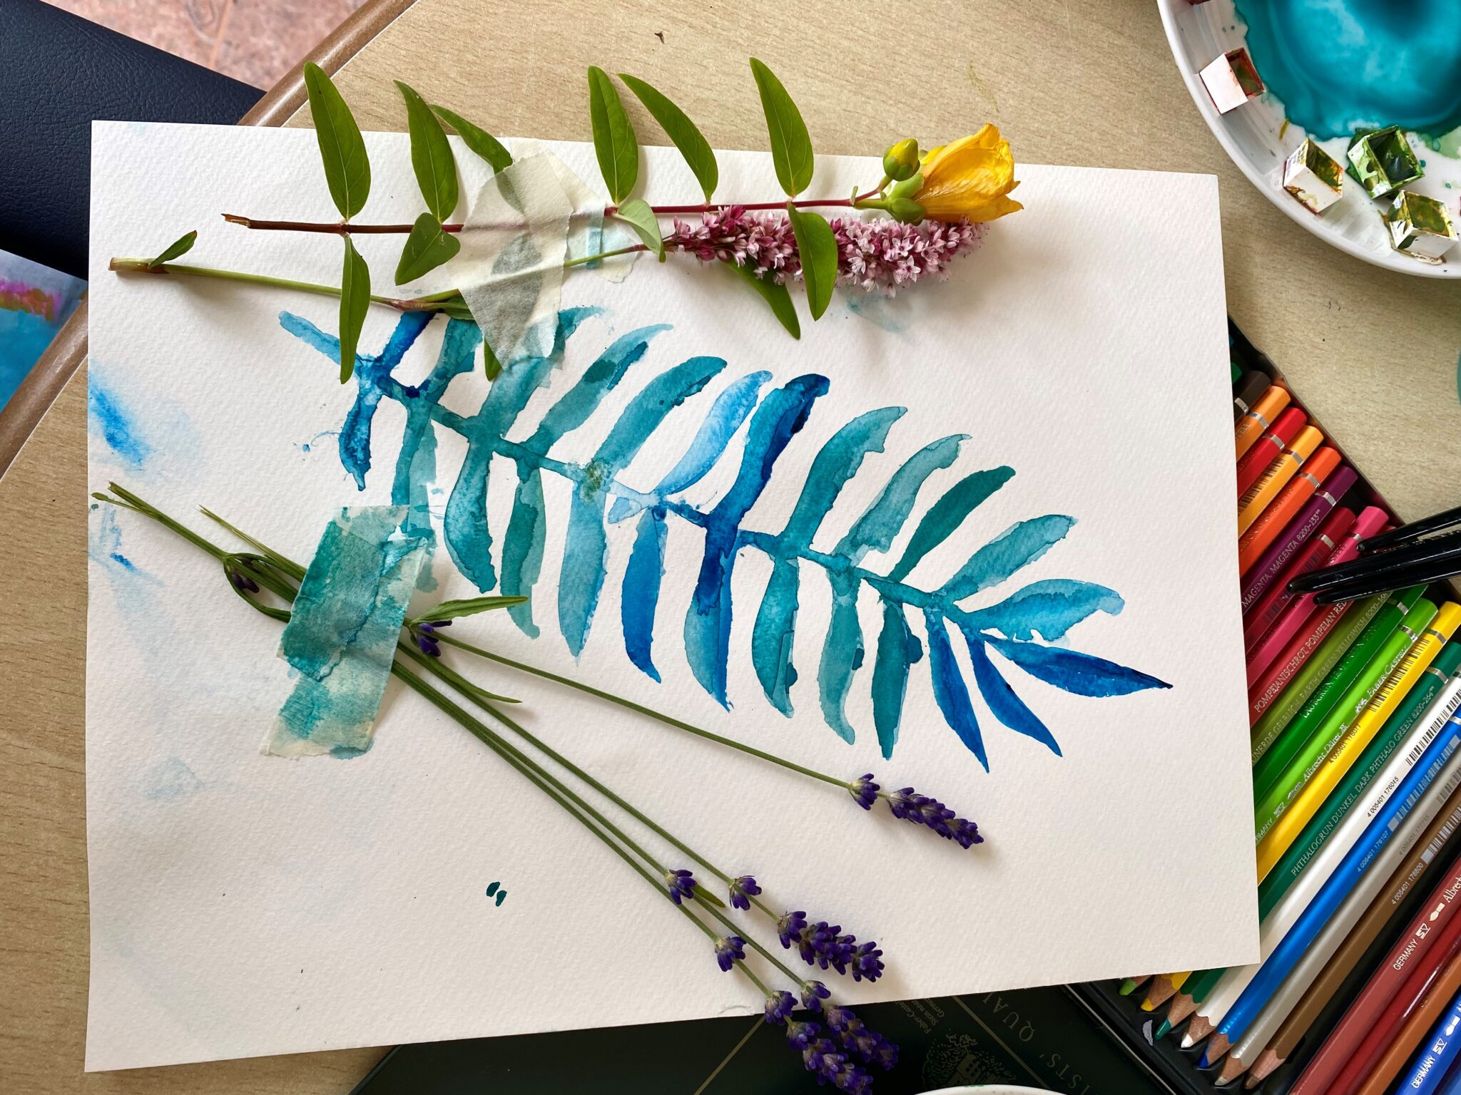
Saolta Arts is seeking a Project Coordinator
Saolta Arts, in partnership with Galway City Council, Galway County Council, Croí Heart and Stroke charity and HSE West North West, is seeking a motivated, experienced and highly organised contractor to deliver Mending HeArts, a Creative Health and Wellbeing Project, supported by the Creative Ireland Programme, Department of Tourism, Culture, Arts, Gaeltacht, Sport and Media.

The Mending HeArts Project Coordinator role will operate as a contract of service between the contractor and Saolta Arts CLG. Work on this project will require flexibility and travel between hospitals, health and community settings in Galway City and County.

Deadline: 5pm, 6 January 2025

More information here.

_____________________________________________________________

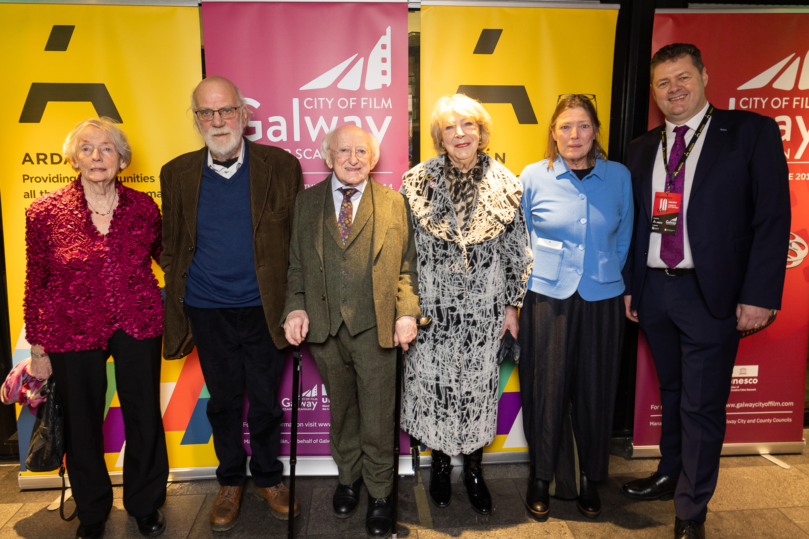

Galway UNESCO City of Film Celebrates 10-Year Anniversary with Tribute to Iconic Filmmaker Bob Quinn

On Friday, November 29th, 2024, Galway UNESCO City of Film celebrated a major milestone with a special event honouring the groundbreaking work of acclaimed filmmaker Bob Quinn, whose contributions have profoundly shaped Irish cinema. Taking place at the Pálás Cinema, the evening featured a reception, the presentation of a prestigious award, and a screening of ‘Poitín’, a film that is a key cornerstone in Quinn’s illustrious career.

More information here.

_____________________________________________________________


Fresh Film invite applicants for Ireland’s Young Filmmaker of the Year

For the 2025 marks the 29th annual festival Fresh Film welcome submissions from film artists, schools, youth groups, youth theatres, youth film clubs, or organisatiatins that have already made or intend to make films with young people (aged 7-18).
The closing date for receipt of entries is Friday 10th January 2025

More information here.

_____________________________________________________________

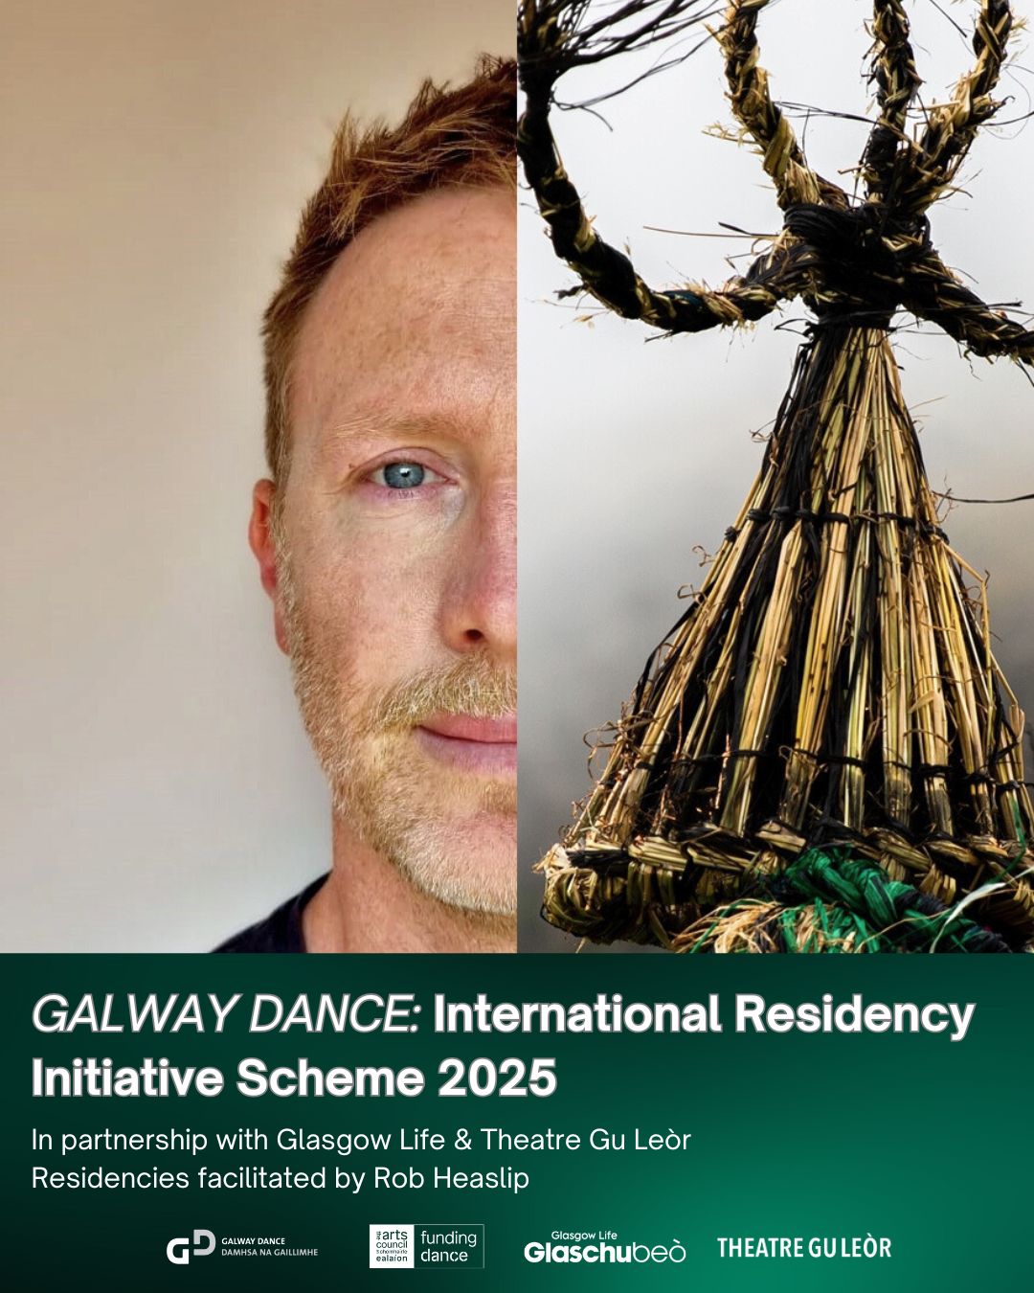

Just Announced: Galway Dance's International Residency Initiative Scheme

Galway Dance has secured funding from the Arts Council to work in partnership with Glasgow Life and Theatre Gu Leòr to bring four artists together into a studio (two based in Ireland and two based in Scotland). Artist Rob Heaslip will facilitate the studio time, creating a space for artists to explore and exchange.
Artists who work outside of dance are welcome to apply.
Closing date January 10th 2025

More information here.

_____________________________________________________________

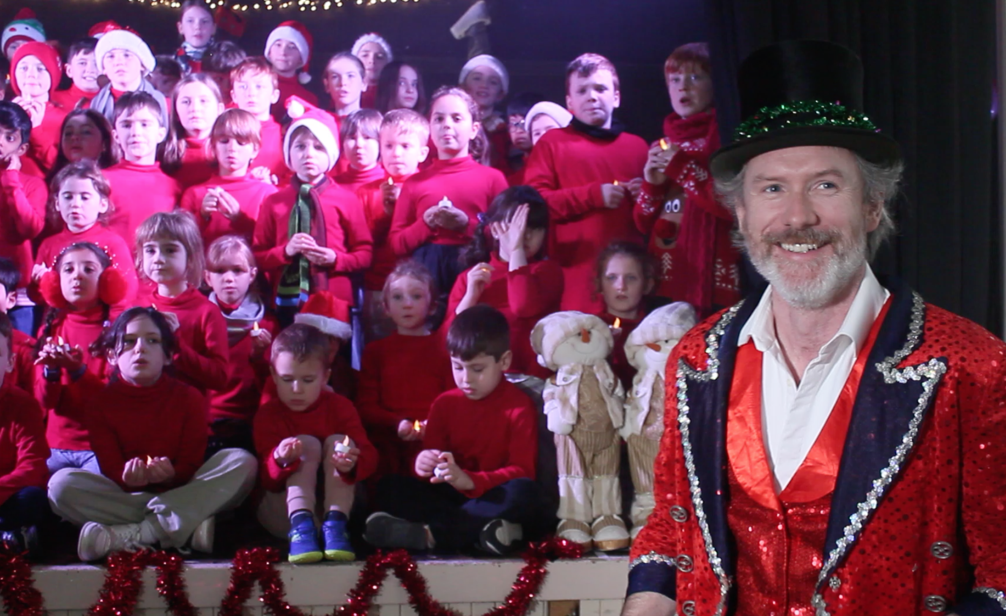

Niall Teague and Saint Nicholas’ Parochial School, Galway, release a Christmas Classic

Saint Nicholas’ Parochial School, Galway have joined folk musician Niall Teague to release a new festive classic ‘Christmas Time is Coming Soon’. The song was penned back in 2022 and was very much on the shelf until Niall’s daughter Louie, a 5th class pupil at Saint Nicholas’ Parochial School brought the lyrics to school in early November.

You can hear the song and watch the music video here.

_____________________________________________________________
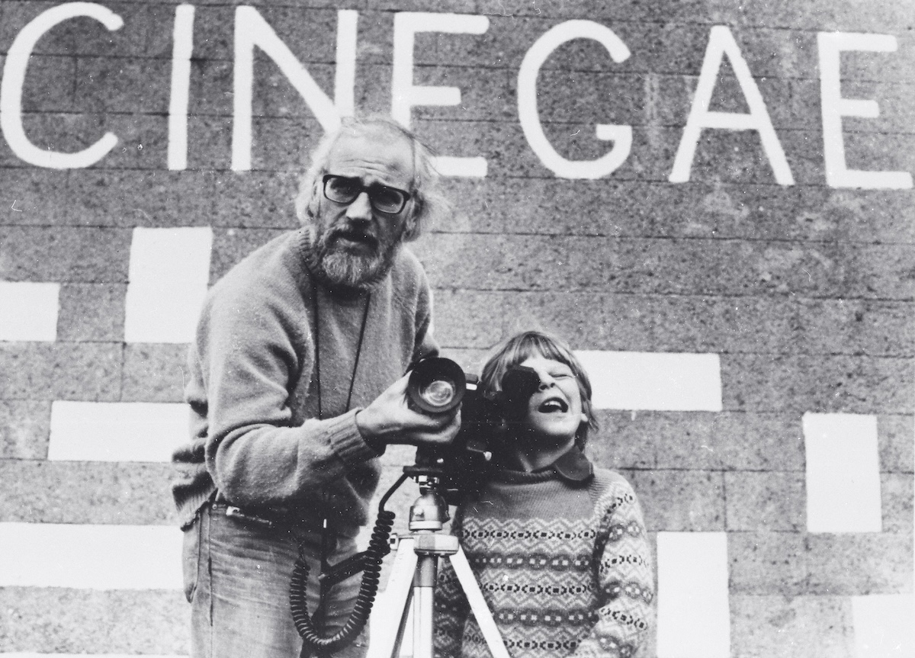

‘Count Me Out’ – New Book by Irish Filmmaker Bob Quinn

Edited by Toner Quinn, Count Me Out spans seven decades of Bob Quinn’s influential work and thinking. It explores his filmmaking during the Gaeltacht civil rights movement of the 1970s, including the first Irish-language feature film Poitín; the groundbreaking Atlantean series linking Ireland to North Africa; his role in the activism that led to TG4; and his critiques of RTÉ and the societal impact of television advertising. The book also includes extracts from an unpublished memoir.

Count Me Out: Selected Writings of Filmmaker Bob Quinn, a landmark collection of essays and articles by the renowned Irish filmmaker, photographer and writer, will be published in hardback in February 2025 and is now available for pre-order.
_________________________________________________________
Failte Ireland Invites Creative Events Listings
Do you have a great event happening in Ireland this year? Promote it with Fáilte Ireland!
Advertise your upcoming events to irelandwestinfo@failteireland.ie and
Register & add your events through the events portal linked to Discover Ireland.
www.FailteIrelandEvents.ie/
_________________________________________________________
Galway City Council Night-Time Economy & This is Galway Invites Events Listings
Do you have a great event happening from 6pm? Promote it with This is Galway!
Simply email Kate.Howard@galwaycity.ie with a brief summary of your event and receive a special code to access the events page, where you can add all the necessary details and promote your offering. Free.
More information.
_________________________________________________________
Send us your Listings & News
We can share your posts! Email up to 50 words to arts@galwaycity.ie with a high-resolution landscape image. Images and text may be edited to fit.
___________________________________________________________________
GCC Arts Office Social Media
Facebook: www.facebook.com/ArtsOfficeGalwayCity
Instagram: @artsofficegalwaycity
X: @cityartsgalway
___________________________________________________________________
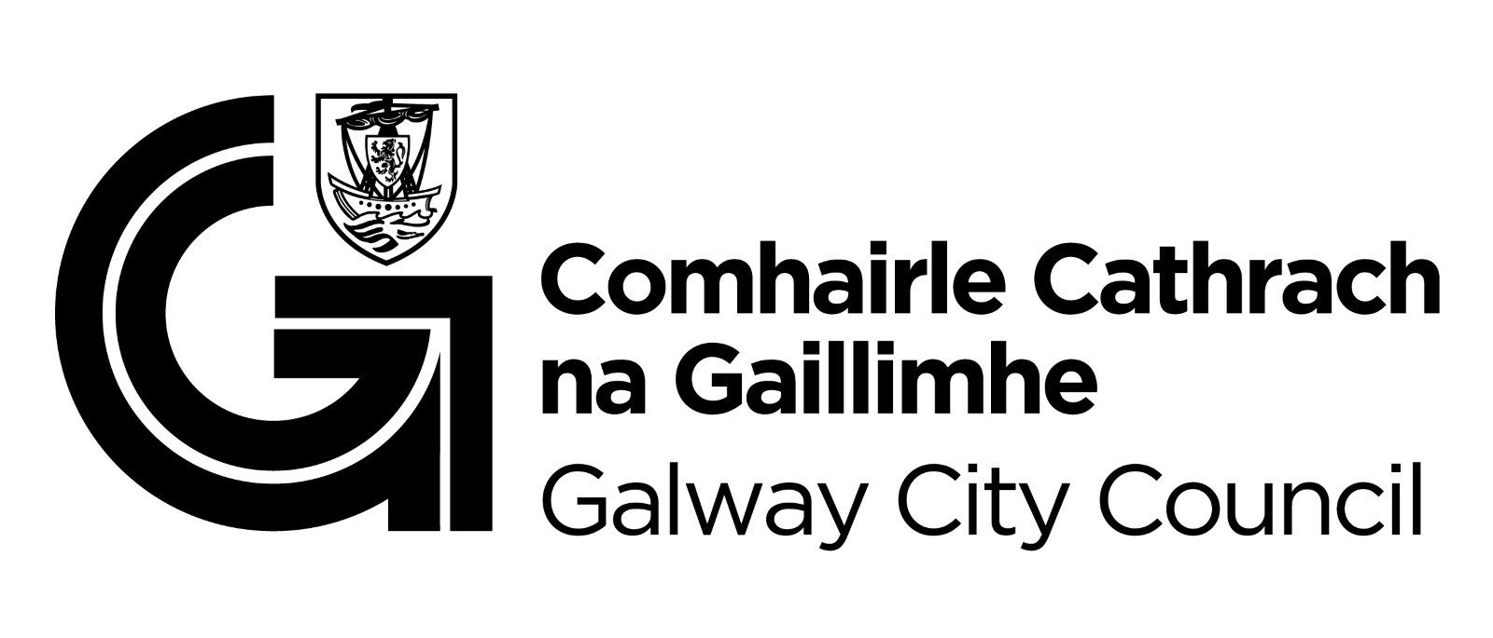

You are getting this email because you are on the Galway City Council Arts Office mailing list. Unsubscribe by emailing arts@galwaycity.ie and ask to be removed.

