Galway City Council Arts Newsletter Late January
Welcome to the second Arts Office newsletter for January.
Below you will find Opportunities, News, Listings and Events for creative practitioners and people interested and involved in arts and culture in Galway City.
Happy reading, from the Galway City Arts Office team.
_____________________________________________________________
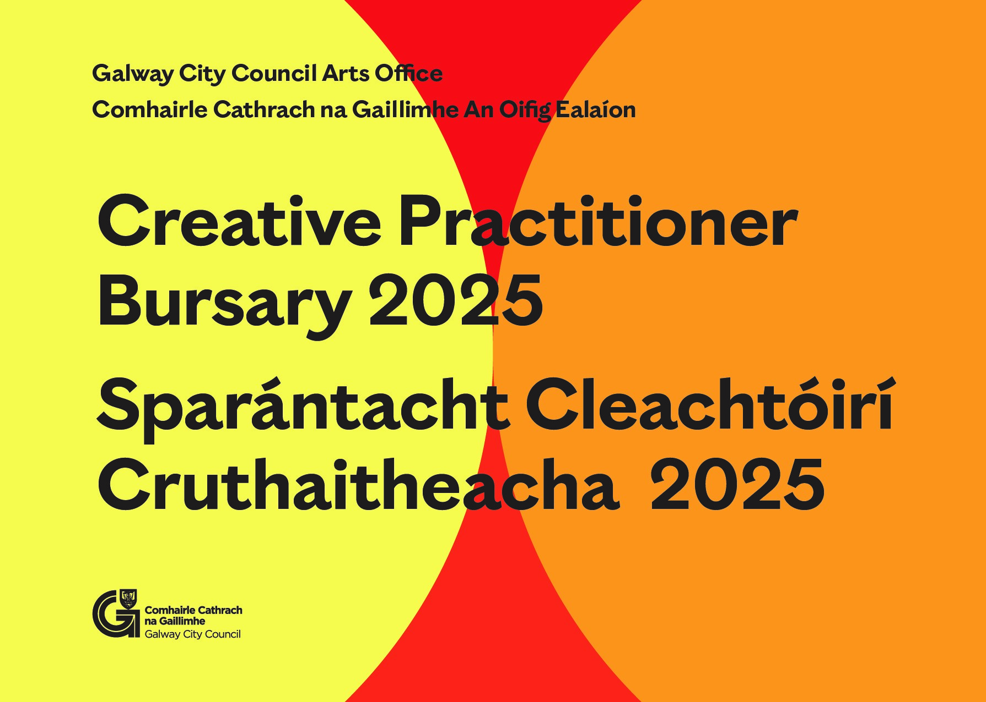
Creative Practitioners Bursary 2025
Galway City Council invites applications to the Creative Practitioner Bursary 2025.
The bursary is for Galway City-based creative practitioners to develop new work and to support creative and professional practices.

Application Deadline: Tuesday, 25 February 2025

More information here

_____________________________________________________________
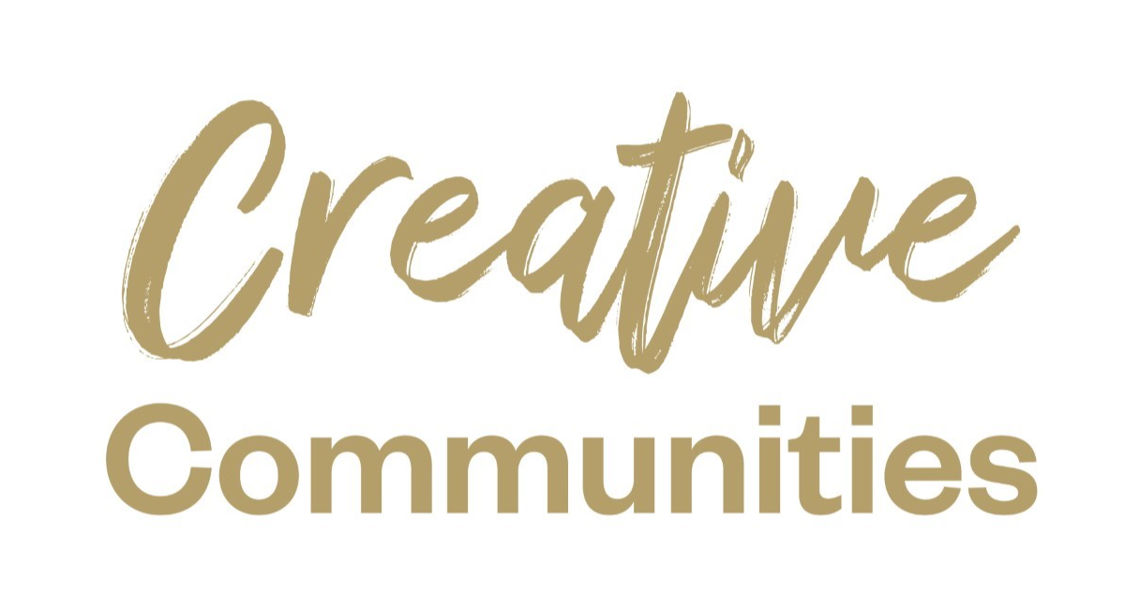
Creative Communities Grant Applications Closing 31st January
This open call invites creative practitioners, organisations, and community groups to propose community focused creative projects and activities that will take place in Galway City in 2025.

Closing date for applications: Friday 31 January 2025, 4pm

More information here.

_____________________________________________________________
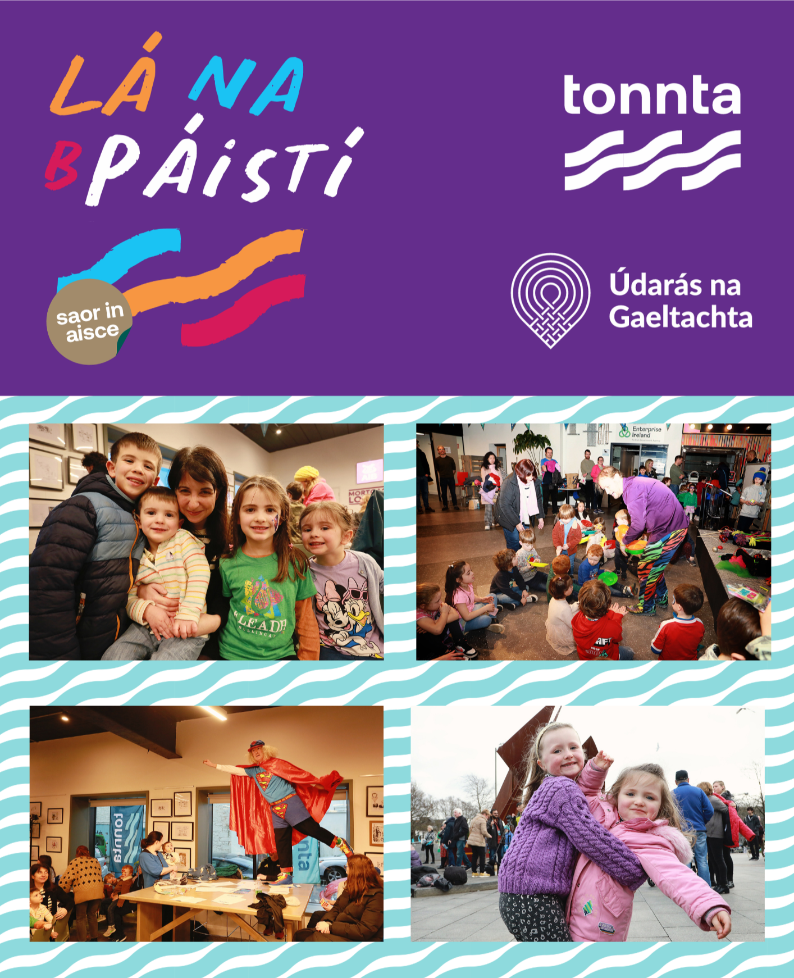
Tonnta Festival returns to Galway City
Tonnta – Galway’s newest festival, celebrating the Irish language and Galway as a bilingual city, is set to return from January 30th to February 2nd. The festival features a number of themes, but the primary one is to celebrate Galway’s status as a bilingual city.
Throughout the weekend, there are opportunities for festival-goers to (re)awaken their interest in the Irish language through a host of engaging and inspiring events. Learn some moves at the Céilí Mór, marvel at the fire shows in Eyre Square, or join in some family friendly fun at Lá na bPáistí.
More information here.

_____________________________________________________________

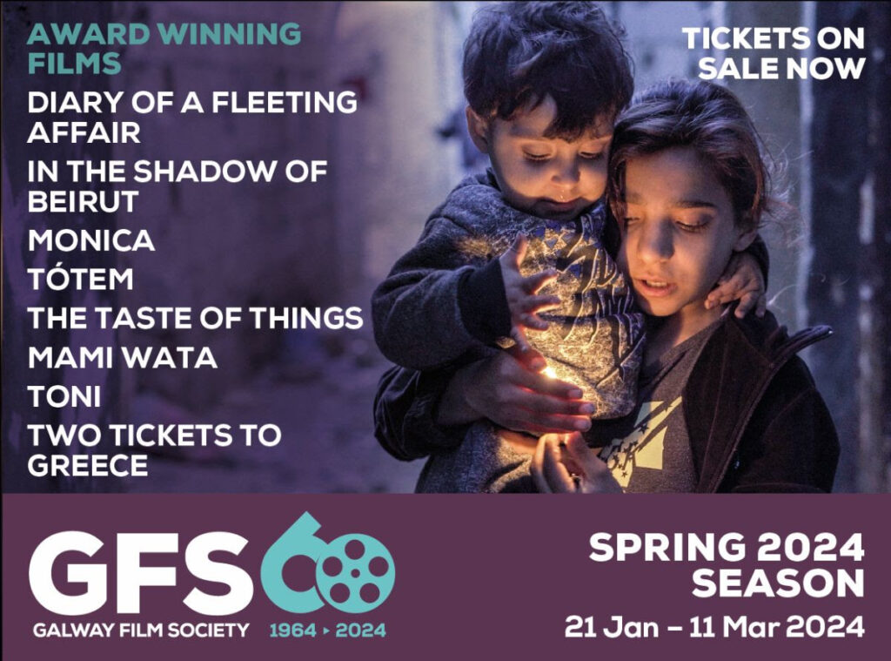
Galway Film Society 6 Week Spring Season at Pálás
GFS is delighted to announce that it will run a 6 week Spring season at Pálás, commencing Sunday 19th/Monday 20th January 2025.

More information here.

_____________________________________________________________
Arts and Disability Masterclass
Mayo Arts Service is looking for between 12 and 16 performance artists interested in working in the area of Arts and Disability to participate in this master class. The session will be delivered at Ballina Arts Centre, Ballina by Petal Pilly, Artistic director of Blue Teapot Theatre Company, Galway along with two actors from the company, on Tuesday 28th January 2025.

Anyone interested in participating should contact Damien O’Connor, Arts and Disability Coordinator, Mayo County Council, 094 906 4363, doconnor@mayococo.ie

_____________________________________________________________
Skylight 47 Seeking Submissions for Issue 20
Skylight 47 poetry magazine is seeking submissions for its next issue, Issue 20, which will launch in Summer 2025. Submissions are being accepted between 15 January & 28 February (deadline midnight 28 February).

More information here
_____________________________________________________________
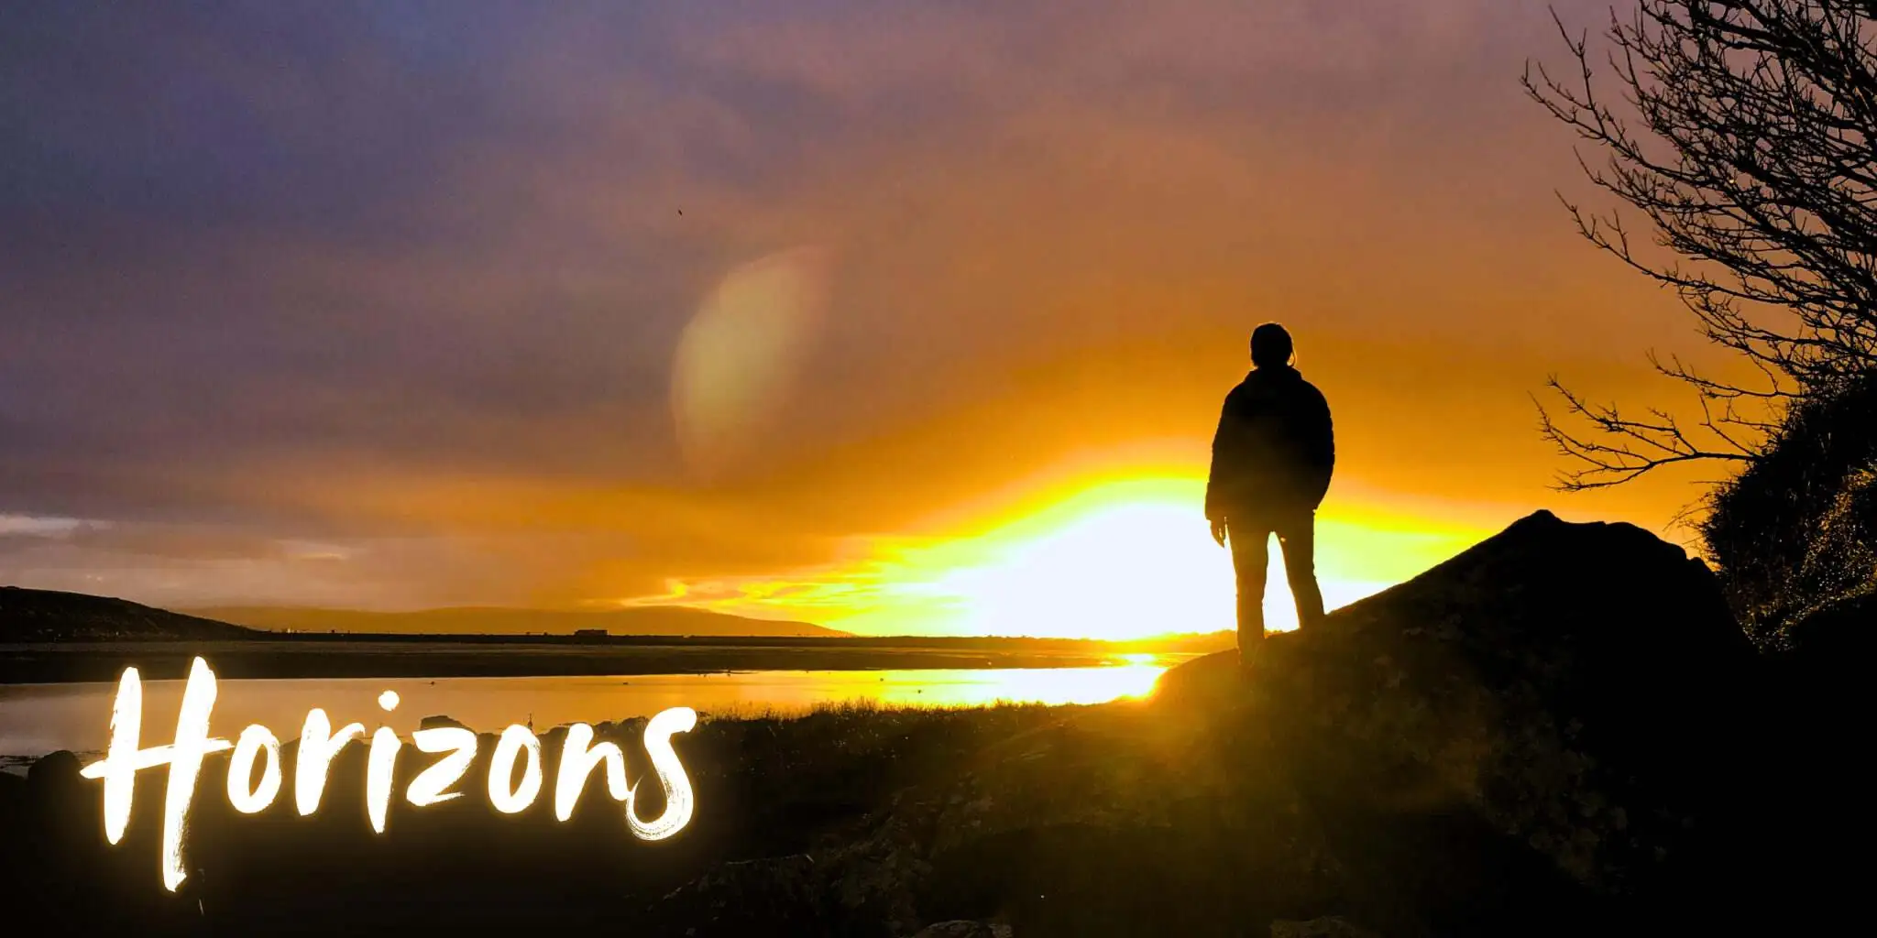
The Moth & Butterfly International Festival of Storytelling & Improvisation
Moth and Butterfly are delighted to present their 5th annual Moth & Butterfly International Festival of Storytelling & Improvisation this coming Brigit’s Weekend, (Thursday January 30th - Sunday February 2nd).

This year’s festival includes collaborations with Arts & Action, Tonnta, The Galway City Museum and the Athenry Heritage Centre, and offers stories and events to suit every palate.

More information here.

_____________________________________________________________
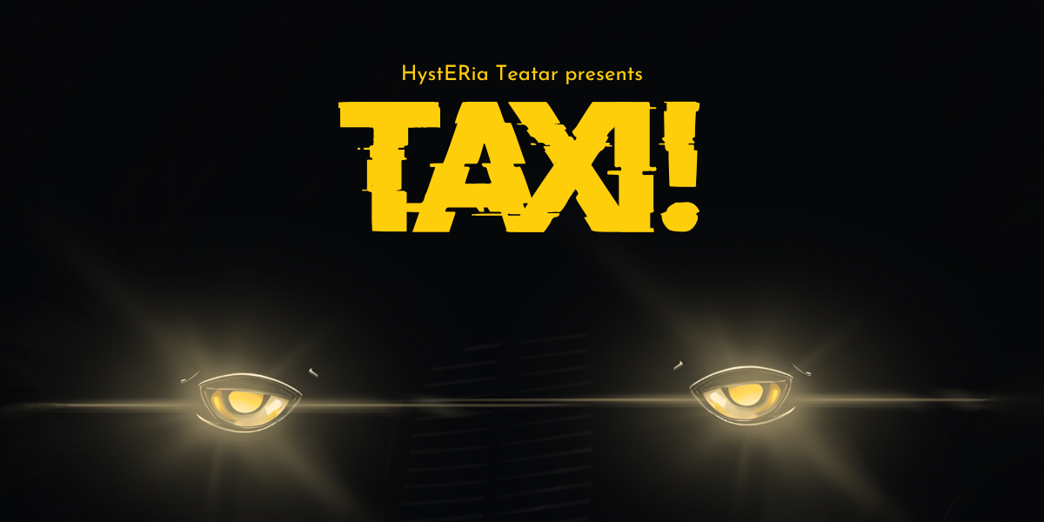
HystERia Teatar Presents: TAXI!
Step into the life of Matthew, a taxi driver navigating more than just the bustling streets of the city. Through candid encounters with passengers - a mother juggling single parenthood, an estranged lover, and many others - Taxi! Dives right into themes of identity, fate, family and the invisible threads that connect us all.
Venue: Mick Lally Theatre, Galway
When: Feb 5th - 7th, 8PM

More information here.
_____________________________________________________________
Failte Ireland Invites Creative Events Listings
Do you have a great event happening in Ireland this year? Promote it with Fáilte Ireland!
Advertise your upcoming events to irelandwestinfo@failteireland.ie and
Register & add your events through the events portal linked to Discover Ireland.
www.FailteIrelandEvents.ie/
_________________________________________________________
Galway City Council Night-Time Economy & This is Galway Invites Events Listings
Do you have a great event happening from 6pm? Promote it with This is Galway!
Simply email Kate.Howard@galwaycity.ie with a brief summary of your event and receive a special code to access the events page, where you can add all the necessary details and promote your offering. Free.
More information.
_________________________________________________________
Send us your Listings & News
We can share your posts! Email up to 50 words to arts@galwaycity.ie with a high-resolution landscape image. Images and text may be edited to fit.
___________________________________________________________________
GCC Arts Office Social Media
Facebook: www.facebook.com/ArtsOfficeGalwayCity
Instagram: @artsofficegalwaycity
X: @cityartsgalway
___________________________________________________________________
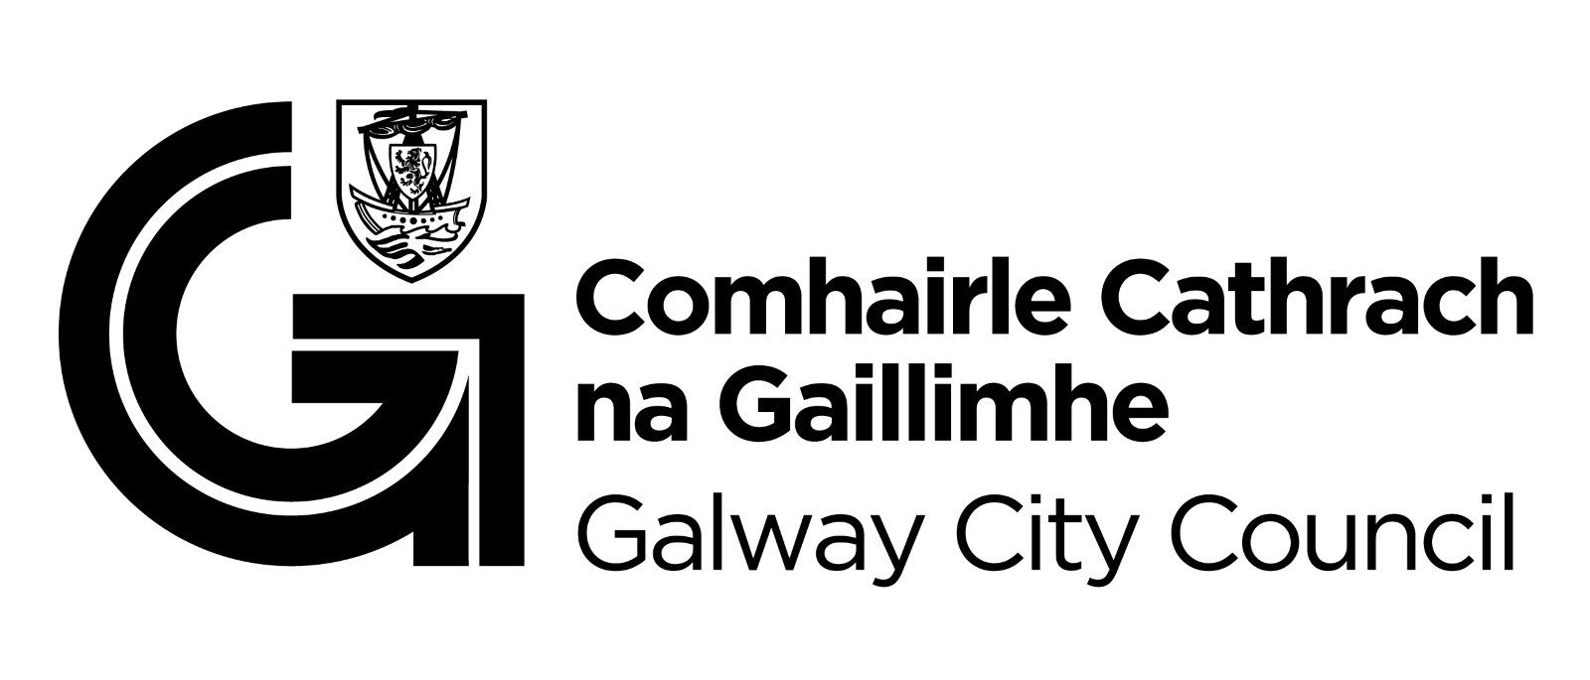
You are getting this email because you are on the Galway City Council Arts Office mailing list. Unsubscribe by emailing arts@galwaycity.ie and ask to be removed.

