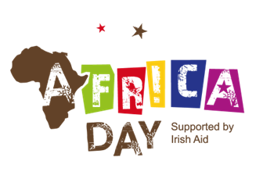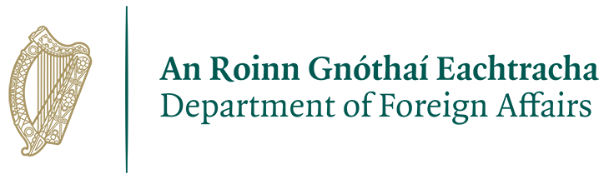**AFRICA DAY**

**25th May 2025**

**Africa Day is an annual worldwide celebration of the people, cultures and potential of this wonderful continent.** **Held on 25 May each year, Africa Day is a chance for people to come together and celebrate the diversity of Africa.** **Irish Aid at the Department of Foreign Affairs is once again pleased to provide financial support to local authorities to plan events for Africa Day.**

Galway City Council are inviting groups/organisations who are interested in organising an event/celebration/initiative are to complete the attached application form and return by email to [candc@galwaycity.ie](mailto:candc@galwaycity.ie) by close of business on **Friday 14th February**.

Please note that the proposed event should take place as close as possible to Africa Day 2025, and ideally **no later than ten days either side of Sunday, 25th of May 2025**.

Galway City Council will submit a collated application to Irish Aid at the Department of Foreign Affairs for an event, or series of events for Africa Day 2025. Pending final approval by the Department, approval may be granted to applicants on the basis that:

* The events/activities being proposed promote a positive image of Africa; highlight Ireland’s priorities in Africa, as outlined in the Government’s development policy, [A Better World](https://www.irishaid.ie/media/irishaid/aboutus/abetterworldirelandspolicyforinternationaldevelopment/A-Better-World-Irelands-Policy-for-International-Development.pdf) and [Ireland’s Strategy for Africa to 2025](https://www.dfa.ie/media/dfa/publications/Global-Ireland---Irelands-Strategy-for-Africa-to-2025.pdf). Events should have a public information and ideally an education component.
* The events are not profit-making and have a particular emphasis on attracting families.
* The proposed activities and associated costings demonstrate good value for money and an appropriate use of public funds.
* The programming of your event (i.e. music performances and other ‘headline’ cultural content) must be pre-approved by Irish Aid prior to confirming any bookings.
* Health and safety is considered a strict priority and ensuring compliance is critical to Africa Day events nationwide. Food Traders must supply local authorities with EHO registration details and a copy of their registration letter from the HSE – if they do not usually trade as a food trader in an outdoors environment, they will need to notify the EHO and get clearance to sell food before applying to trade at Africa Day events. All food trader employees must have basic Food Safety/Handling training. The principal of the food unit must have HAACAP training.
* 50% of the payment is made to qualifying applicants upon award of a ‘letter of offer’ and completion of the Form A.
* The outstanding 50% is paid upon satisfactory execution of the event. This includes the submission of a Form B, full report of the events, including a detailed budget and report on coverage and attendance, invoices and receipts.

|  |  |  |
| --- | --- | --- |
| **Section 1: Contact Details** | | |
| **Group/Organisation Name** |  | |
| **Contact Name** |  | |
| **Position in Group** |  | |
| **Email Address** |  | |
| **Phone No.** |  | |
| **Any other Local Partners** |  | |
|  | | |
| **Section 2: Event Details** | | |
| * 1. **Please give a description of your group’s proposed Africa Day event (500 words)**   *Please include information about the event location(s); participants; how African cultures will be celebrated; engagement with partner organisations; expected attendance figure.* | | |
|  | | |
| * 1. **How will the event / activity be managed?**   *Please include information about who is undertaking event management tasks, including ensuring health and safety compliance; coordination of participating groups; and crowd control measures.* | | |
|  | | |
| * 1. **Please give full details of public indemnity insurance, including the level of indemnity cover and who / what body will be indemnified for the purpose of this activity.** | | |
|  | | |
| * 1. **Please detail the date(s) and time of your proposed event(s) / activity (Note: event should take place as close to the 25th of May as possible, and no earlier or later than 10 days either side):** | | |
|  | | |
| **2.5 How do you propose to promote your Africa Day event(s) / activity?** | | |
|  | | |
| **2.6 Will you be able to supply timely high-resolution images / video of the event for use online?** | | |
|  | | |
|  | | |
| **Section 3: Budget** | | |
| Please note that funding to a **maximum of €4,000** only will be considered per application. | | |
| **3.1 Please list the costs associated with your proposed event below:** | | |
|  | | € |
|  | | € |
|  | | € |
|  | | € |
|  | | € |
|  | | € |
| **Total costs for Event/ Activity:** | | **€** |
| **Total funding requested:** | | **€** |
| **Please confirm any resources or funding for this event/activity, and how you will cover any remaining costs.** | |  |

|  |
| --- |
| **Deadline for Submission of Funding Applications** |
| The deadline for receipt of completed funding application forms is close of business on **Friday, 14 February 2025**. Please return completed forms to [candc](mailto:africaday@dfa.ie)@galwaycity.ie.  You will be notified of the decision taken in relation to your application in April 2025. |