**Galway City Council Arts Newsletter Late November 2024**

Welcome to this fortnight’s newsletter. Below you will find a Galway City Council Arts Office grant announcement (closing in early 2025), a major climate action project, a graduate residency opportunity and more. Email mail us if you would like your activities shared in this newsletter, details below,

Happy reading, from the Galway City Arts Office team.

**_____________________________________________________________**

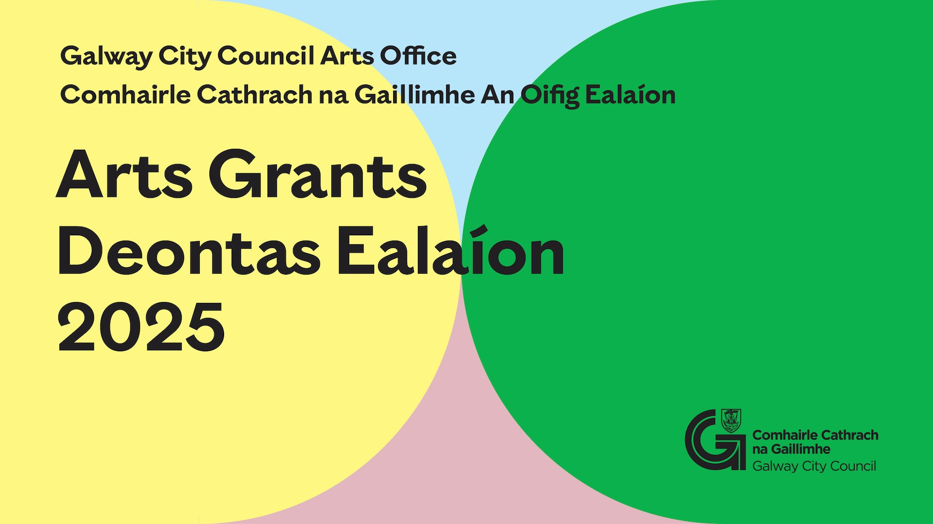

**Galway City Council: Arts Organisation Grants**

Galway City Council now invites applications for the Arts Organisation Grants 2025.

In accordance with the Arts Act 2003, funding is towards arts activity with the purpose of

* Stimulating public interest in the arts,
* Promoting knowledge, appreciation and practice of the arts or
* Improving standards in the arts.

Arts Grants for Organisations are in two strands:

1) Arts Grant Professional Strand

2) Arts Grant Community, Voluntary and Amateur Strand

Our approach ensures the evaluation and funding is tailored to the distinct needs of both professional arts and community organisation-led arts.

For the Arts Grants 2025 online application and guideline go to

[www.GalwayCity.ie/ArtsGrants](https://www.galwaycity.ie/ArtsGrants)

For further information write to [arts@galwaycity.ie](mailto:arts@galwaycity.ie) with the subject line “Arts Grants 2025 Enquiry”.

**_____________________________________________________________**

**Comhairle Cathrach na Gaillimhe: Deontais Ealaíon d'Eagraíochtaí**

Tá iarratais á lorg ag Comhairle Cathrach na Gaillimhe do Dheontais Ealaíon 2025. De réir an Achta Ealaíon 2003, tairgtear maoiniú do ghníomhaíocht ealaíon chun:

* Suim an phobail sna healaíona a spreagadh,
* Eolas, léirthuiscint agus cleachtadh ar na healaíona a chur chun cinn, nó
* Caighdeáin sna healaíona a fheabhsú.

Tá Deontais Ealaíon d’Eagraíochtaí in dhá mhír:

1) Sraith Gairmiúl den Deontas Ealaíon

2) Pobal na gCistí Ealaíona, Sraith Amaitéarach agus Deonach

Le theacht ar an bpróiseas iarratais ar líne na nDeontas Ealaíon 2025 agus treoir maidir le hiarratas a dhéanamh téigh chuig [www.galwaycity.ie/deontaisealaion](https://www.galwaycity.ie/deontaisealaion)

**_____________________________________________________________**

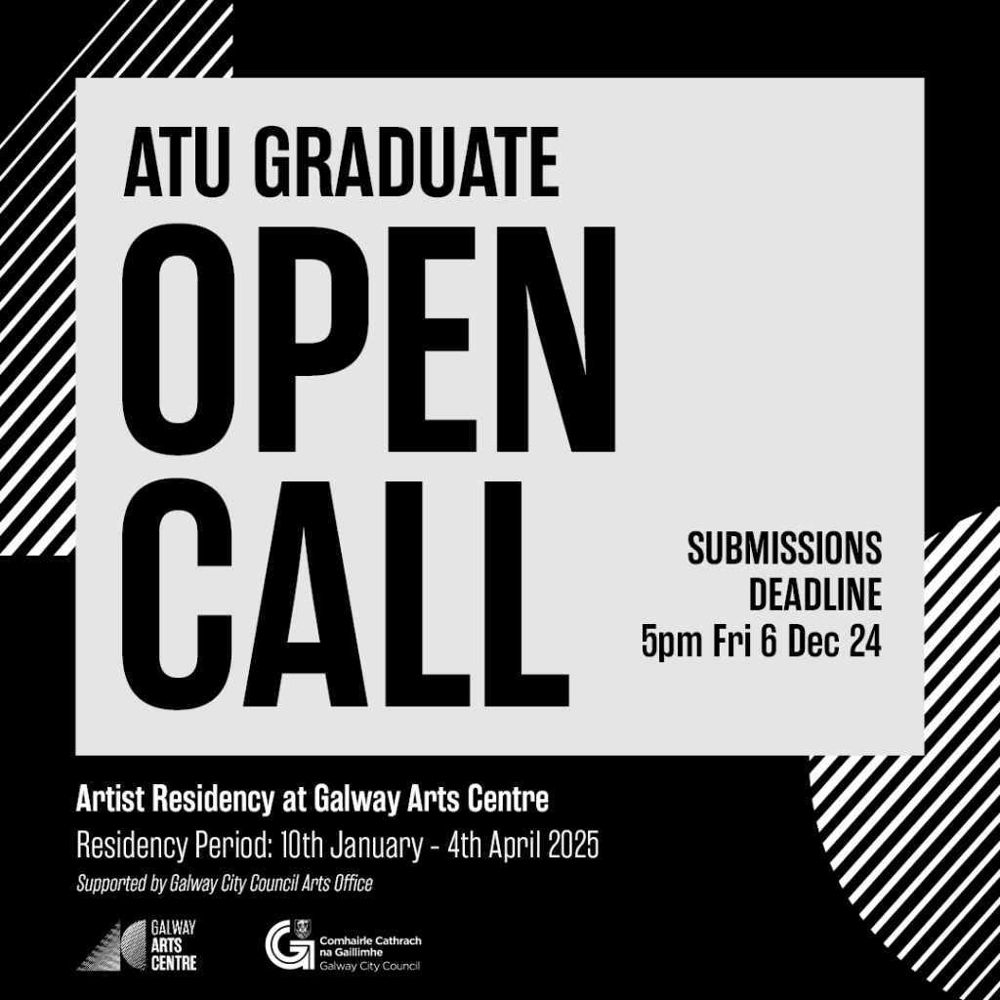

Galway City Arts Office and Galway Arts Centre are pleased to announce an exciting opportunity for a recent graduate from the Atlantic Technology University in Galway. We are inviting applications for a 12-week artist residency, to support and nurture emerging artistic talent in our vibrant local community.

The award is delivered through a partnership between Galway Arts Centre and Galway City Arts Office. The residency is funded through Galway City Arts Office and Galway Arts Centre.

**Residency Period: 10 Jan to 4 April 2025**

[**Galway Arts Centre X Galway City Arts Office Graduate Residency**](https://www.galwayartscentre.ie/for-artists/news-and-opportunities/)

**___________________________________________________________________**

**Artists Announced for New Residency Programme Focusing on Air Quality and Pollution**

Residencies to unite art, science, and community in Galway’s ‘The Air We Share’ climate action initiative.

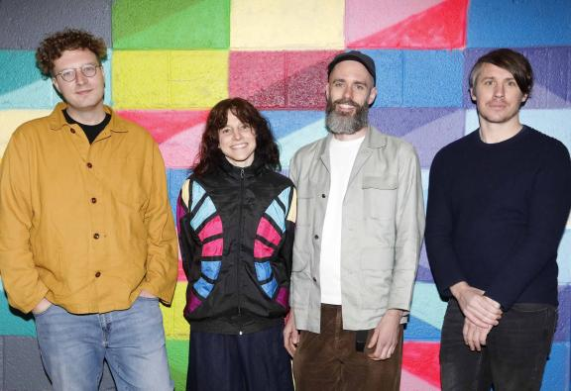  
  
Image caption: Pictured in Shantalla, Galway City’s Westside, at the announcement of three art commissions under the new ‘The Air We Share’ artists-in-residence programme are, from left, Christopher Steenson, Paula McCloskey, Sam Vardy and Leon Butler. PHOTO: Mark Stedman

On the 25 November 2025 [Galway Arts Centre](https://www.galwayartscentre.ie/), in conjunction with [Galway City Council](https://www.galwaycity.ie/), announced the awarding of three art commissions under an innovative new artist-in-residence programme. The programme supports artists to engage with the communities of Galway City’s Westside and to creatively respond to scientific research on air quality and climate conducted by local citizens and climate scientists from the University of Galway.

The artist-in-residence programme lies at the creative heart of ‘The Air We Share’, a collaborative climate action initiative launched in July 2024. The initiative examines and highlights the causes, impacts, and potential solutions to air pollution. Through artistic interventions, citizen science, and community action in Galway’s Westside, it aims to deepen public understanding of air and its critical role in our shared environment.

Aligned with these objectives, the selected artists have been commissioned to develop innovative and collaborative arts projects that interpret and respond to scientific concepts and data on air quality, the atmosphere, and climate. They have been awarded funding to develop their projects between now and July 2025, when the final artworks will be presented publicly.

The selected artists are:

**Leon Butler**: Galway-based artist Leon Butler’s project ***Phosphene*** blends art and technology to transform air quality data into a community experience. By using sensors to track and interpret this data, Butler will create “data sculptures” that reveal the health of Galway’s built environment in new ways. The project invites the local community to participate in design sessions to shape how air data is visualised, making the often-invisible aspects of air quality engaging and accessible to all.

**Christopher Steenson**: Multidisciplinary artist Christopher Steenson’s project ***I talk to the wind*** explores air pollution through the act of breathing. His work will incorporate sound walks using live air pollution data and community workshops that consider climate futures through writing and discussion. Drawing on Galway’s air quality data, insights from scientists, and ideas generated through community workshops, Steenson’s project will connect participants with the realities of air pollution and its impacts on daily life through the shared experience of breath.

Director and Curator of Galway Arts Centre, Megs Morley, commented: “After a highly competitive open call selection process, we are thrilled to announce the artists chosen for ‘The Air We Share’ artist-in-residence programme. In the context of the current climate challenges that we face as a society, programmes such as ‘The Air We Share’ that bring together artists, scientists, communities, public institutions and cultural organisations are critical to our understanding and addressing the issues at hand.   
  
“The selected artists bring an exceptional wealth of artistic experience to ‘The Air We Share’ programme. Over the coming months, they will develop engaging interdisciplinary projects that explore innovative ways of understanding the sources and effects of air pollution, as well as the actions we can take to catalyse positive collective change.”  
  
Chief Executive of Galway City Council, Leonard Cleary added: “The artist-in-residence programme brings creativity into the heart of ‘The Air We Share’, a transformative climate action initiative guided by the theme ‘Making the Invisible Visible’, which highlights air pollution as a critical environmental health risk.  
  
“Working alongside the EU's Net Zero Cities initiative, ‘The Air We Share’ helps inform Galway City Council's climate policies and, through community involvement, aims to inspire cultural and behavioural shifts towards climate action grounded in fairness, collaboration, and positive change. As the project’s lead partner, we are delighted to support the artists in developing community-engaging interventions and look forward to their creative responses next summer.”  
  
‘The Air We Share’ is a recipient of the Creative Climate Action Fund, an initiative of the Creative Ireland Programme, funded by the Department of Tourism, Culture, Arts, Gaeltacht, Sport and Media in collaboration with the Department of the Environment, Climate and Communications. The fund supports creative, cultural and artistic projects that build awareness around climate change and empower citizens to make meaningful behavioural transformations.  
  
For further information, visit [theairweshare.ie](https://www.theairweshare.ie/).

**_____________________________________________________________**

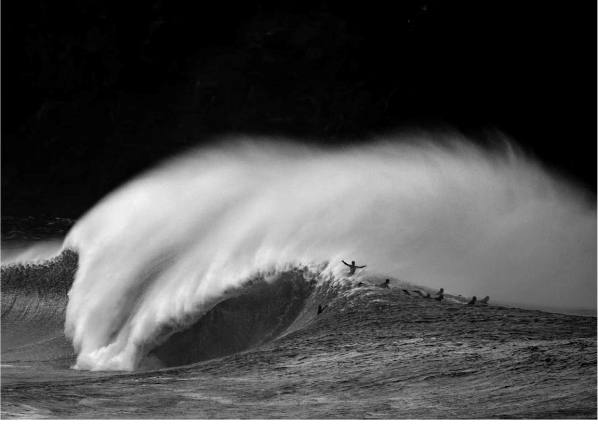

**The Irish Surf Film Festival 2024**

Galway City Council Arts Office were delighted to support The Irish Surf Film Festival, which took place in Pálás Cimena on 23rd and 24th November and brought together representatives from the Irish coastal community; with lens-based artists and board riders celebrating our unique coastal assets through powerful films, shorts, photography and storytelling. Congratulations to all the film makers and to Gary Mc Call for winning the photography competition with his evocative photograph that captured ‘Farraige Cháite’. Macdara Ó’ Cuaig, a fisheries scientist from Cill Ciaran, told the audience about the use of this phrase which refers to the bit of the wave that lifts or sprays off the top when the wind catches it, this has been beautifully captured by Gary. Each piece of media in the film festival told the story of an incredible relationship between the sea and the community.

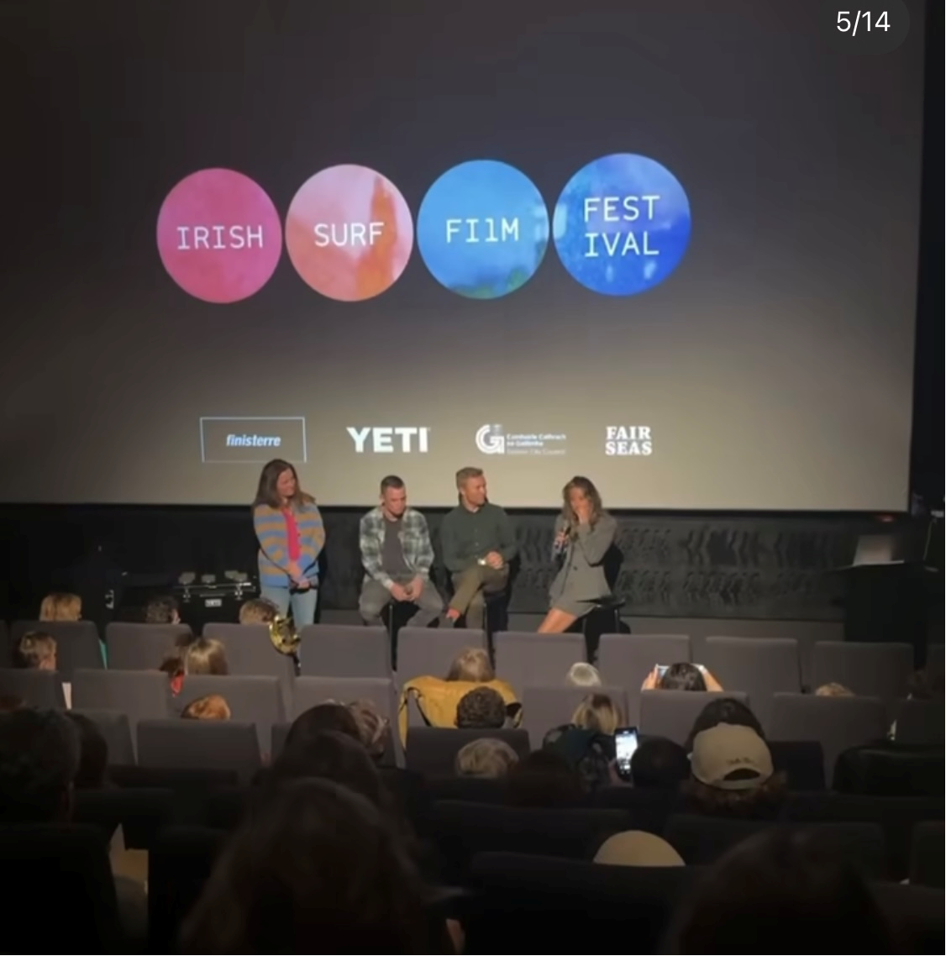

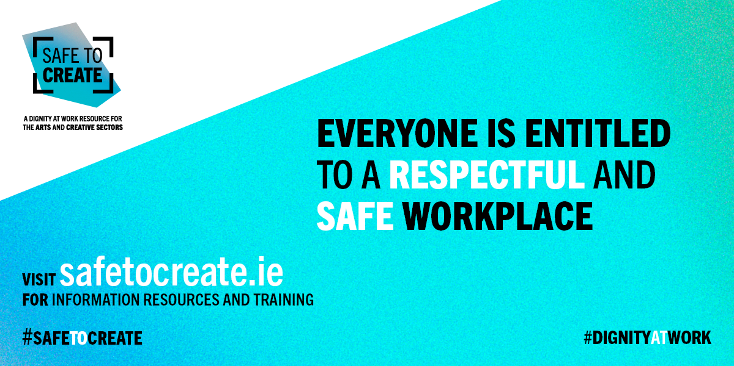

**Safe to Create**

Earlier this year, Safe to Create asked artists, and arts and creative workers, including senior leaders, to share their reflections on the work of the Safe to Create programme. You can now watch David O'Doherty's insightful short video below.

More training courses will be added in the future.

More [information and resources](https://eur04.safelinks.protection.outlook.com/?url=https%3A%2F%2Fscanner.topsec.com%2F%3Fd%3D1122%26r%3Dshow%26u%3Dhttps%253A%252F%252Firishtheatreinstitute.us10.list-manage.com%252Ftrack%252Fclick%253Fu%253Dccff406802315c48806cad68e%2526id%253D4149325aa8%2526e%253D1b40055617%26t%3Db56a118587b0c721eb137697bc75b5756dc6941a&data=05%7C02%7Carts%40galwaycity.ie%7Cf0e5a60ba882489a729b08dcfe74e600%7Cd7a0f67a0cae4b21abdbb5186f6e07a9%7C0%7C0%7C638665028530644749%7CUnknown%7CTWFpbGZsb3d8eyJFbXB0eU1hcGkiOnRydWUsIlYiOiIwLjAuMDAwMCIsIlAiOiJXaW4zMiIsIkFOIjoiTWFpbCIsIldUIjoyfQ%3D%3D%7C0%7C%7C%7C&sdata=iEWqipRSKwtEtQUUpPfAssZRSQL%2FIW7T4fiQj%2BxG20s%3D&reserved=0)**AU**

**_____________________________________________________________**

**Galway Camera Club**

Galway Camera Club are delighted to announce that, in conjunction with Cope Galway an exhibition of the Club's work will be on display in Cope's new premises in Newtownsymth, Galway, from the 25th November to 8th December. As an early Christmas present, some of the pictures on display will be donated to Cope.

[Further information here](https://galwaycameraclub.com/).

**_____________________________________________________________**

**Galway Film Society**

Join Galway Film Society for the last few films of the Galway Film Society's winter season: **The Teacher, Elaha** and **The Crime is Mine**.

Additionally, there will be a special Christmas screening (8th and 9th of December) of the classic film **Bell, Book and Candle.**

[Further information](https://www.palas.ie/galway-film-society-programme).

**________________________________________________________________**

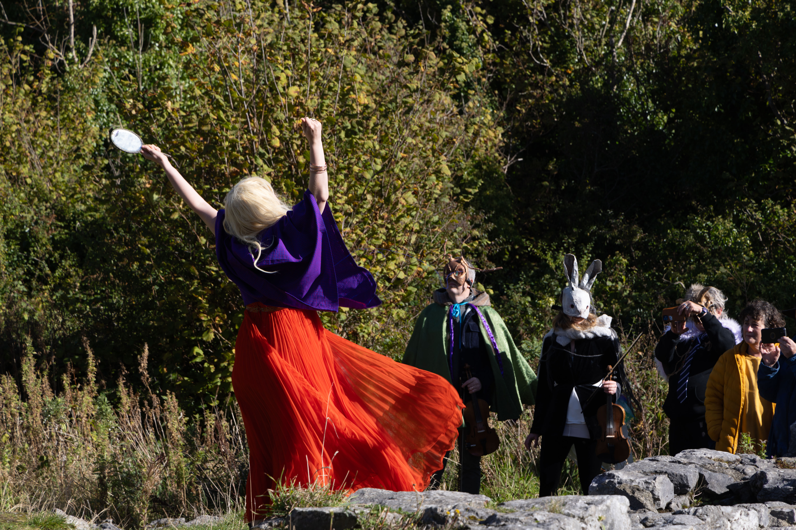

**Eastside Arts Festival**

Galway City Council are delighted to have support the recent Eastside Arts Festival, an exciting new festival by and for the communities living and working in east Galway City. The intergenerational festival programme brought together visual arts, performing arts, interactive workshops, and nature-based activities. Highlights included storytelling, art exhibitions, a performance in Merlin Woods, an upcycling workshop, a local history talk, African dance, samba, choral music, and a céilí.

See the video [here.](https://youtu.be/n0rHkxJ4FGo?si=vW0f-L2RML5n3i4J)

If you live or work in Eastside and have suggestions or ideas for next year’s festival, contact the Culture & Creativity Team on [CandC@GalwayCity.ie](mailto:CandC@GalwayCity.ie).

[Further information](https://eastsideartsfestival.ie/).

**________________________________________________________________**

**Send us your Listings & News**

We can share your posts! Email up to 50 words to [arts@galwaycity.ie](mailto:arts@galwaycity.ie) with a high-resolution landscape image. Images and text may be edited to fit.

**___________________________________________________________________**

**GCC Arts Office Social Media**

Facebook: [www.facebook.com/ArtsOfficeGalwayCity](https://scanner.topsec.com/?d=1122&r=show&u=https%3A%2F%2Fwww.facebook.com%2FArtsOfficeGalwayCity&t=a6b33347cd65717d4a93047cc8b1c9f7c5d8a4c9)

Instagram: [@artsofficegalwaycity](https://www.instagram.com/artsofficegalwaycity?utm_source=ig_web_button_share_sheet&igsh=ZDNlZDc0MzIxNw==)

X: [@cityartsgalway](https://x.com/CityArtsGalway?s=20)

**___________________________________________________________________**

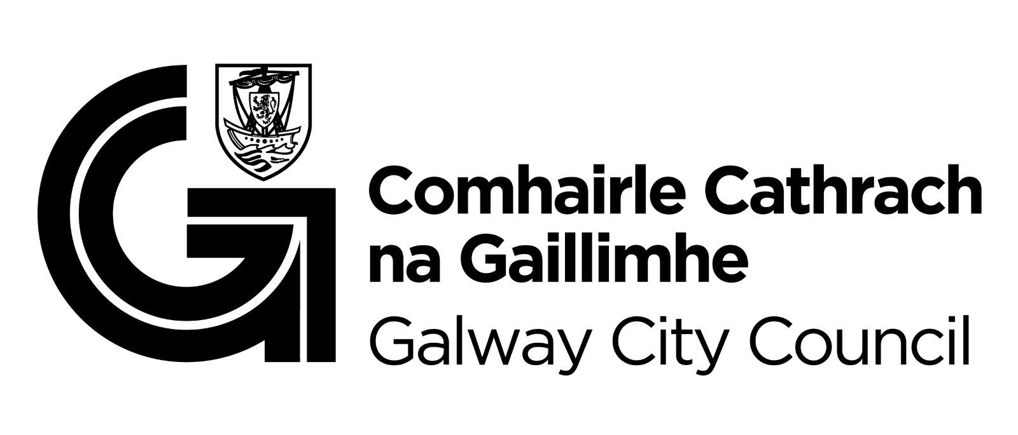

You are getting this email because you are on the Galway City Council Arts Office mailing list. Unsubscribe by emailing [arts@galwaycity.ie](mailto:arts@galwaycity.ie) and ask to be removed.