Welcome to this fortnight’s newsletter. Below, you will find opportunities, events, and useful information for arts organisations and creative practitioners based in Galway City.
Happy reading, from the Galway City Arts Office team.
_____________________________________________________________
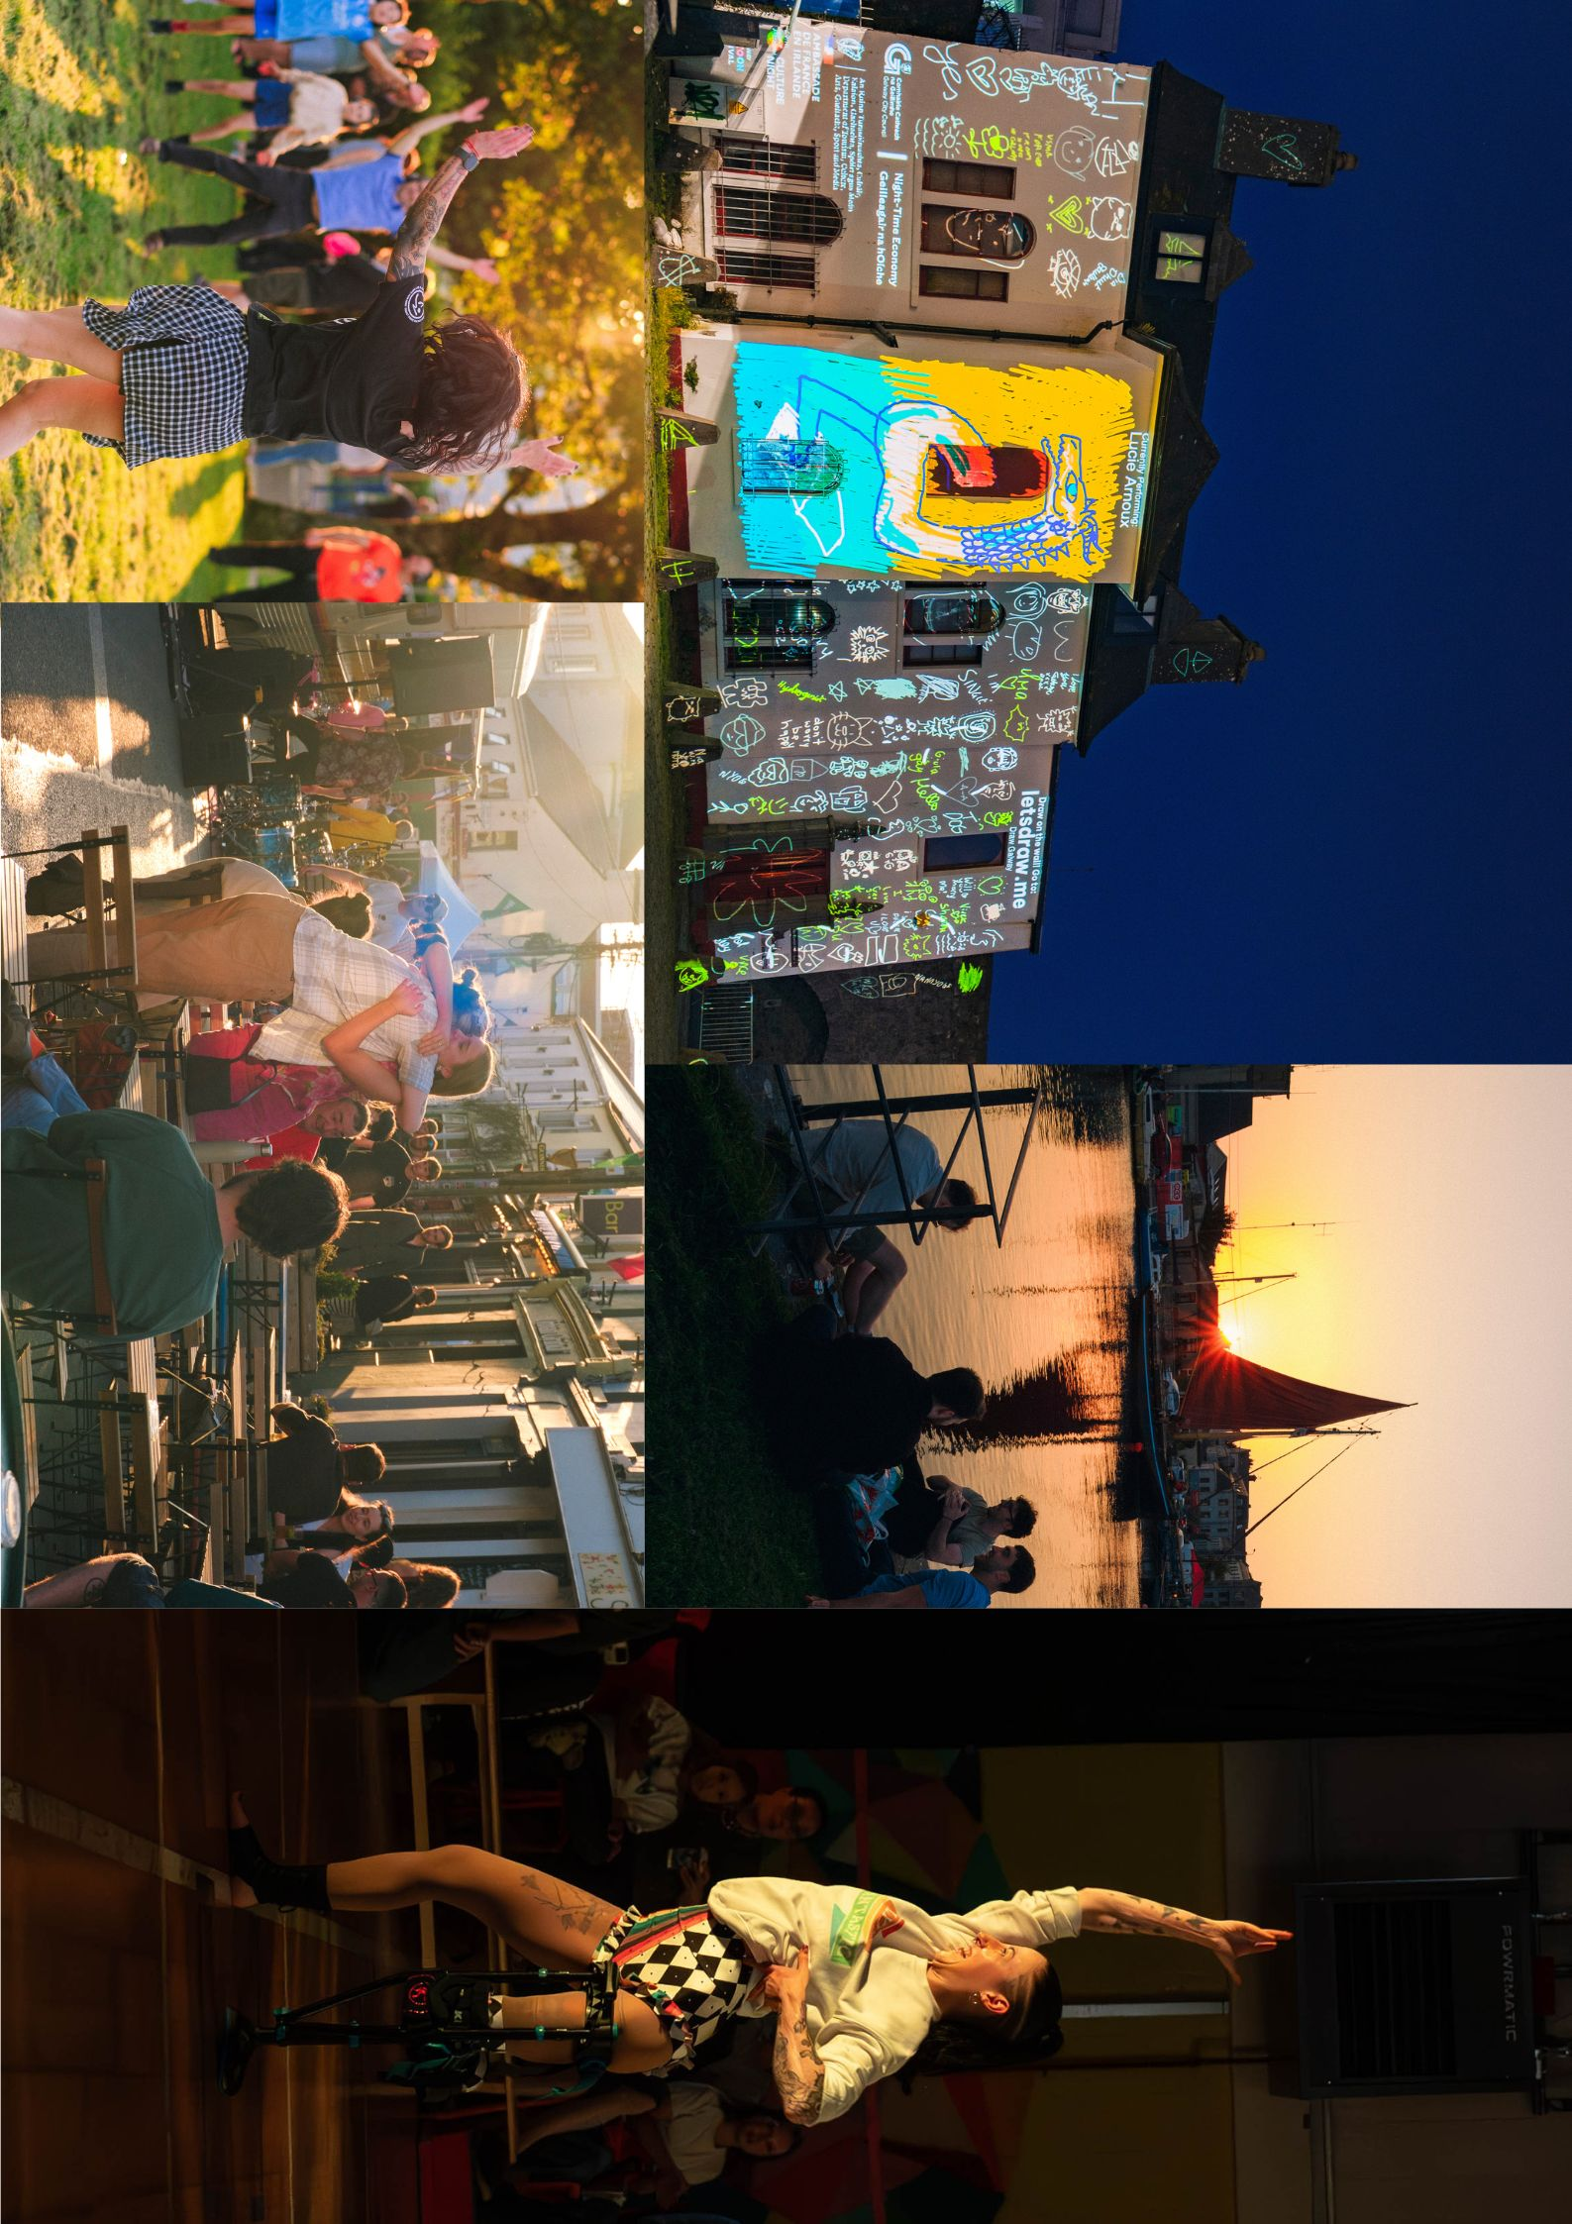
Culture Night 2024 – A Great Success!
Galway City came alive on Friday, 20th September, for another spectacular Culture Night celebration. Thousands of locals and visitors enjoyed an evening filled with free performances, exhibitions, and interactive workshops, all showcasing Galway's rich and diverse artistic community. From live music and theatre to visual arts and performance, venues across the city opened their doors, offering something for everyone. The Galway City Arts Office extends a heartfelt thank you to all the artists, participants, and attendees for making this year’s Culture Night a truly memorable event.
Did you enjoy #CultureNight2024 in Galway City? Your feedback is important to make Culture Nights of the future even better, so please take a moment to fill out this short survey.
_____________________________________________________________
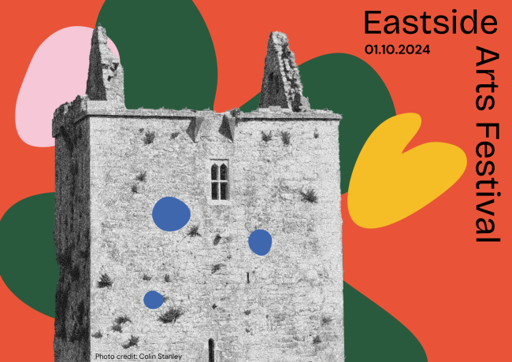
Launch of Eastside Arts Festival
You are cordially invited to the launch of the first Eastside Arts Festival, an exciting new, community-led festival for East Galway, at the ARD Family Resource Centre, on Tuesday 1 October at 6.30pm.
Mayor of Galway City, Cllr Peter Keane, will officially launch the Festival. The event will feature a panel discussion, an exhibition, and song and dance performances. Light refreshments will be provided.
More information here.
_____________________________________________________________
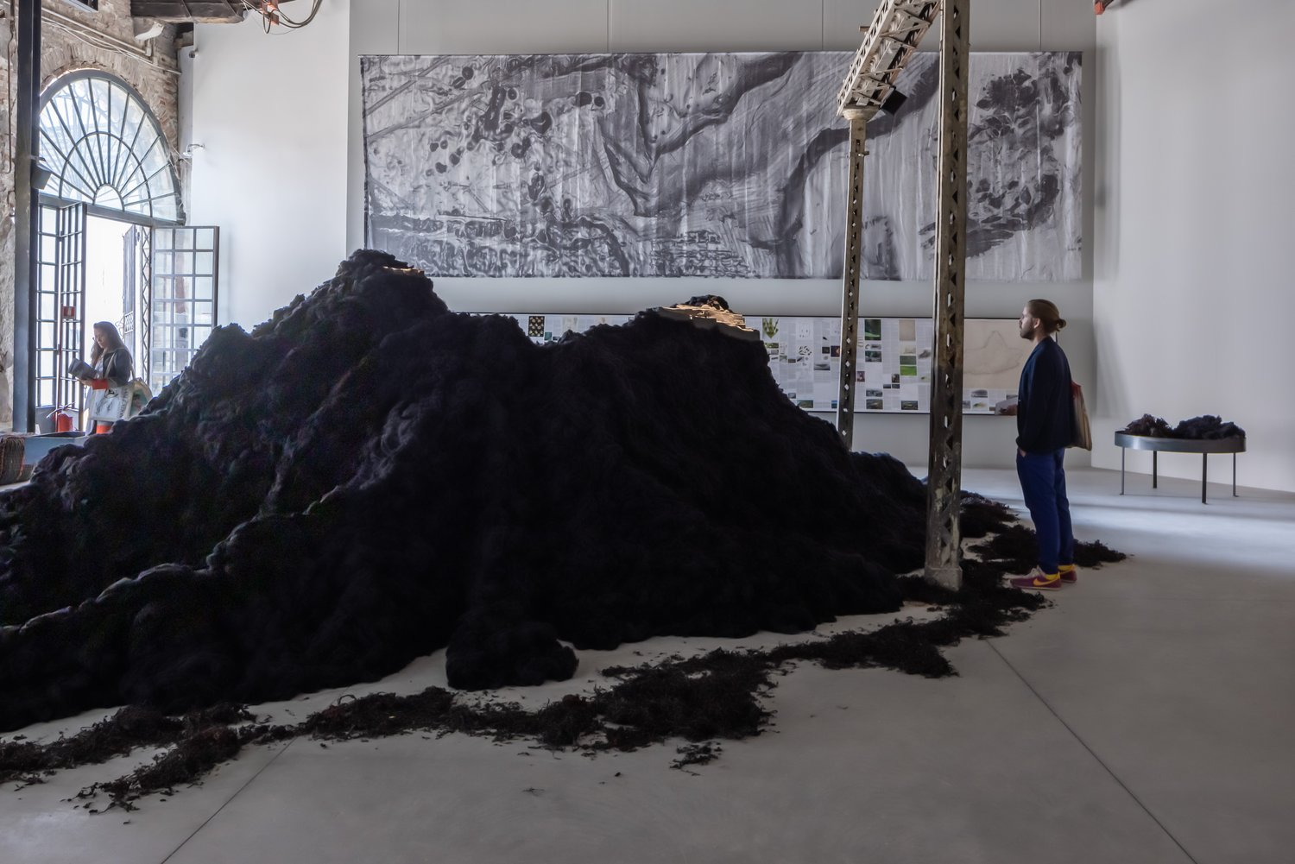
Architecture at the Edge: In Search of Hy-Brasil
Curated by a team of five architects: Peter Carroll, Peter Cody, Elizabeth Hatz, Mary Laheen and Joseph Mackey; Ireland’s national pavilion at the Venice Architecture Biennale 2023, In Search of Hy-Brasil, derives from an intense engagement with the islands of Ireland and is a direct provocation to all of us to reimagine the vast combined territory of land and ocean we call our home.
Find out more about this event, and others in the festival at the festival program.
_____________________________________________________________
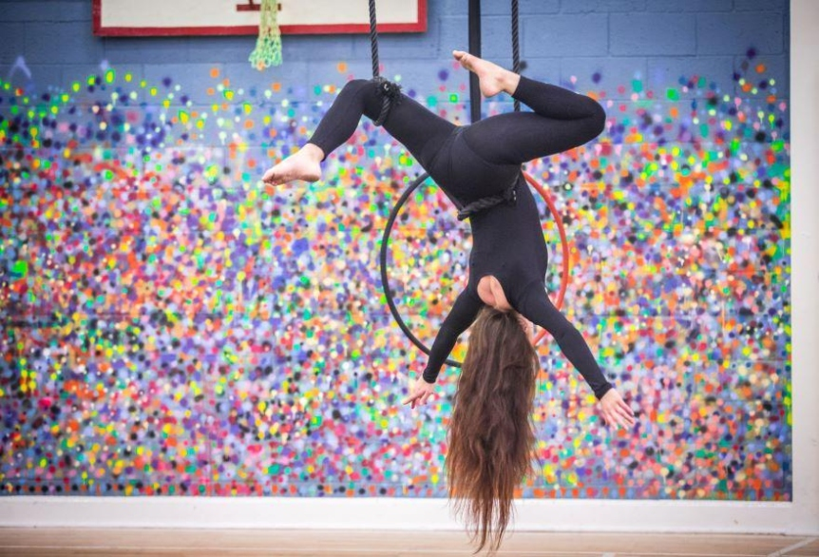
Galway Community Circus Hiring General Manager

Galway Community Circus is searching for a passionate and experienced General Manager to join our vibrant team. The deadline to apply is Sunday 29th September 2024.

More information here.

_____________________________________________________________
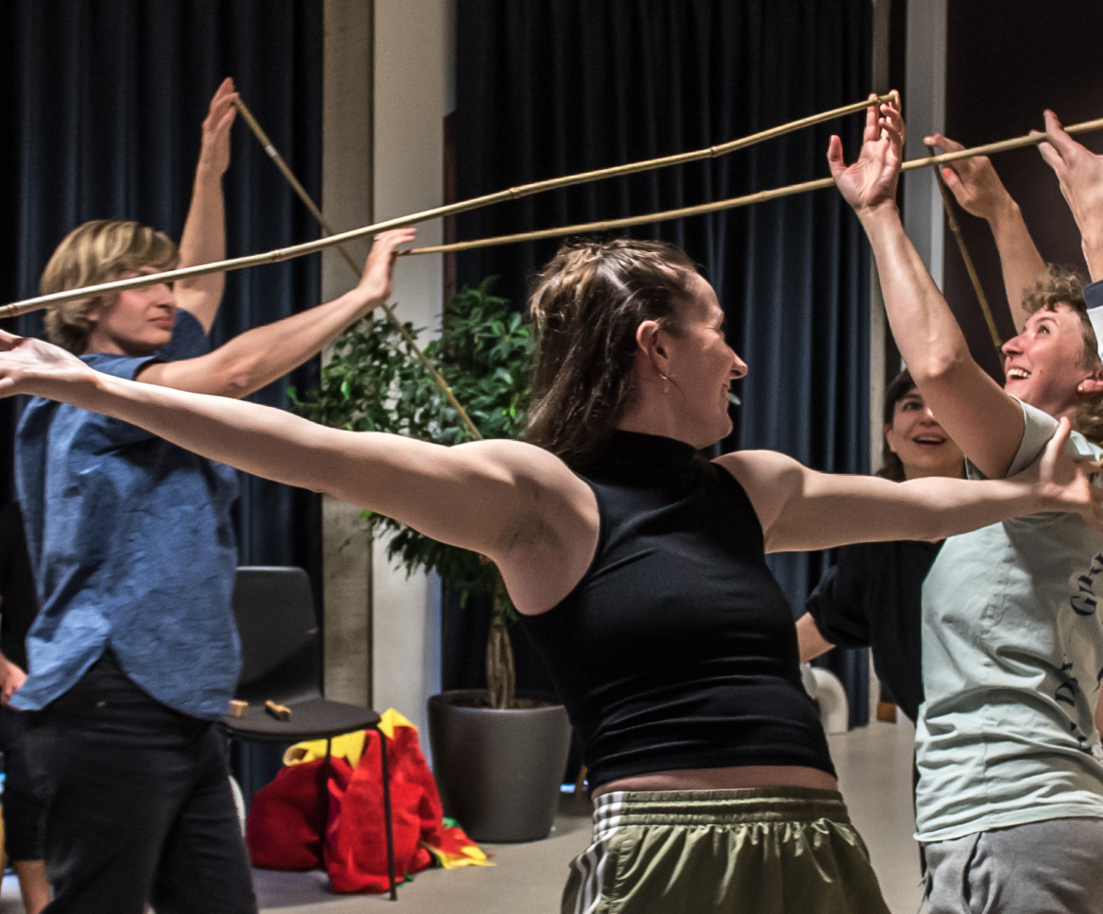

Artist Opportunity: Apply for BABEL Round 4

Baboró seeks two artists to participate in professional development workshops hosted by international European festivals.
If selected, you will:
- Participate in two 5-day practical sessions in 2025 with a cohort of 11 other professional artists from across Europe;
- Experience two European children's arts festivals with your workshop cohort;
- Receive a daily fee of €200 to cover workshop and travel days. The cost of all travel, accommodation and festival tickets will be covered.

This is a great opportunity for artists passionate about developing performances for young audiences

More information here.

_____________________________________________________________
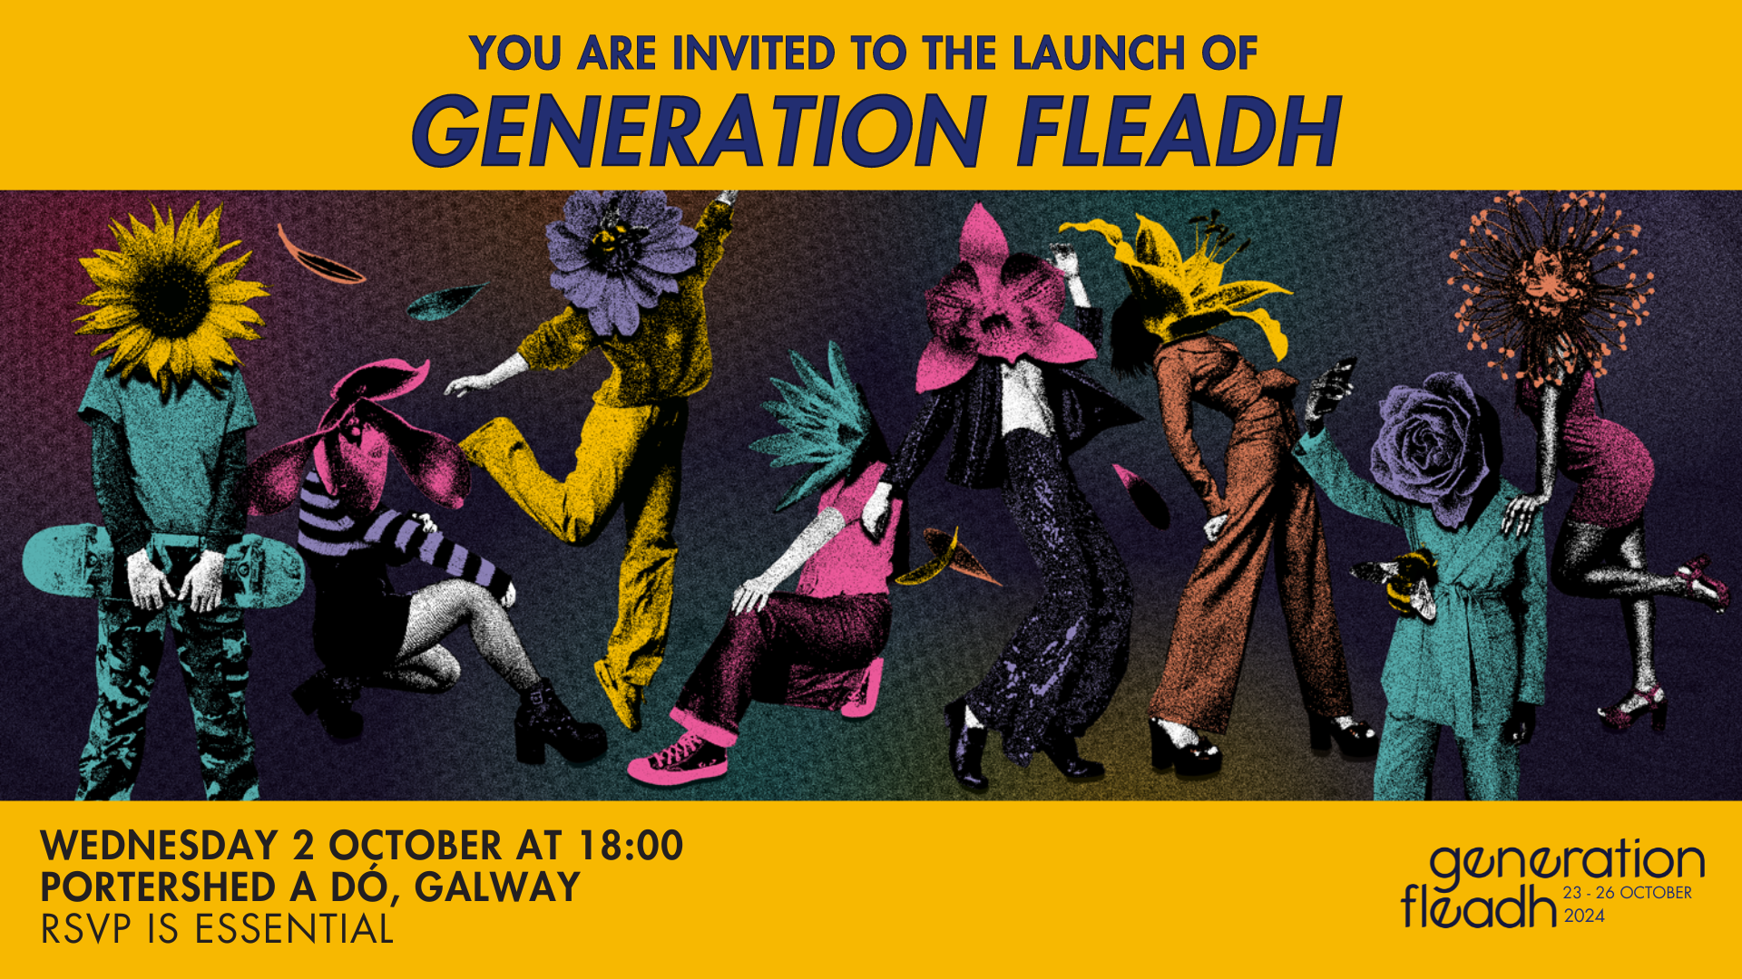

Launch of GENERATION Fleadh

GENERATION Fleadh is the younger half of the Galway Film Fleadh for people aged 12 – 24. The 2024 festival, which takes place from 23 – 26 October 2024, will comprise a 4-day event with film screenings and an educational film programme, an annual outreach programme in Galway City and County, collaborations with festivals and events, all informed by the youth voice through the GENERATION Fleadh Council and youth review panels.

The Fleadh will be formally announced on the 2nd of October at 6pm in Portershed a dó.

RSVP HERE by Friday, 27th September at 17:00
_____________________________________________________________
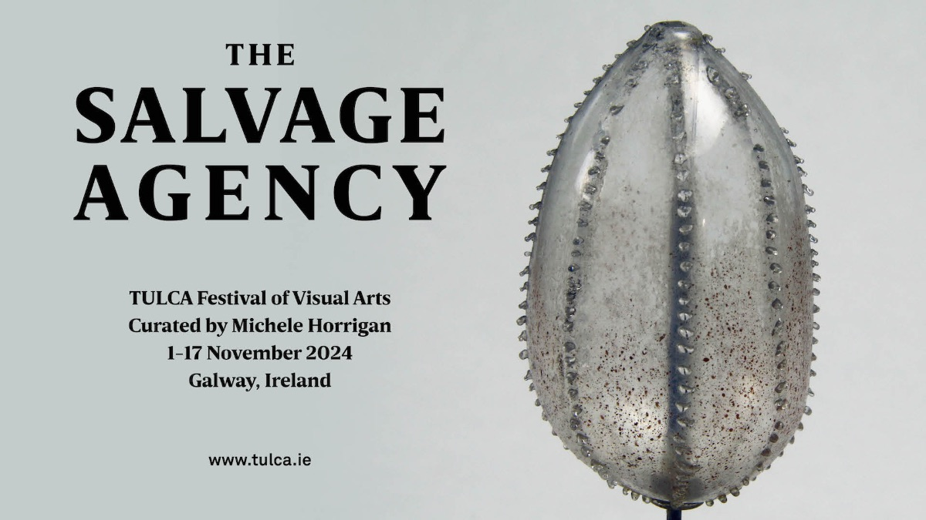
Announcement: Contributors to TULCA 2024

TULCA Festival of Visual Arts is pleased to announce the contributors to its 22nd festival edition, titled The Salvage Agency curated by artist Michele Horrigan. TULCA 2024 will be presented across multiple venues and locations in Galway from 1-17 November 2024. Established as the west of Ireland’s key annual showcase of contemporary art, TULCA continues to embrace Galway’s art institutions, cultural initiatives and public space together, presenting Irish and international artistic positions vital to our understanding of life today.

Full festival programme and a commissioned publication will be released in October 2024.

More info on contributors here.

_________________________________________________________
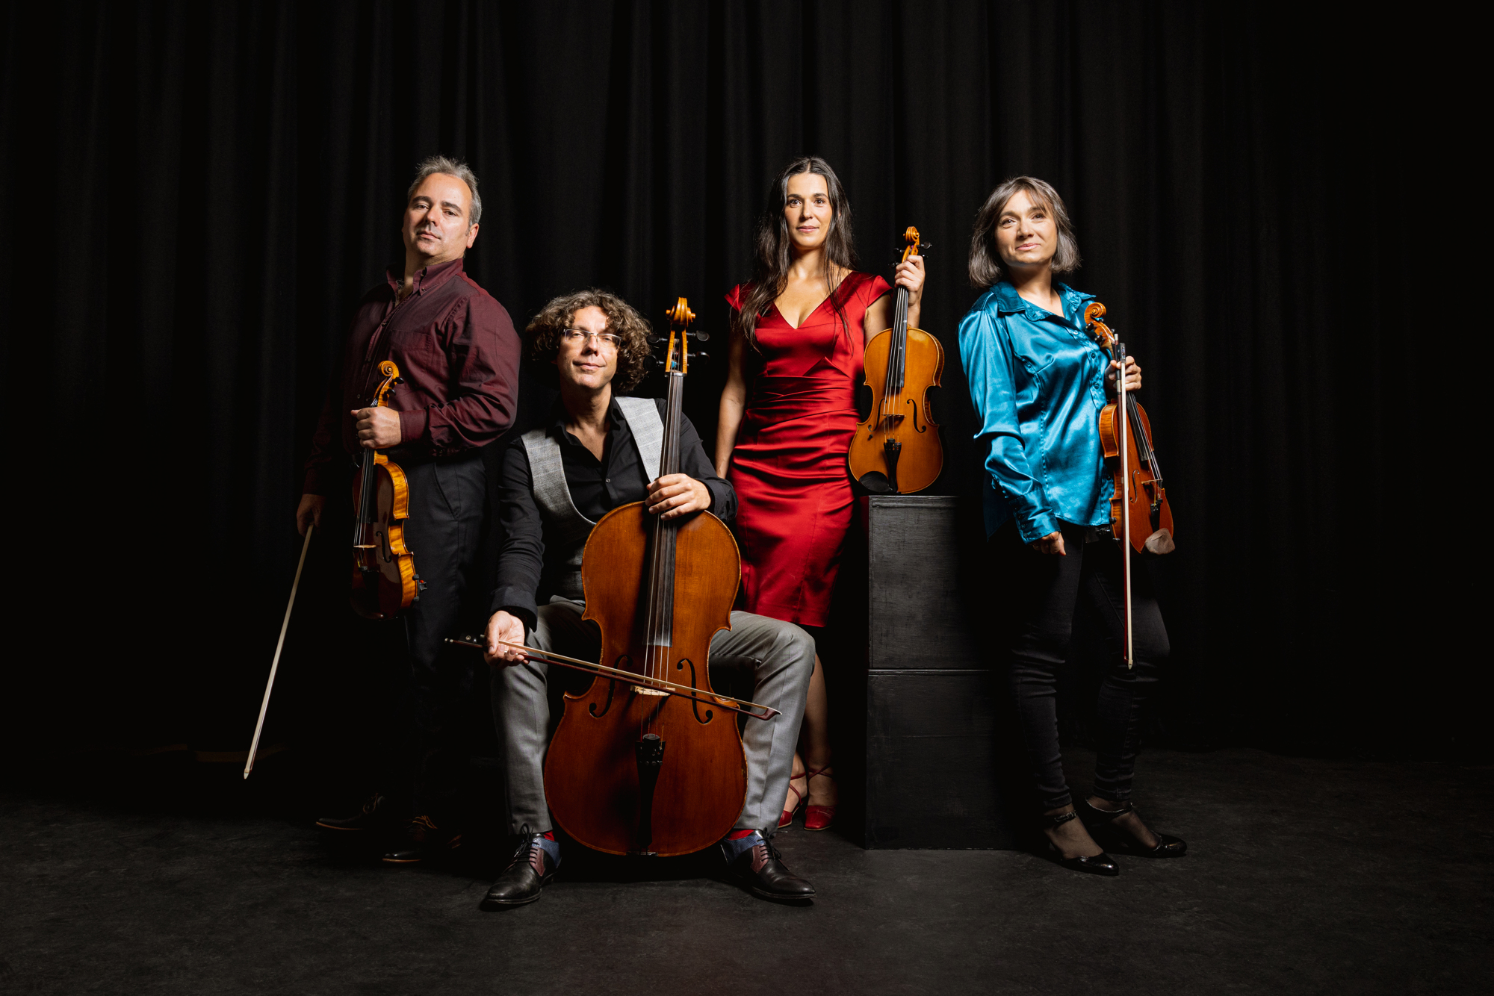
Galway Music Residency: Michaelmas at Lunchtimes
Galway Music Residency continues its musical journey through the Celtic Calendar with repertoire celebrating Michaelmas at Lunchtimes with ConTempo on Tuesday 1 October, 1:10pm in St Nicholas’ Collegiate Church. The programme features works looking at the completion of harvest and movement into winter.
This event is FREE, all welcome. No booking needed.
More information here.
_____________________________________________________________

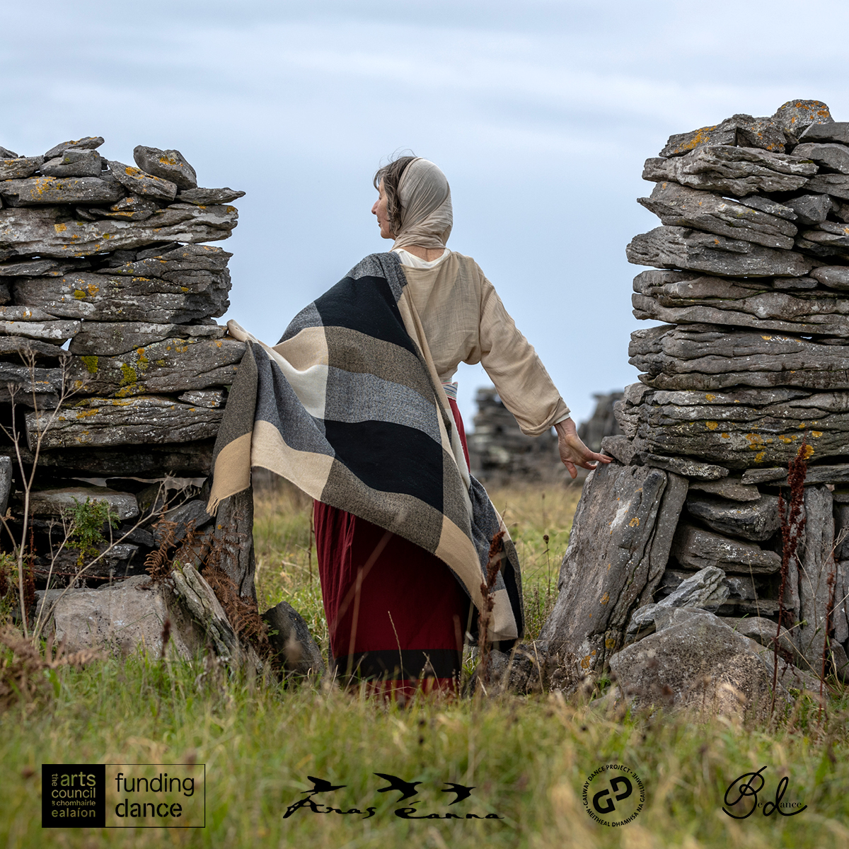

Síreacht agus Sult 12 – 31st October
Bernadette Divilly, dance artist in residence in collaboration with lens based visual artist Cormac Coyne will exhibit in Áras Éanna Arts Centre in October 2024. The exhibition will be launched by Professor Rióna Ní Fhrighil on Saturday 12th of October, and will run for the remainder of the month.
More information here.

_________________________________________________________

Start a Social Enterprise Business Course 2024
Do you have an idea for social or environmental change? Apply for the 2024 Start a Social Enterprise Business Course!
Offered by Rethink Ireland in partnership with IPB Insurance, this free six-week online course provides a solid foundation for new social enterprises. The carefully designed modules dive into essential business skills, finance basics, developing a social mission, and how to legally establish a social enterprise.
Applications are open until 1pm, Friday 27th September. Apply today!
________________________________________________________
Failte Ireland Invites Creative Events Listings
Do you have a great event happening in Ireland this year? Promote it with Fáilte Ireland!
Advertise your upcoming events to irelandwestinfo@failteireland.ie and
Register & add your events through the events portal linked to Discover Ireland.
www.FailteIrelandEvents.ie/
_________________________________________________________
Galway City Council Night-Time Economy & This is Galway Invites Events Listings
Do you have a great event happening from 6pm? Promote it with This is Galway!
Simply email Kate.Howard@galwaycity.ie with a brief summary of your event and receive a special code to access the events page, where you can add all the necessary details and promote your offering. Free.
More information.
_________________________________________________________
Send us your Listings & News
We can share your posts! Email up to 50 words to arts@galwaycity.ie with a high-resolution landscape image. Images and text may be edited to fit.
___________________________________________________________________
GCC Arts Office Social Media
Facebook: www.facebook.com/ArtsOfficeGalwayCity
Instagram: @artsofficegalwaycity
X: @cityartsgalway
___________________________________________________________________
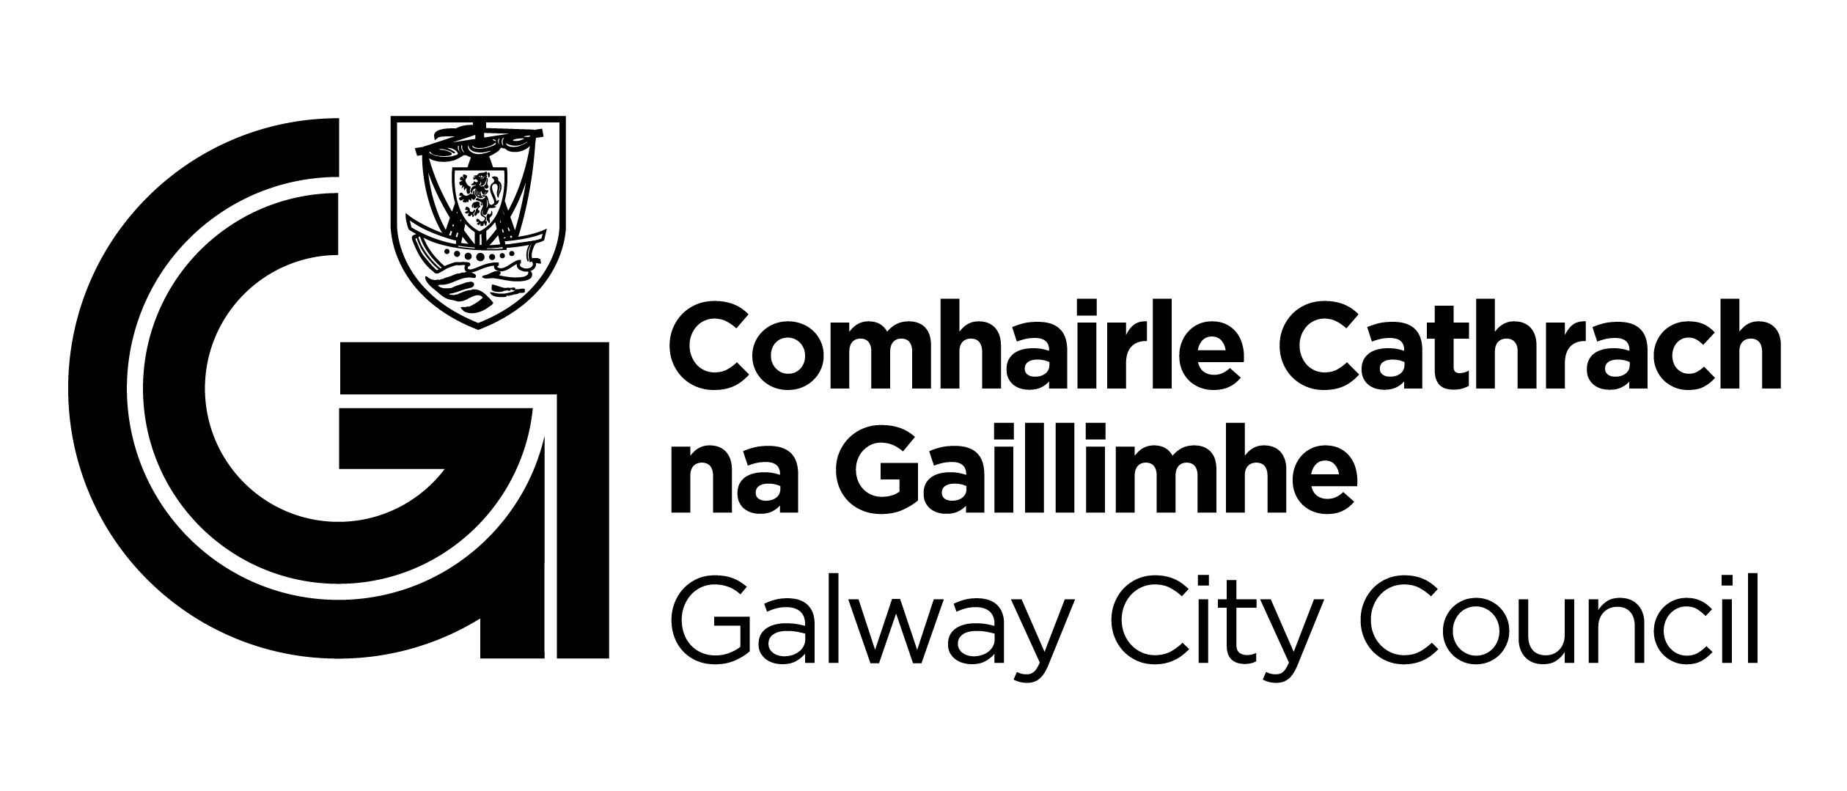
You are getting this email because you are on the Galway City Council Arts Office mailing list. Unsubscribe by emailing arts@galwaycity.ie and ask to be removed.

