**____________________________________________________________**

**Title: Galway City Council Arts Newsletter Late October 2024**

Welcome to this fortnight’s newsletter. Below you will find Galway City Council Arts Office Content, External Content, News, Opportunities, and Listings/Events.

Happy reading, from the Galway City Arts Office team.

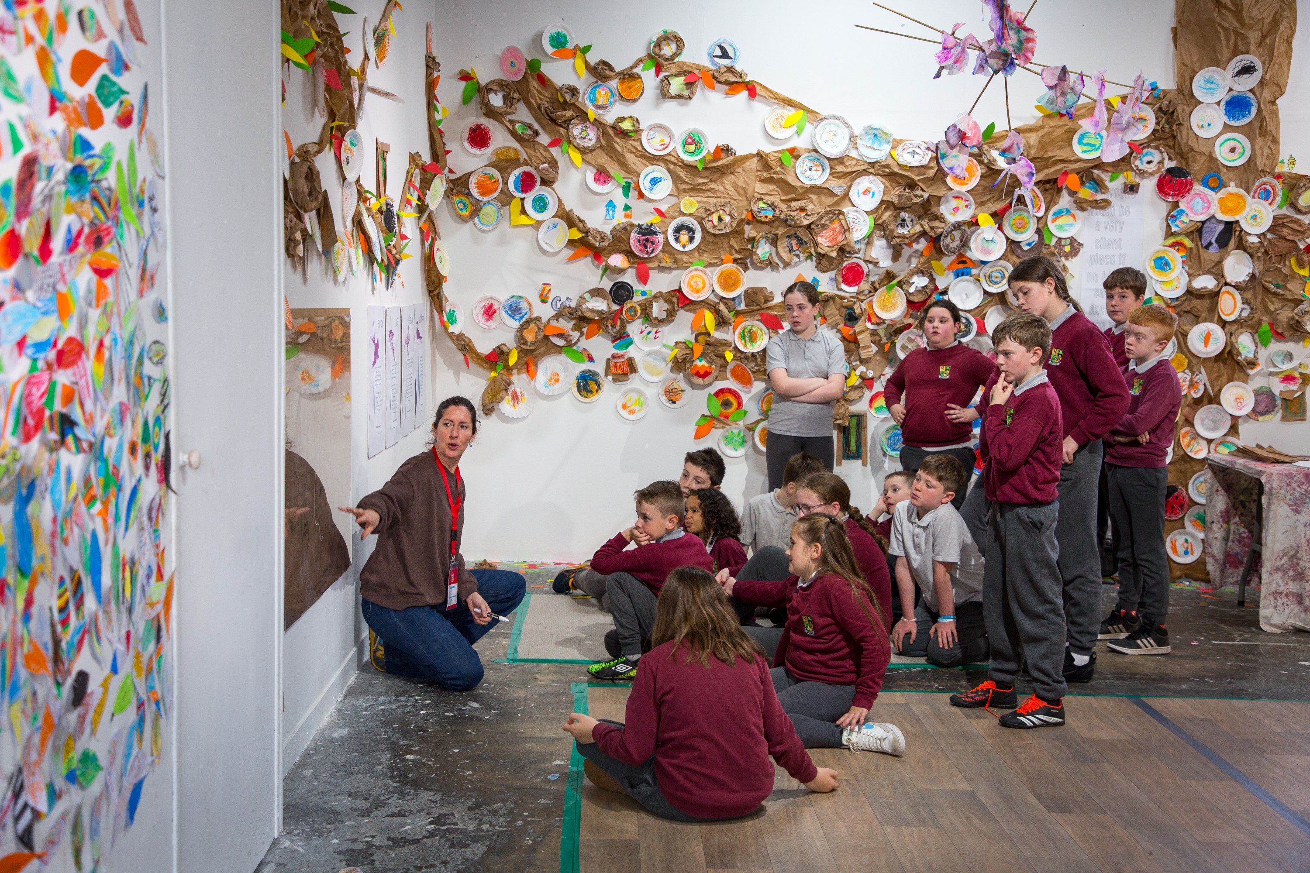

Baboro Job Listing

We're hiring a School Projects Manager and are doing one more push before the deadline next Thursday,

Further info: [https://www.baboro.ie/news-events/join-our-team-school-projects-manager](https://eur04.safelinks.protection.outlook.com/?url=https%3A%2F%2Fscanner.topsec.com%2F%3Fd%3D1122%26r%3Dshow%26u%3Dhttps%253A%252F%252Fwww.baboro.ie%252Fnews-events%252Fjoin-our-team-school-projects-manager%26t%3D72bf76ad63da3cf48d38c10d6fa17d23512f5aa7&data=05%7C02%7Carts%40galwaycity.ie%7C2824b828e4be45122a5e08dcef6882b9%7Cd7a0f67a0cae4b21abdbb5186f6e07a9%7C0%7C0%7C638648479647585987%7CUnknown%7CTWFpbGZsb3d8eyJWIjoiMC4wLjAwMDAiLCJQIjoiV2luMzIiLCJBTiI6Ik1haWwiLCJXVCI6Mn0%3D%7C0%7C%7C%7C&sdata=VXszDBdgj7OekS3Y3OKZlWhP0hL%2BkqbhS6s7p6cqj9M%3D&reserved=0)

**________________________________________________________________**

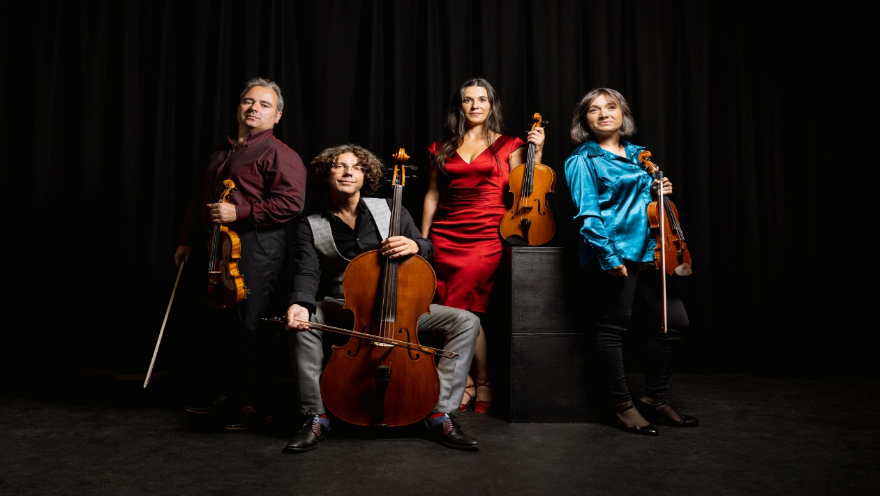

**Galway Music Residency**

Lunchtimes with Contempo Tuesday 5 November, 1:10pm at St Nicholas’ Collegiate Church

Galway Music Residency presents its penultimate programme in its musical journey through the Celtic Calendar. GMR’s International Guest Artist, Sander Saarmets, will join ConTempo for a Samhain themed programme. Free, all are welcome. No booking required.

Further info: [www.thegalwaymusicresidency.ie](https://www.thegalwaymusicresidency.ie)

**Galway Film Society**

The new season of the Galway Film Society is in full swing! Join us on Sundays at 8pm or Mondays at 6:30pm for our screenings of critically acclaimed films in Pálás cinema. Upcoming films: *Black Dog*, *Small Things Like These* and *Blackbird Blackbird Blackberry*. Book tickets on [palas.ie](https://eur04.safelinks.protection.outlook.com/?url=https%3A%2F%2Fscanner.topsec.com%2F%3Fd%3D1122%26r%3Dshow%26u%3Dhttp%253A%252F%252Fpalas.ie%26t%3Dcf607836a48cd4ebb29a381a4a32dbae05f6572d&data=05%7C02%7Carts%40galwaycity.ie%7C15dfea27cf1d4c66a91f08dceeb47369%7Cd7a0f67a0cae4b21abdbb5186f6e07a9%7C0%7C0%7C638647706010912470%7CUnknown%7CTWFpbGZsb3d8eyJWIjoiMC4wLjAwMDAiLCJQIjoiV2luMzIiLCJBTiI6Ik1haWwiLCJXVCI6Mn0%3D%7C0%7C%7C%7C&sdata=Tu%2FvFdVBhGvYeC3ZN%2B5%2BwykoPVNBpZcmk1oNgyuG1BI%3D&reserved=0).

Further information: [palas.ie](https://eur04.safelinks.protection.outlook.com/?url=https%3A%2F%2Fscanner.topsec.com%2F%3Fd%3D1122%26r%3Dshow%26u%3Dhttp%253A%252F%252Fpalas.ie%26t%3Dcf607836a48cd4ebb29a381a4a32dbae05f6572d&data=05%7C02%7Carts%40galwaycity.ie%7C15dfea27cf1d4c66a91f08dceeb47369%7Cd7a0f67a0cae4b21abdbb5186f6e07a9%7C0%7C0%7C638647706010912470%7CUnknown%7CTWFpbGZsb3d8eyJWIjoiMC4wLjAwMDAiLCJQIjoiV2luMzIiLCJBTiI6Ik1haWwiLCJXVCI6Mn0%3D%7C0%7C%7C%7C&sdata=Tu%2FvFdVBhGvYeC3ZN%2B5%2BwykoPVNBpZcmk1oNgyuG1BI%3D&reserved=0).

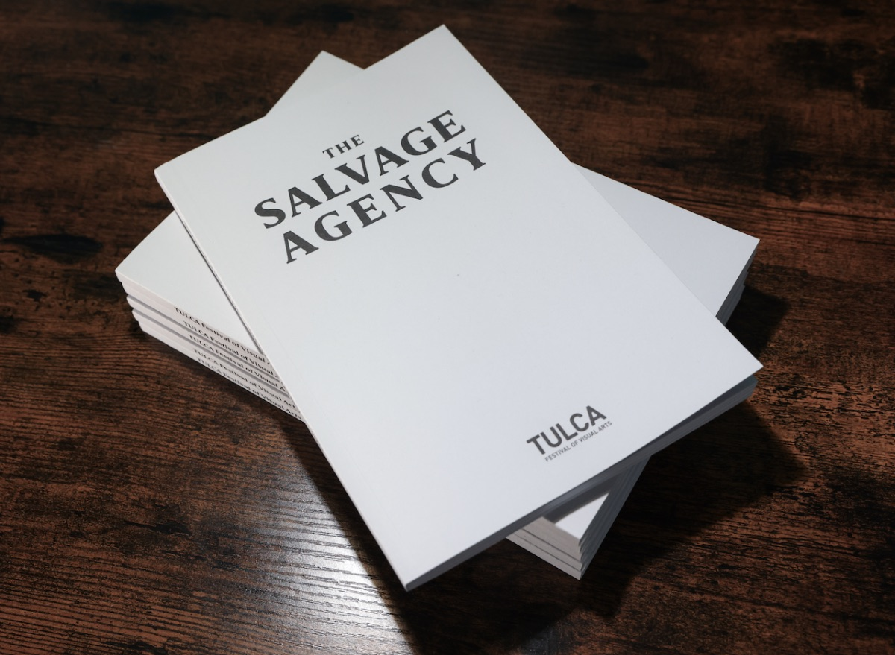

**Tulca New Publication – The Salvage Agency**

TULCA Publishing is pleased to announce the release of its latest publication as part of this year's TULCA Festival of Visual Arts programme.  
  
**The Salvage Agency** considers the agency and role of art in contemporary ecology and environmental action. Galway, on the edge of the northeast Atlantic, is a unique location for a heightened awareness of what is at stake. Explorations of landscape, seascape and nature, public space, colonial history, political structures, the TULCA Publishing is pleased to announce the release of its latest publication as part of this year's TULCA Festival of Visual Arts programme.  
  
Further info:[www.tulca.ie](https://www.tulca.ie)

**_____________________________________________________________**

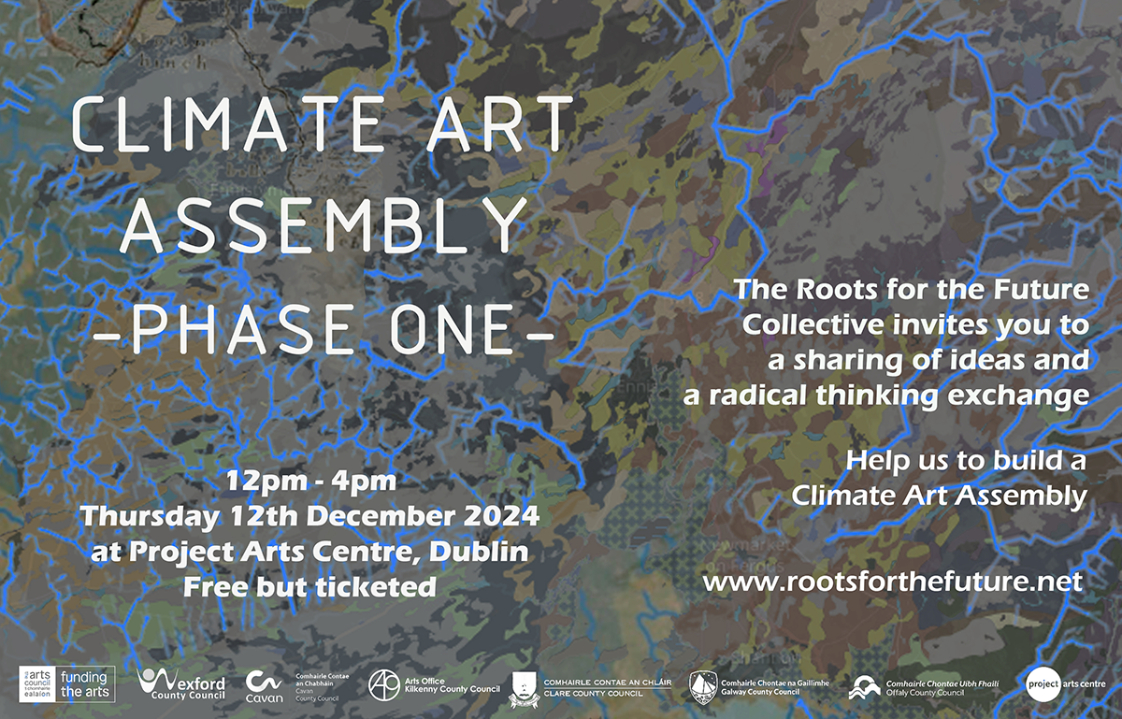

**Climate Art Assembly**

We would like to invite you to a public sharing of work from our collective. The **Climate Art Assembly Phase One** at Project Arts Centre place on **Thursday December 12th between 12 - 4pm.** If you live closer to Wexford you might wish to attend an earlier meeting happening in Cow House Studios on the 6th December 2-4pm

We would be thrilled if you could join us to see the work and ideas that have emerged, and to contribute to the discussion around where it is heading next.

Date: December

Time: 12.00 - 4.00 pm  
Location: Project Arts Centre, Dublin

More info: Climate Art Assembly and Roots For The Future [HERE.](https://eur04.safelinks.protection.outlook.com/?url=https%3A%2F%2Fscanner.topsec.com%2F%3Fd%3D1122%26r%3Dshow%26u%3Dhttps%253A%252F%252Fwww.rootsforthefuture.net%252F%26t%3Dab29a4e64e52c54a62427bd6ac3be737a2cb0d96&data=05%7C02%7Carts%40galwaycity.ie%7C66e26af038c747e9aef208dcf2a08fb5%7Cd7a0f67a0cae4b21abdbb5186f6e07a9%7C0%7C0%7C638652018661151136%7CUnknown%7CTWFpbGZsb3d8eyJWIjoiMC4wLjAwMDAiLCJQIjoiV2luMzIiLCJBTiI6Ik1haWwiLCJXVCI6Mn0%3D%7C0%7C%7C%7C&sdata=wOnXEjn2iyeupX26IVMyFBu3jBuey1wlfOe3I4U7D8c%3D&reserved=0)

**_____________________________________________________________**

**PRESS RELEASE – 3 Kinds of Music**

Galway Music Residency presents its renowned multi-genre series once again this winter in the iconic Mick Lally Theatre. This popular series is co-curated by Galway Music Residency’s International Resident Guest Artist for 2024, Estonian Electronic Artist Sander Saarmets, and Galway Artists and Composers Aengus Hackett and Anna Mullarkey.

**Date**: 9th November & 14th December 2024  
**Time:** 3.00 pm  
**Location:** Mick Lally Theatre

**More Info**: [www.galwaymusicresidency.ie](https://www.galwaymusicresidency.ie)

**___________________________________________________________________**



**Job Opportunity at Ardan**

Ardán is Hiring an Event Manager for FíS Summits 2025

Ardán is inviting expressions of interest for the role of Event Manager to deliver its annual FÍS Summits in Galway City in February and April 2025.The successful candidate will work with Ardán’s Event Programmers and Comms and Marketing Executive to manage the events.

Further Info: [https://ardan.ie/event/ardan-is-hiring-an-event-manager-for-fis-summits-2025/](https://eur04.safelinks.protection.outlook.com/?url=https%3A%2F%2Fscanner.topsec.com%2F%3Fd%3D1122%26r%3Dshow%26u%3Dhttps%253A%252F%252Fardan.ie%252Fevent%252Fardan-is-hiring-an-event-manager-for-fis-summits-2025%252F%26t%3D7b8f7876eef4ffcba68d150a64dede94c967d0f4&data=05%7C02%7Carts%40galwaycity.ie%7C3f3300aeb5974f2fa6a508dceeead893%7Cd7a0f67a0cae4b21abdbb5186f6e07a9%7C0%7C0%7C638647939817031946%7CUnknown%7CTWFpbGZsb3d8eyJWIjoiMC4wLjAwMDAiLCJQIjoiV2luMzIiLCJBTiI6Ik1haWwiLCJXVCI6Mn0%3D%7C40000%7C%7C%7C&sdata=RiGpueQshwxQaNR01K%2B8T5tV%2Fc2aNgxa5eWcBKEXtf8%3D&reserved=0)

**_____________________________________________________________**

**Safe to Create: Disability Awareness Training**

Aimed mainly at employers working in the arts and creative sectors in Ireland, this training session looks at disability in an Irish context, language, legislation, medical vs social models of disability, positive business case for disability, challenging misconceptions, reasonable accommodations and disclosure.Facilitated by Employers for Change’s Programme Manager, Anna Boda (she/her), this training will give you a better understanding of the diversity of disability, existing barriers and how you can be a disability champion in your workplace.The session takes place online on Wed 23 October and will be approx. 1 hour 30 mins, including time for questions. Live captioning will be provided.

Further Info: [https://www.eventbrite.ie/e/safe-to-create-disability-awareness-training-online-tickets-1007515946317?aff=oddtdtcreator](https://eur04.safelinks.protection.outlook.com/?url=https%3A%2F%2Fscanner.topsec.com%2F%3Fd%3D1122%26r%3Dshow%26u%3Dhttps%253A%252F%252Fwww.eventbrite.ie%252Fe%252Fsafe-to-create-disability-awareness-training-online-tickets-1007515946317%253Faff%253Doddtdtcreator%26t%3D8d4da6e3c1ea226b2ff9aefad0cdab1be66329af&data=05%7C02%7Carts%40galwaycity.ie%7C3250fd17f45e45eed48308dceeb169a5%7Cd7a0f67a0cae4b21abdbb5186f6e07a9%7C0%7C0%7C638647692987861094%7CUnknown%7CTWFpbGZsb3d8eyJWIjoiMC4wLjAwMDAiLCJQIjoiV2luMzIiLCJBTiI6Ik1haWwiLCJXVCI6Mn0%3D%7C0%7C%7C%7C&sdata=89TFPtaFNIBIxRAKDmsJT5YTmhXx8B%2FYlDNMz5gQkBI%3D&reserved=0)

**_________________________________________________________**

**Failte Ireland Invites Creative Events Listings**

Do you have a great event happening in Ireland this year? Promote it with Fáilte Ireland!

Advertise your upcoming events to [irelandwestinfo@failteireland.ie](mailto:irelandwestinfo@failteireland.ie) and

Register & add your events through the events portal linked to Discover Ireland.

www.FailteIrelandEvents.ie/

**_________________________________________________________**

**Galway City Council Night-Time Economy & This is Galway Invites Events Listings**

Do you have a great event happening from 6pm? Promote it with This is Galway!

Simply email [Kate.Howard@galwaycity.ie](mailto:Kate.Howard@galwaycity.ie) with a brief summary of your event and receive a special code to access the events page, where you can add all the necessary details and promote your offering. Free.

[More information.](https://thisisgalway.ie/nighttime/)

**_________________________________________________________**

**Send us your Listings & News**

We can share your posts! Email up to 50 words to [arts@galwaycity.ie](mailto:arts@galwaycity.ie) with a high-resolution landscape image. Images and text may be edited to fit.

**___________________________________________________________________**

**GCC Arts Office Social Media**

Facebook: [www.facebook.com/ArtsOfficeGalwayCity](https://scanner.topsec.com/?d=1122&r=show&u=https%3A%2F%2Fwww.facebook.com%2FArtsOfficeGalwayCity&t=a6b33347cd65717d4a93047cc8b1c9f7c5d8a4c9)

Instagram: [@artsofficegalwaycity](https://www.instagram.com/artsofficegalwaycity?utm_source=ig_web_button_share_sheet&igsh=ZDNlZDc0MzIxNw==)

X: [@cityartsgalway](https://x.com/CityArtsGalway?s=20)

**___________________________________________________________________**

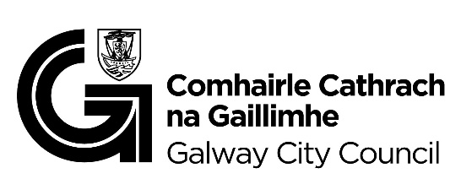

You are getting this email because you are on the Galway City Council Arts Office mailing list. Unsubscribe by emailing [arts@galwaycity.ie](mailto:arts@galwaycity.ie) and ask to be removed.