Galway City Council Early August Arts Newsletter
Welcome to the Arts Office newsletter. This fortnight’s offering includes a funding call out, the launch of Craft Month, a Moth and Butterfly event, and an exhibition by artist Áine Phillips.
Happy reading, from the Galway City Arts Office team
_____________________________________________________________
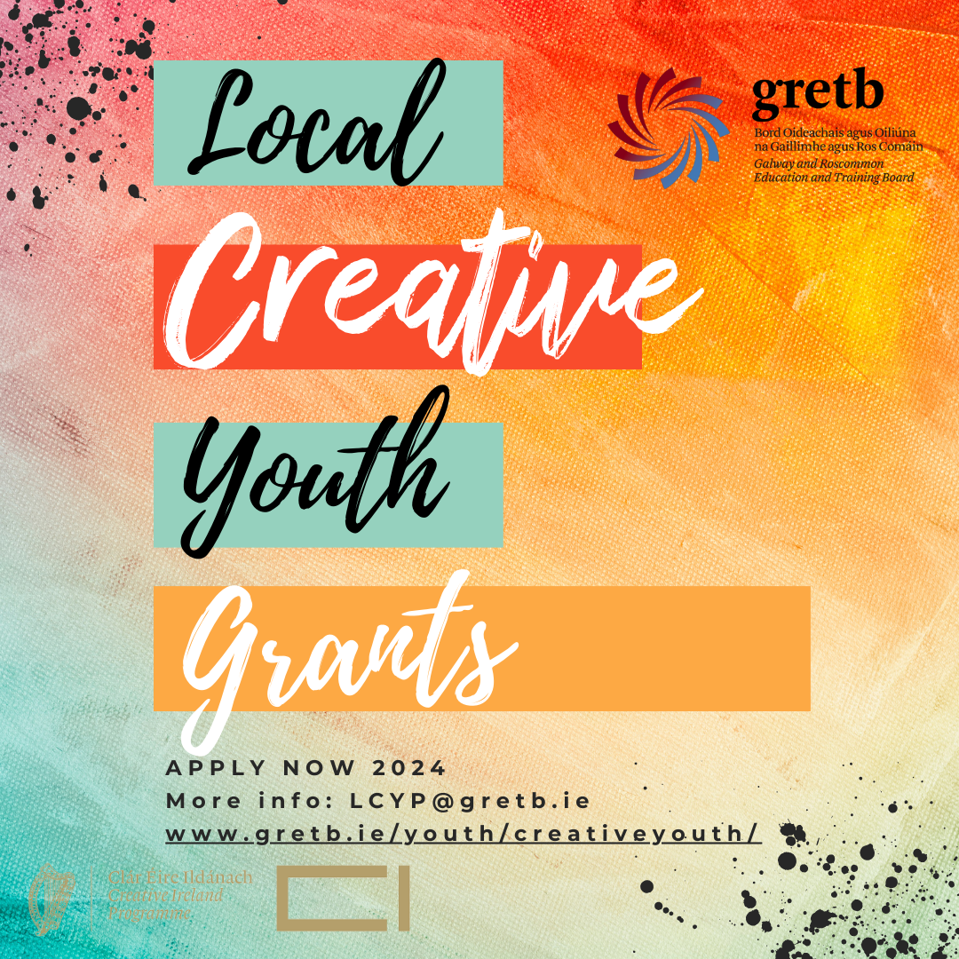

Local Creative Youth Grants with GRETB

Galway and Roscommon Local Creative Youth Partnership (LCYP), administered by the Galway and Roscommon Education and Training Board (GRETB) has grant funding available in 2024 under a Creative Youth Grant Scheme. The scheme supports the development of child and youth creativity in Galway and Roscommon.

Maximum Grant Available: €3000

More information here

_____________________________________________________________

Arts Council Visual Artists Workspace Scheme

Applications for the Arts Council’s Visual Artists Workspace Scheme open on the 13 August, with a closing date of 12 September 2024.

The purpose of the Visual Artists Workspace Scheme is to support artists’ workspaces throughout the country to provide the best possible working environment for visual artists and, where feasible, to enable a level of subsidy for the artists working in these spaces.

Artists who are seeking a letter of support should reach out to the Arts Office by emailing arts@galwaycity.ie as early as possible. Please contact us at least two weeks in advance of your application.

More information about the scheme here

_____________________________________________________________
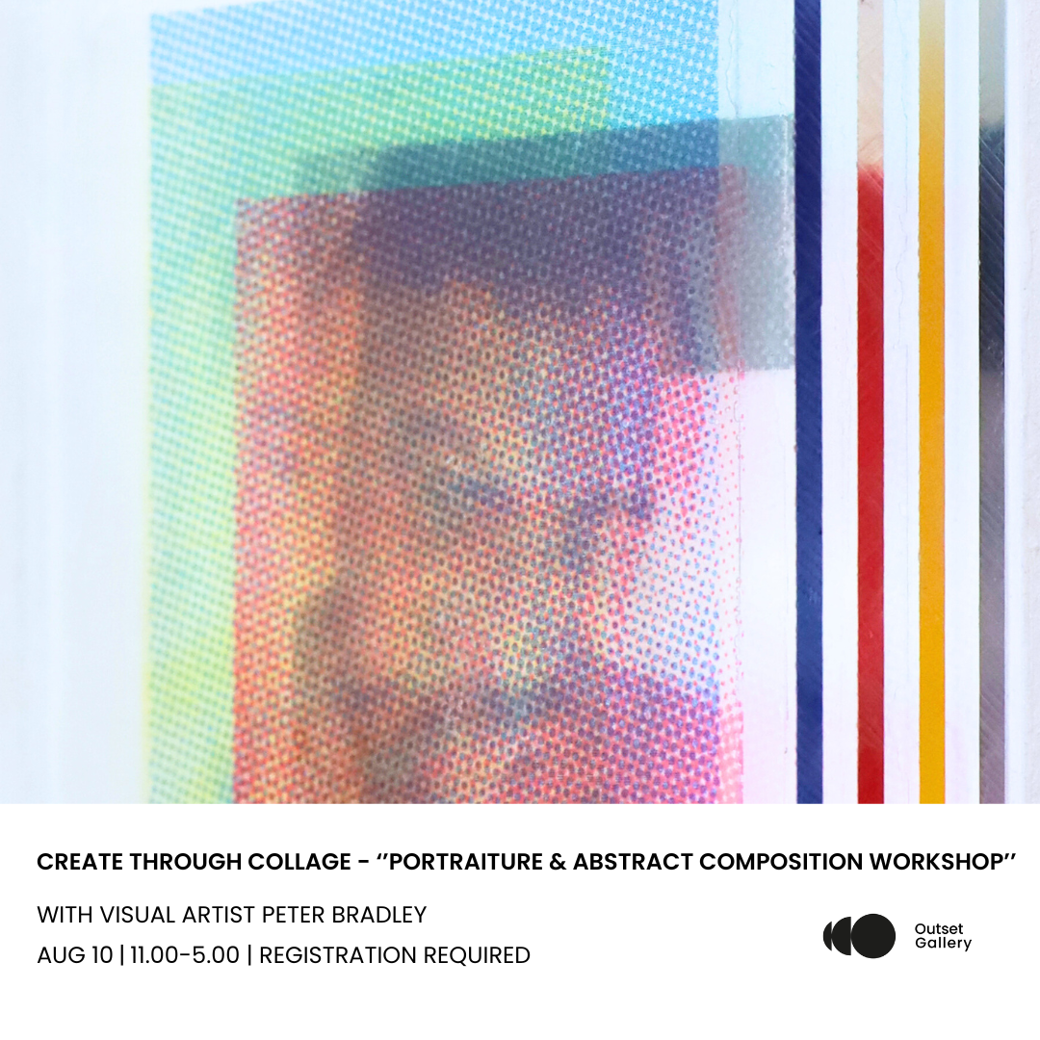

Create Through Collage Workshop with Visual Artist Peter Bradley

In this full-day workshop, participants will delve into the exciting techniques of mixed media collage, guided by Peter Bradley, whose work was featured in the Galway International Arts Festival 2024. The session will cover portraiture and abstract composition, encouraging participants to think outside the box and push the boundaries of traditional image-making.

More information here

_____________________________________________________________
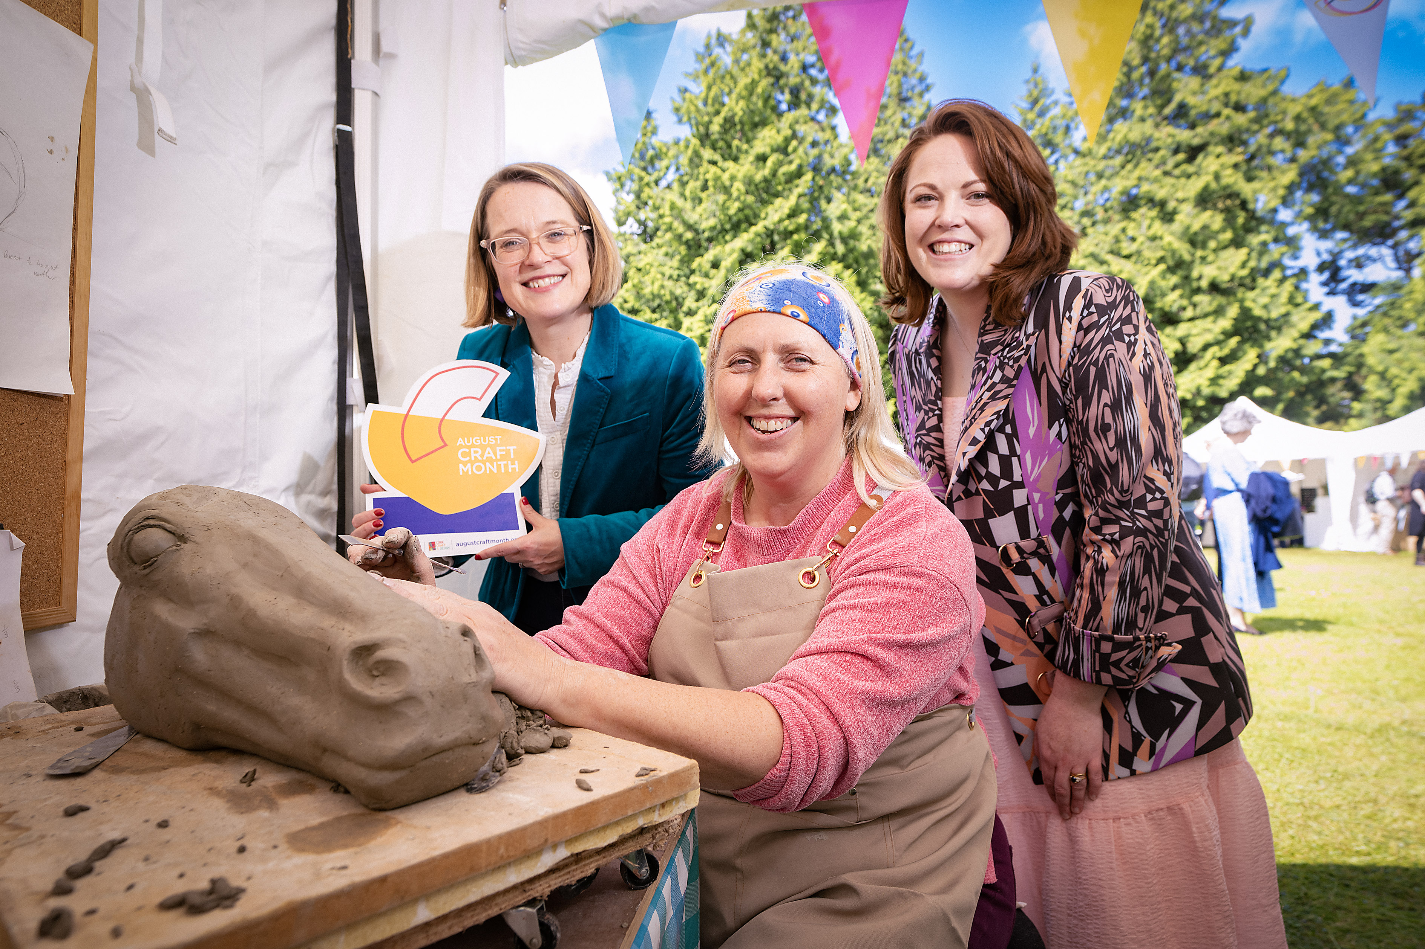

August Craft Month 2024: Ireland’s Biggest Celebration of Craft

August Craft Month, a month-long celebration of local craft across the island of Ireland launches with a host of exciting events nationally. People can enjoy creative craft celebrations on their doorstep, as well as hit the road on a craft-inspired adventure or staycation. The programme provides unmissable opportunities to experience, participate in, support, buy and learn about the local stand-out craft sector.

More information here

_____________________________________________________________
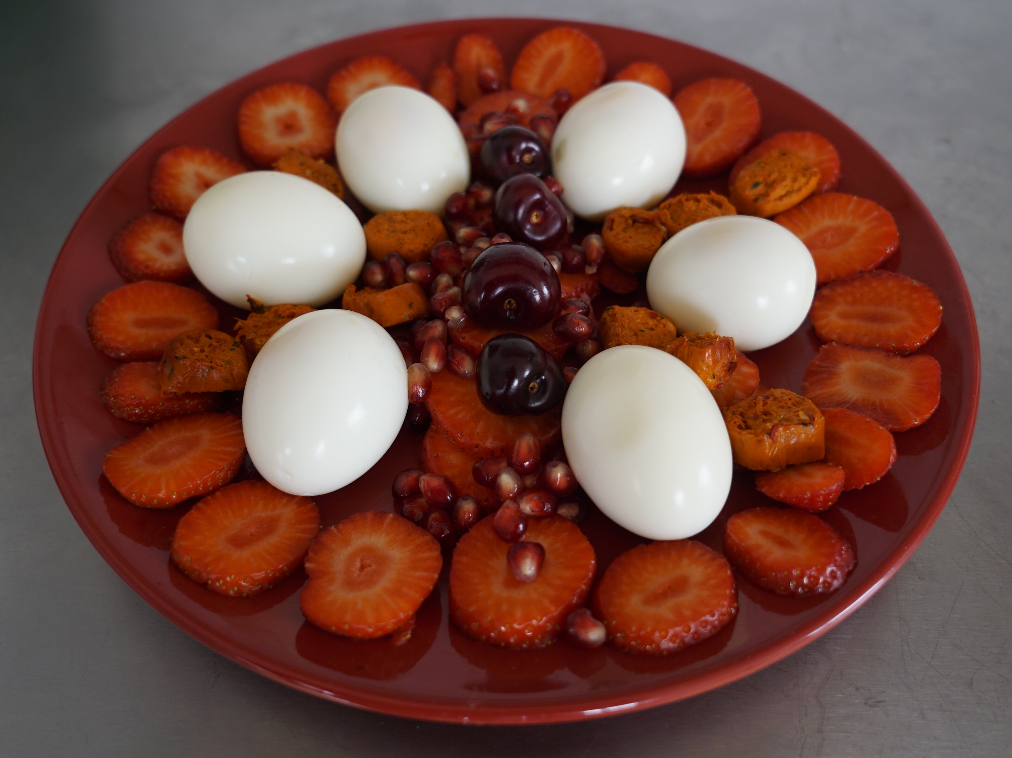

Domestic Bodies by Áine Phillips at 126 Gallery

126 Artist-Run Gallery presents Domestic Bodies, a series of performative installations by Áine Phillips with collaborators Ella Bertilsson and Helena Walsh exploring themes of home, shelter and sustenance in domestic space. The works aim to push the limits and potentials of domestic things to create metaphors for female subjectivity and experience. The exhibition confronts the pleasures, discontents and struggles of habitation: finding, keeping, and the meaning of home.

Show Runs: 7 - 25 August
More Information here

_________________________________________________________
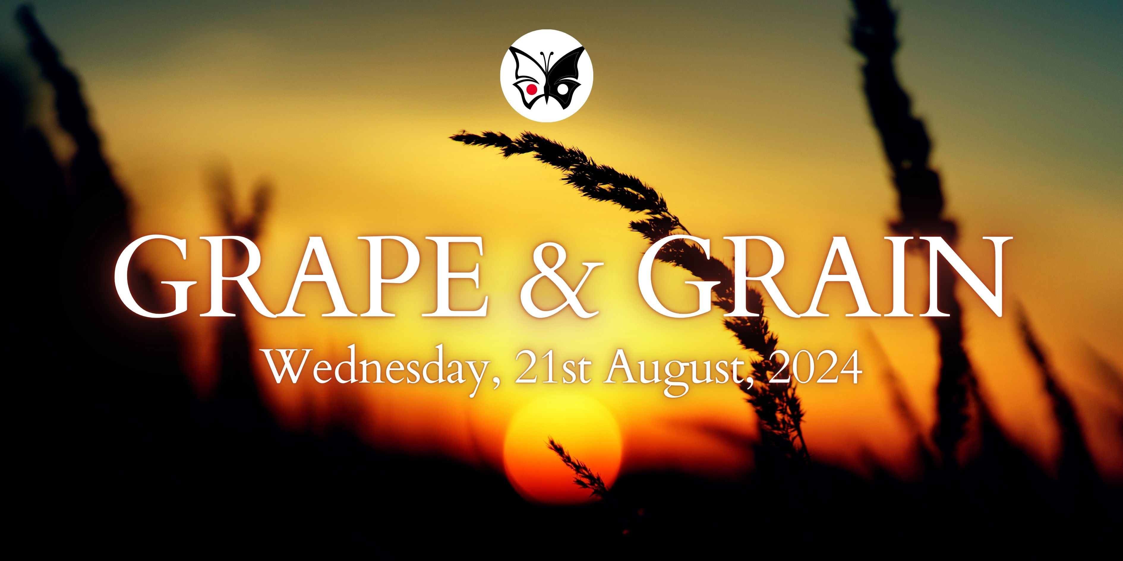

Moth and Butterfly Present GRAPE AND GRAIN

Moth & Butterfly presents a special night of storytelling and improvisation, on the theme of Grape and Grain, featuring top-class performers, held in the atmospheric location of Rouge Restaurant in the heart of Galway City.

Rouge Galway 38 Dominic St
21 August, 2024
Doors 7.00 for seating/refreshments. 7.30 show.
Tïckets are €15 online, via Eventbrite

More Information here

_________________________________________________________
Failte Ireland Invites Creative Events Listings
Do you have a great event happening in Ireland this year? Promote it with Fáilte Ireland!
Advertise your upcoming events to irelandwestinfo@failteireland.ie and
Register & add your events through the events portal linked to Discover Ireland.
www.FailteIrelandEvents.ie/
_________________________________________________________
Send us your Listings & News
We can share your posts! Email up to 50 words to arts@galwaycity.ie with a high-resolution landscape image. Images and text may be edited to fit.
___________________________________________________________________
GCC Arts Office Social Media
Facebook: www.facebook.com/ArtsOfficeGalwayCity
Instagram: @artsofficegalwaycity
X: @cityartsgalway
___________________________________________________________________
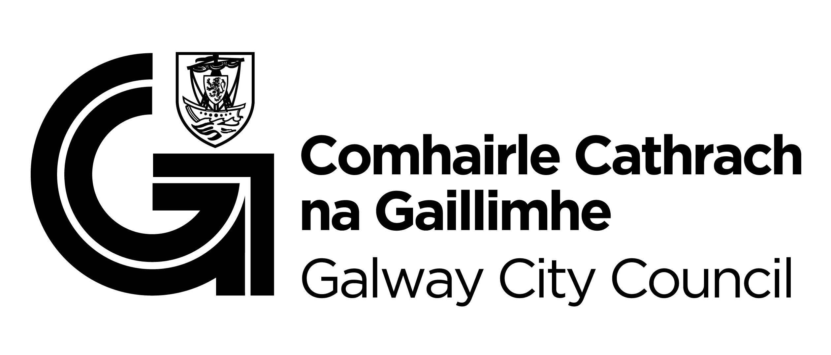

You are getting this email because you are on the Galway City Council Arts Office mailing list. Unsubscribe by emailing arts@galwaycity.ie and ask to be removed.

