Galway City Council Arts Newsletter Early September
Welcome to this fortnight’s newsletter. Below, you will find opportunities, events, and useful information for arts organisations and creative practitioners based in Galway City.
Happy reading, from the Galway City Arts Office team.
_____________________________________________________________
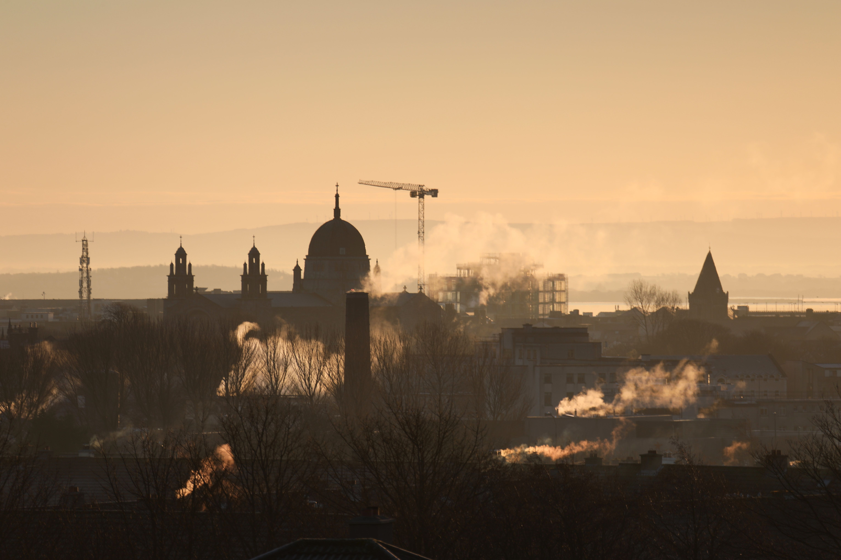

Cultural Partnerships Call for Proposals

Galway City Council is inviting applications from suitably qualified and experienced organisations in Galway City to develop and deliver new programs, projects, or initiatives that will deliver outcomes on the following objectives:
- Creative Children: Develop creative opportunities for/with children and young people.
- Creative Communities: Enable communities to engage and participate.
- Creative City Region: Create opportunities for excellent, diverse, and visible contributions from artists and creative producers in Galway City.

The funding available is €95,000, and it is anticipated that approximately five to six projects will receive support.

Applications close Monday 23rd September

More information here.
_____________________________________________________________
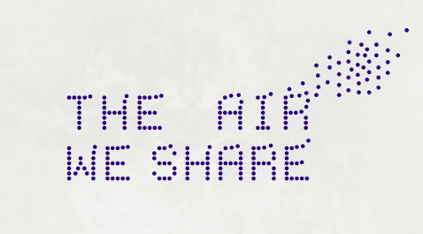

Galway Arts Centre Open Call for 3 Artists Residencies as part of The Air We Share

Galway Arts Centre is delighted to announce an open call for three significant artist-in-residence opportunities in Galway City. The residencies will respond to air pollution research, and engage with creative, climate, and community-driven solutions to air pollution as part of the climate action project, The Air We Share.

More information here.
_____________________________________________________________
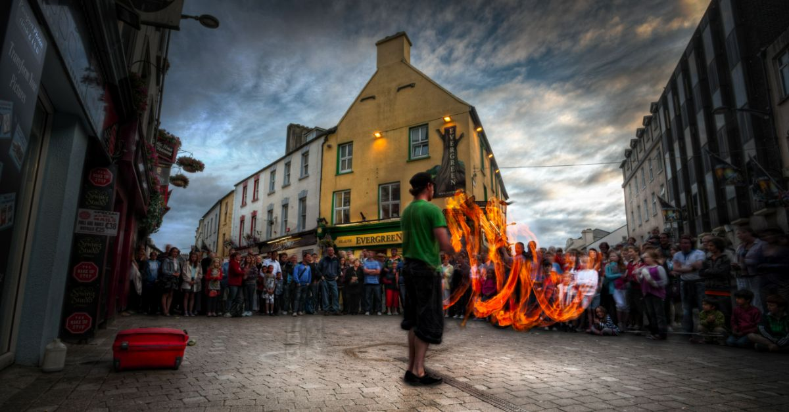

Galway by Night

Galway City Council, in partnership with This is Galway, is excited to announce a new pilot initiative to showcase and promote the city's vibrant night-time economy. A dedicated digital "What's On" guide serving as a central hub for all events and activities happening in Galway after 6pm. The This is Galway website itself will dynamically transition to a "Galway by Night" theme from 6pm onwards, highlighting the city's evening offerings.

To get involved, simply email Kate Howard, Galway's Night-Time Economy Advisor, at Kate.Howard@galwaycity.ie with a brief summary of your event. You will then receive a special code to access the events page, where you can add all the necessary details and promote your offering.

Experience Galway by Night

_____________________________________________________________
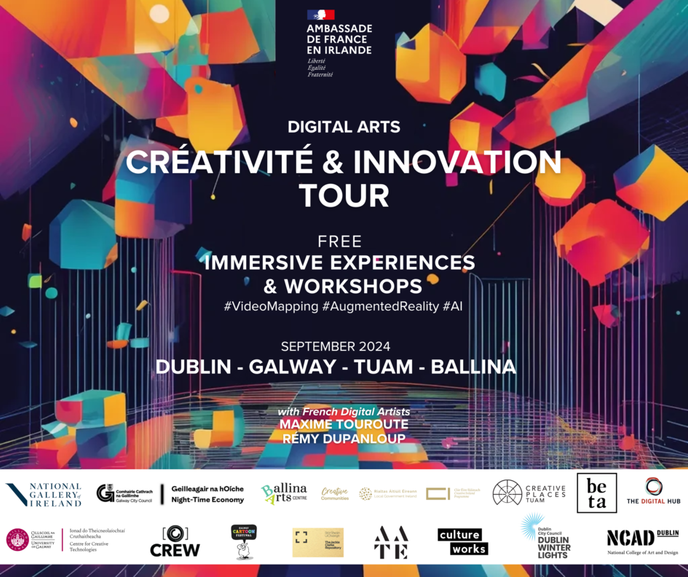

Save the Date: Free Immersive Experiences and Workshops

The Galway City Council Night-Time Economy, in partnership with the French Embassy in Ireland, invites you to an exciting showcase of French expertise in digital creativity through outdoor interactive installations and hands-on workshops on video mapping, augmented reality and AI, led by renowned French digital artists Maxime Touroute and Rémy Dupanloup. Workshops are designed for students and professionals from various cultural sectors.

September 25, 11am-5pm: Centre for Creative Technologies, University of Galway
September 26, 2pm-5pm: CREW, Wellpark Rd

More information and registration here.

_____________________________________________________________
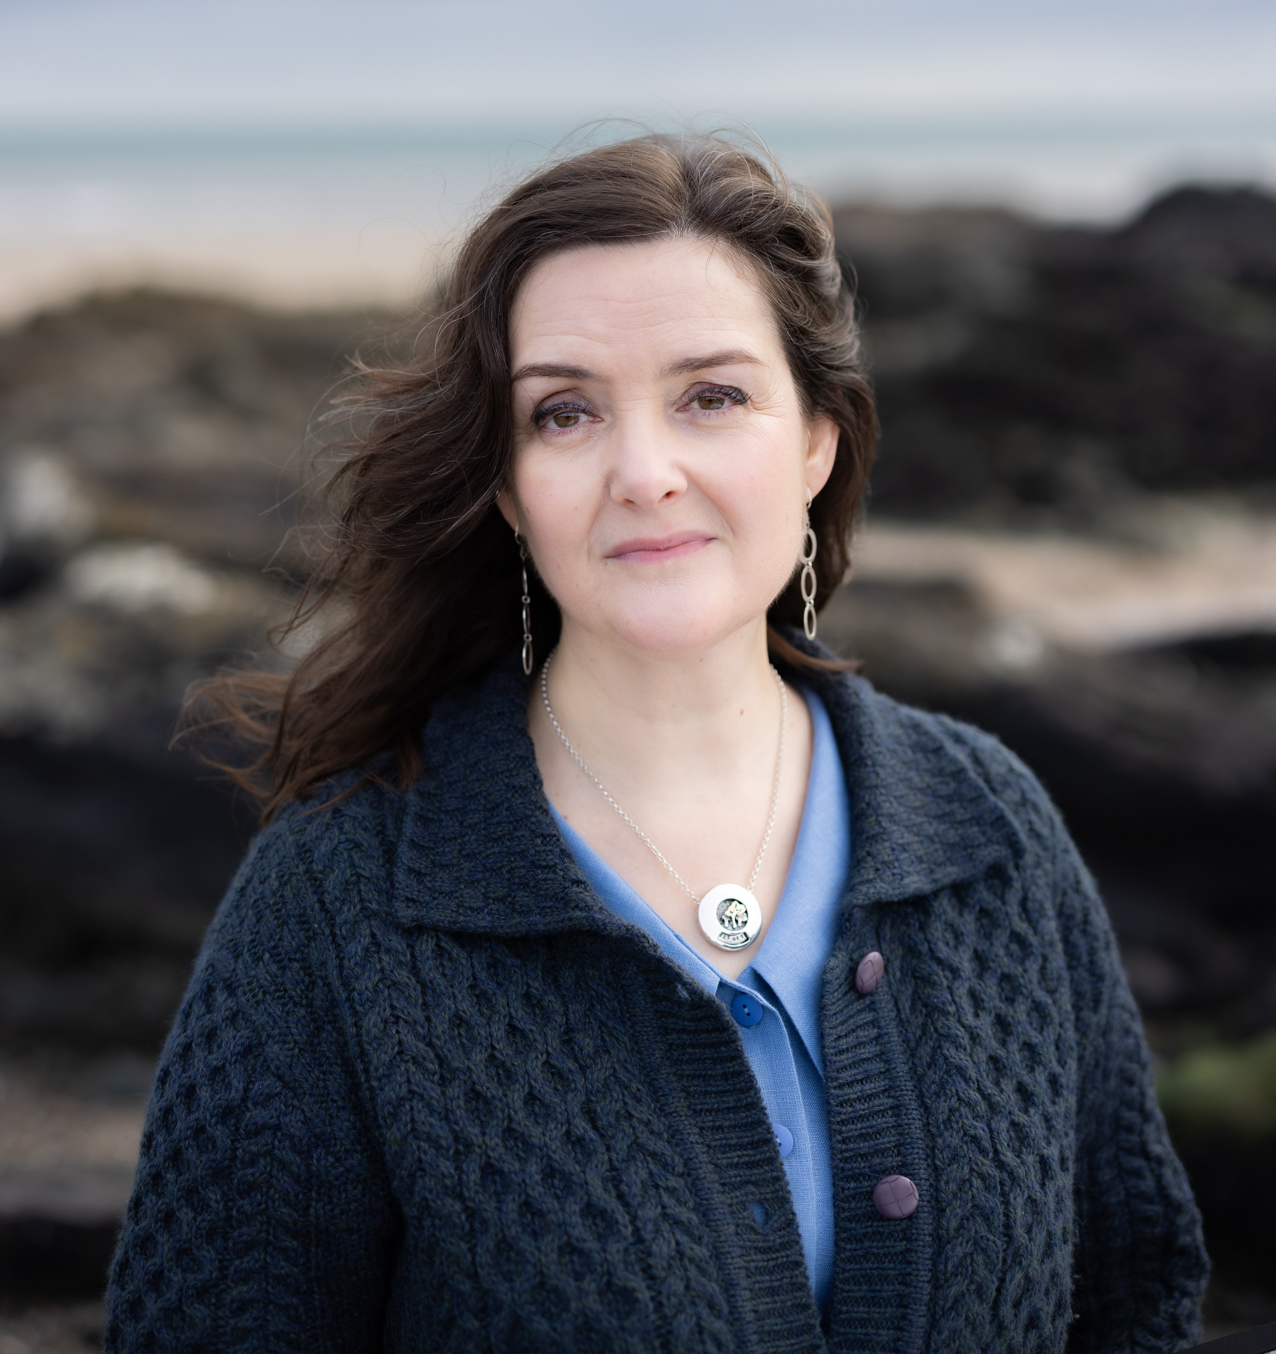

Nuala O'Connor to Judge 2024 Allingham Flash Fiction Competition

Entries in the 2024 Allingham Flash Fiction Competition will be judged by Galway based Nuala O’Connor, acclaimed author of SEABORNE and editor of the e-journal Splonk. Deadline for entries is 29 September.

More Information.

_________________________________________________________
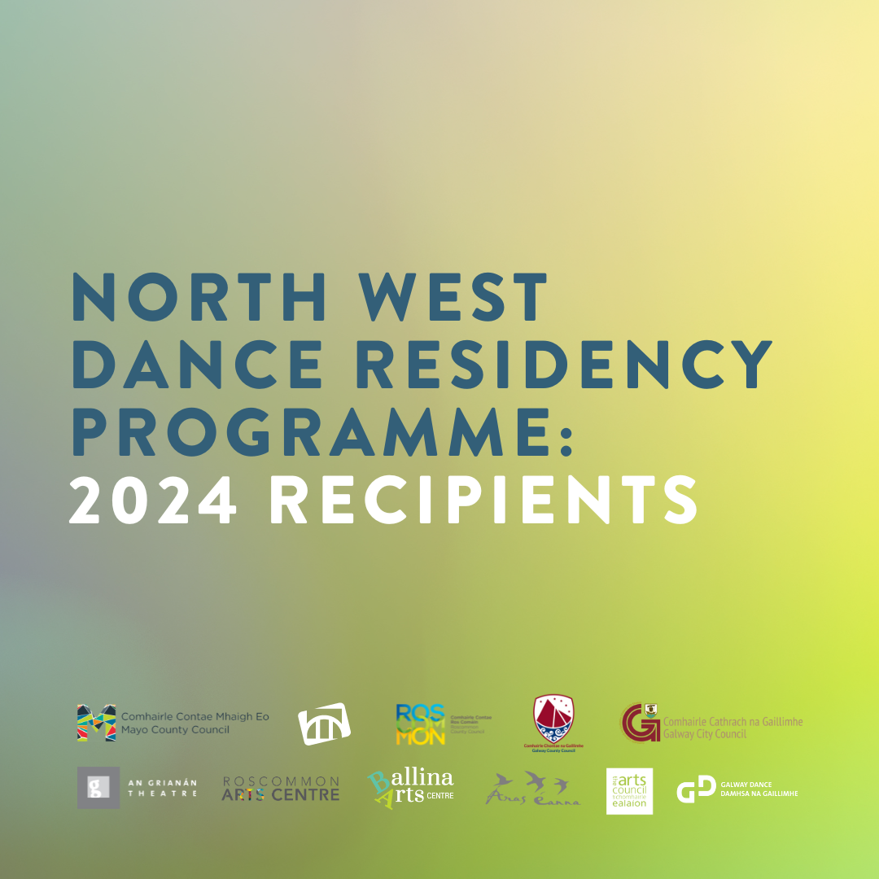

Recipients Announced: North West Dance Residency Programme

After hosting a call-out earlier this year, Galway Dance are delighted to announce the recipients of the North West Dance Residency Programme include local Galway Dancer Roberta Ceginskaite.

This programme is made possible through partnership with a number of local authority arts offices in Galway (city and county), Roscommon, Donegal and Mayo; and a number of venues.

More Information.

_________________________________________________________
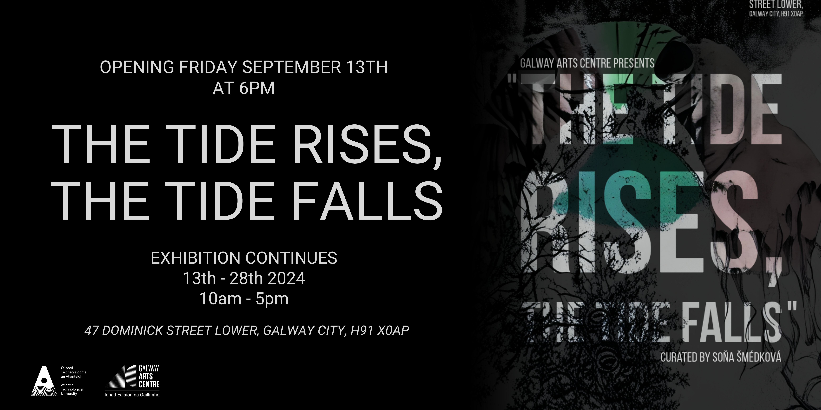

Opening reception of ‘The Tide Rises, The Tide Falls’

You are cordially invited to the opening reception of ‘The Tide Rises, The Tide Falls’ an MA Exhibition of the Department of Creative Arts & Media, curated by Soňa Smédková, which will be launched by Leonard Cleary, City Manager, on Friday 13th September at 6pm. The exhibition showcases work from students of the MA in Creative Practice programme at the Galway Arts Centre, Galway City.

The exhibition will be open Monday - Saturday from the 13th – 28th September, 10am – 5pm.

More Information.

_________________________________________________________
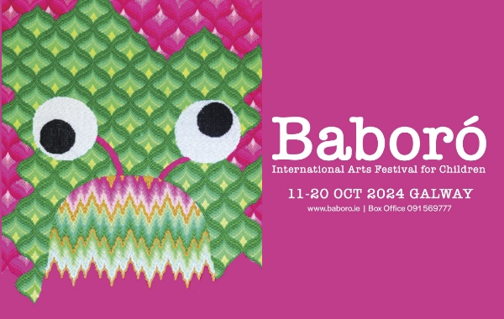

Baboró International Arts Festival for Children Programme

The Baboró team are excited to present a programme for all the senses in their most inclusive festival yet.

As well as a host of brilliant offerings from Irish artists, you can also expect fantastic shows for schools and families from Ireland, Scotland, England, Italy, Sweden, The Netherlands and Belgium - including two from Flanders, an area of Belgium making exceptional work for children.

More Information

_________________________________________________________
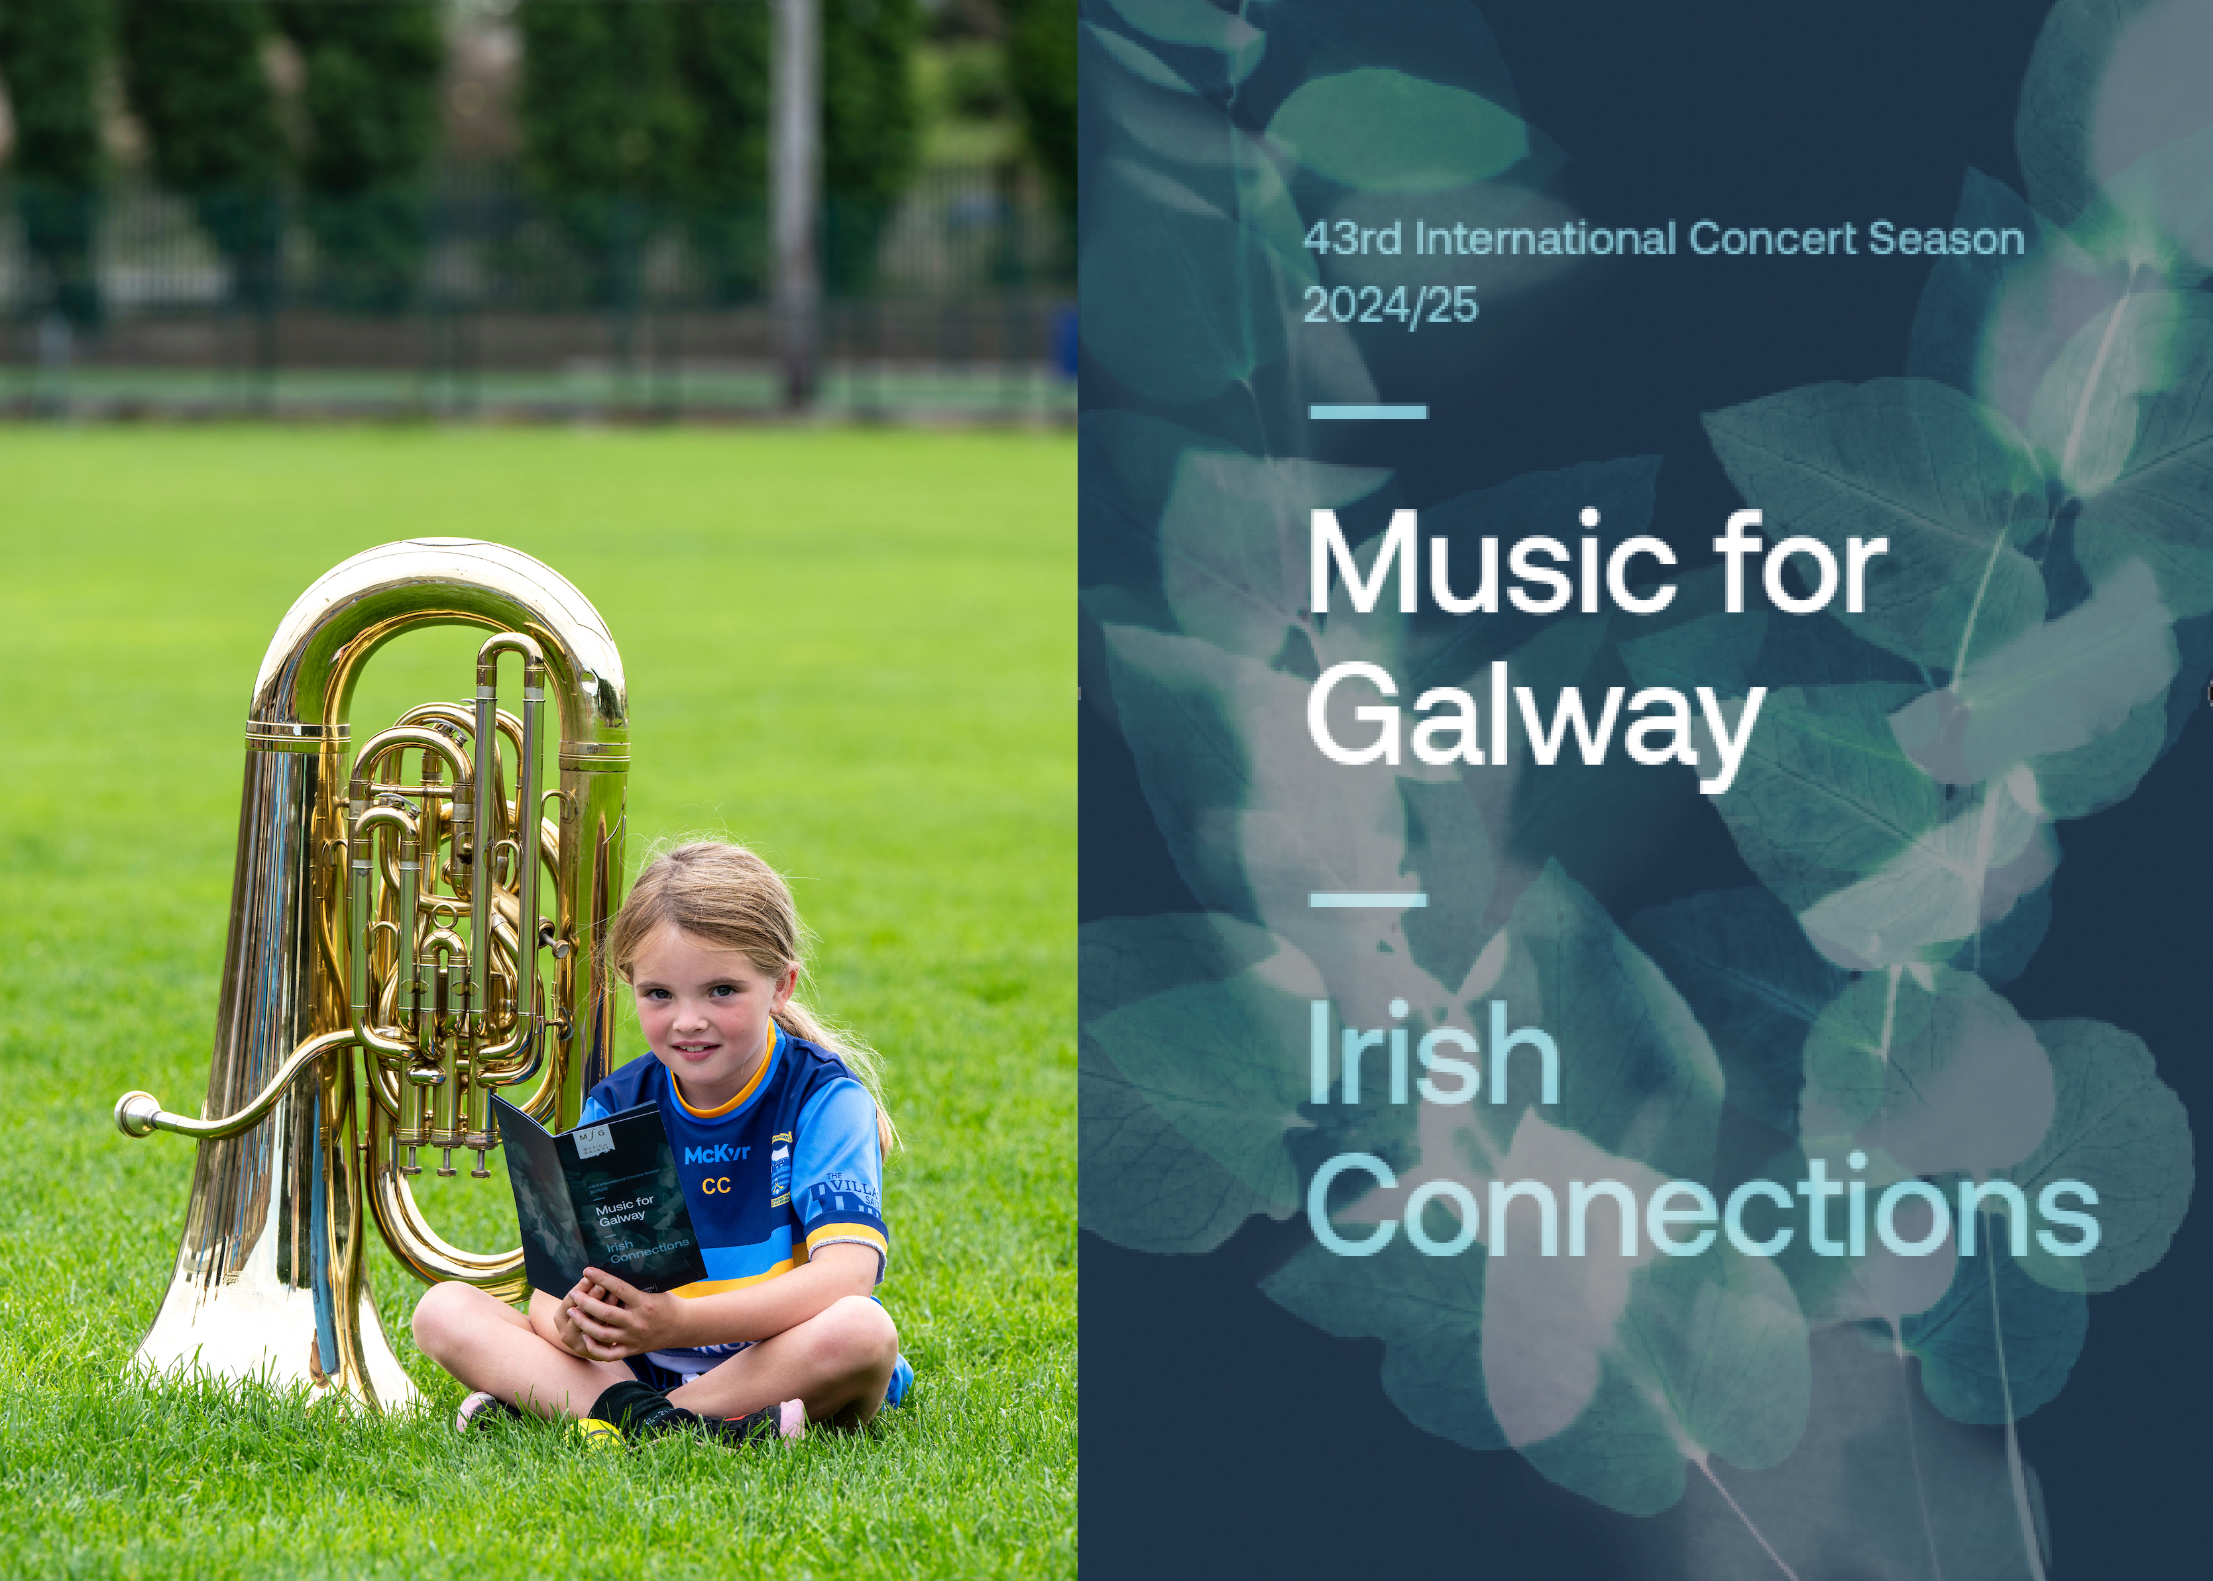

Music for Galway launched 43rd International Concert Season

Music for Galway launched its 43rd International Concert Season on September 2nd. There's anything from Marty Morrissey MCing the RTÉ Concert Orchestra for a night of Sports, Craic and Music, to a visit by the grande-dame of American piano, trail-blazer Anne-Marie McDermott.

More Information

_________________________________________________________
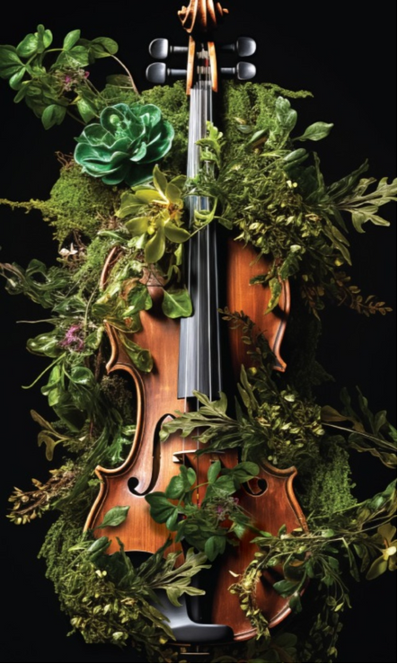

Luminosa 2024 Bláthú: Tickets on Sale Now

Always beautifully presented and memorable concert experiences, tickets are on sale now for Luminosa's September concerts in Galway and Clifden at the Clifden Arts Festival.

Luminosa continues to delight audiences with high-quality performances and an innovative curatorial approach. Their concerts showcase lesser-known works and pieces by Irish composers alongside classical string repertoire staples.

Tickets and More Information

_________________________________________________________
Failte Ireland Invites Creative Events Listings
Do you have a great event happening in Ireland this year? Promote it with Fáilte Ireland!
Advertise your upcoming events to irelandwestinfo@failteireland.ie and
Register & add your events through the events portal linked to Discover Ireland.
www.FailteIrelandEvents.ie/
_________________________________________________________
Send us your Listings & News
We can share your posts! Email up to 50 words to arts@galwaycity.ie with a high-resolution landscape image. Images and text may be edited to fit.
___________________________________________________________________
GCC Arts Office Social Media
Facebook: www.facebook.com/ArtsOfficeGalwayCity
Instagram: @artsofficegalwaycity
X: @cityartsgalway
___________________________________________________________________
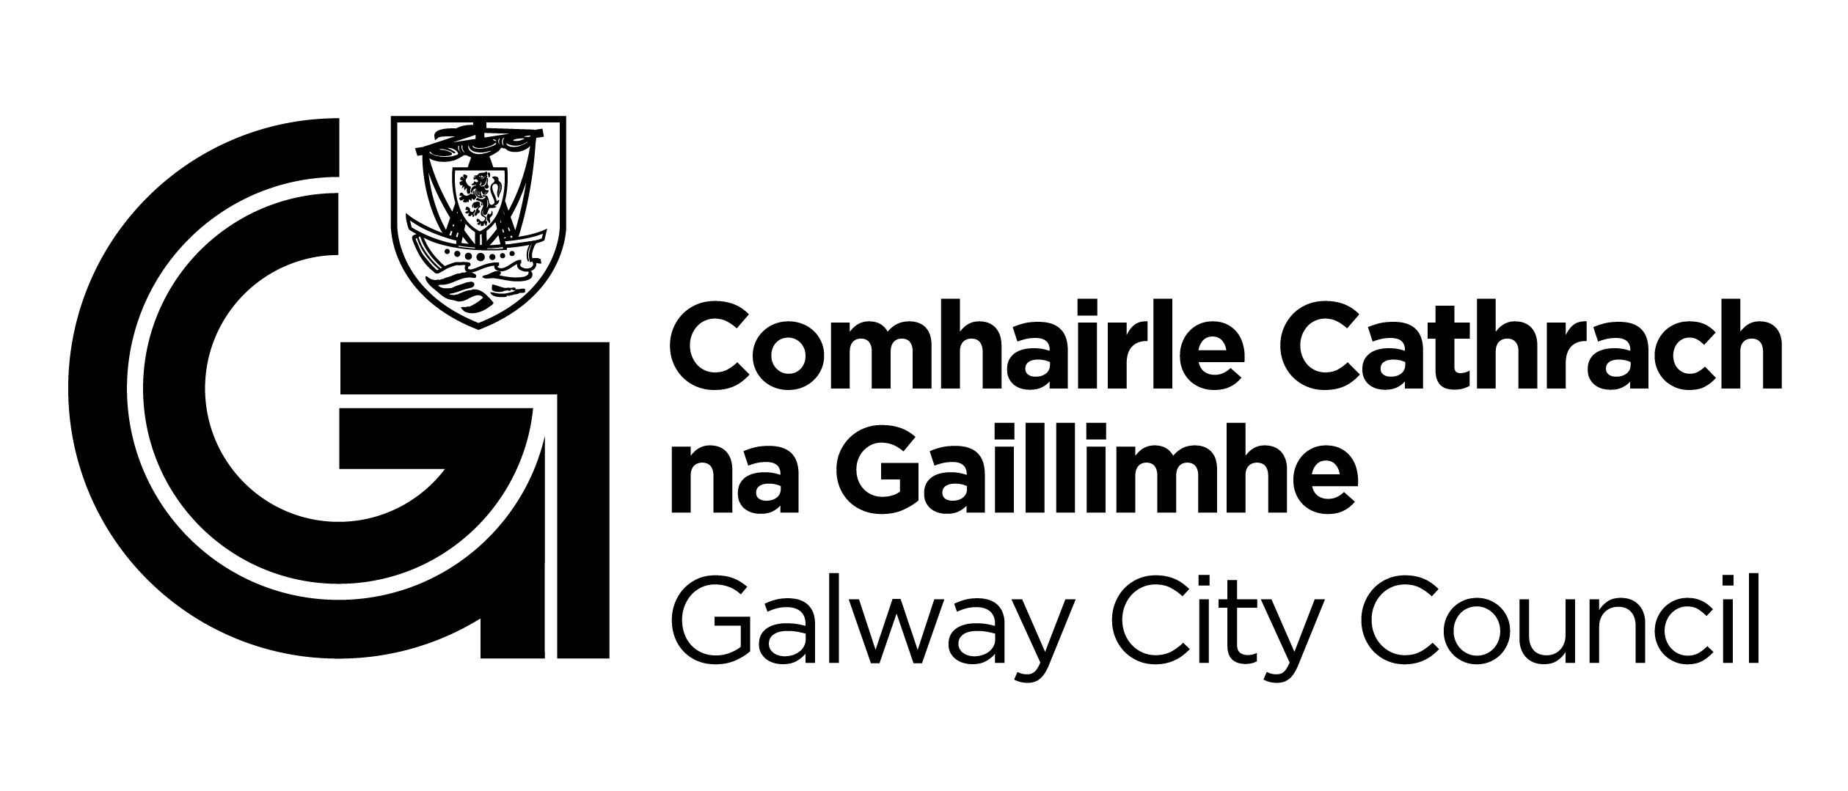

You are getting this email because you are on the Galway City Council Arts Office mailing list. Unsubscribe by emailing arts@galwaycity.ie and ask to be removed.

