**Galway City Council Arts Newsletter Mid-October**

Welcome to this fortnight’s newsletter with opportunities, news, events, and training opportunities. Baboró is in full swing, the first Eastside Arts Festival has been a big success, and a [newt called Alf](https://www.macnas.com/works/macnas-halloween-2024-coming-soon) will visit Galway City very soon!

Happy reading, from the Galway City Arts Office team.

**_____________________________________________________________**

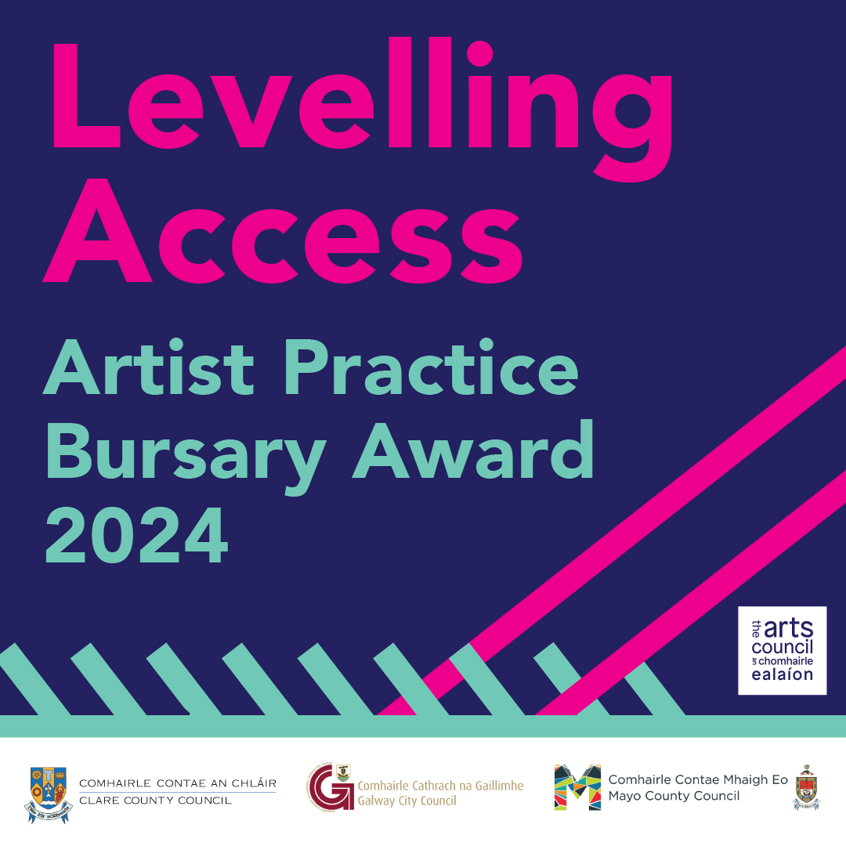

**Levelling Access Artists Practice Bursary Launches**

The Arts Services of Clare County Council, Galway City Council and Mayo County Council are delighted to announce the launch of the Levelling Access Artists Practice Bursary. We are now inviting applications for the Levelling Access Artists Practice Bursary from artists with disabilities, one in each local authority area. The bursary is open to professional artists with disabilities working in any artform and at any stage of their career, resident in Counties Clare or Mayo, or Galway City. The Bursary will support professional artists with disabilities to develop practice; create new work, or develop an artistic project. one award in each local authority area of €5000.00 plus specific access supports, resources and network opportunities. Application forms and guidelines can be [downloaded here](http://GalwayCity.ie/News/2024/Levelling-Access-Artists-Bursary-Launches)

Deadline is Tuesday 19 November. For further information for Galway City applicants contact [arts@galwaycity.ie](mailto:arts@galwaycity.ie) with the subject line "Levelling Access Bursary"

The Levelling Access Artists Practice Bursary is funded by Arts Council Ireland.

**_____________________________________________________________**

Six in the Attic & Virtual Attic 2024-25 Call for Applications

The Irish Theatre Institute (ITI) is accepting applications for its key artist development programme, working with local authority partners including Galway City Council.

Seeking artists with ambitious creative plans for the period from December 2024 to November 2025, who are looking for mentoring, peer support, and access to space, time, and practical resources over a 12-month period. Applicants' resident on the island of Ireland who have an established theatre practice can apply.

[Call for Applications](https://www.irishtheatreinstitute.ie/news/call-for-applications-six-in-the-attic-virtual-attic-2024-25/)

If you're unsure about your eligibility, please don’t assume you're not eligible, ITI are hosting a Zoom Q&A session on October 22 at 1pm to answer any questions [Register for the session here](https://us02web.zoom.us/meeting/register/tZIkd-qqpz0pGtKf6ajODysfnZA1yjLr4Y6B#/registration) or contact Katherine Murphy at [kmurphy@irishtheatreinstitute.ie](mailto:kmurphy@irishtheatreinstitute.ie).

Deadline for applications: 12 November at 4.00pm

**_____________________________________________________________**

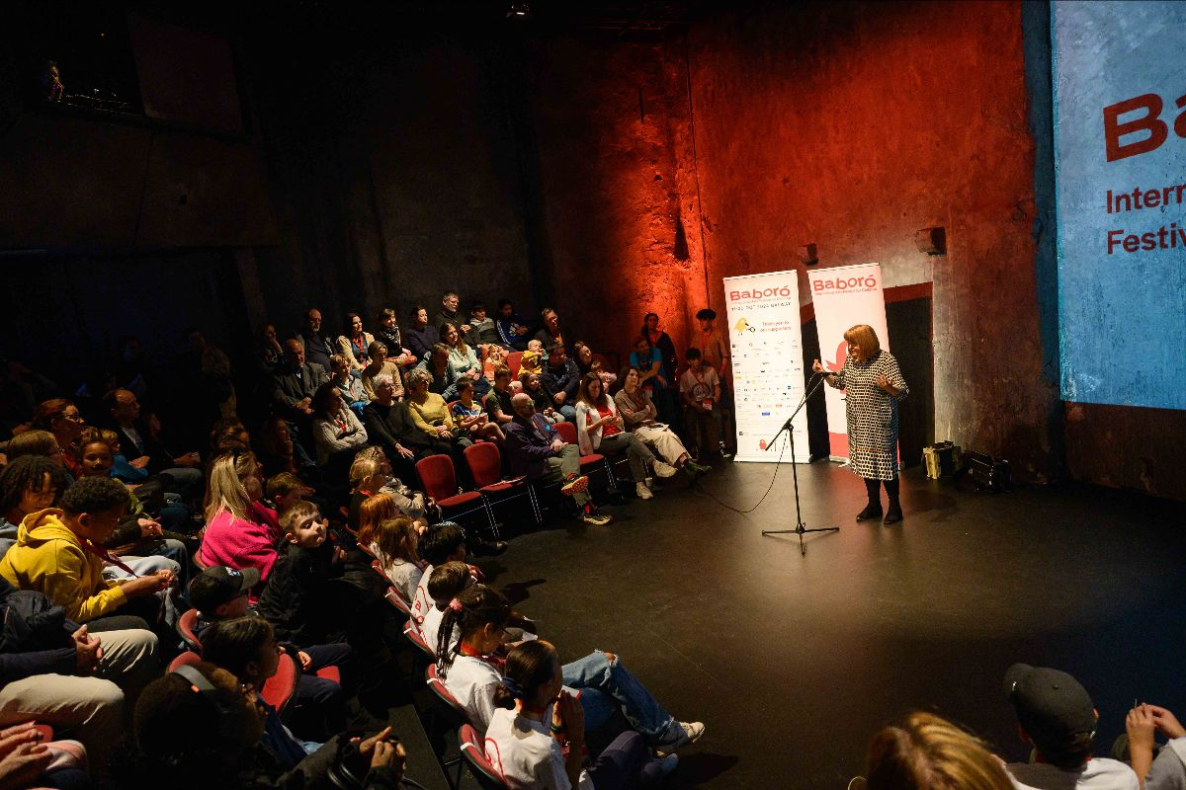

**Baboró Festival in Full Swing!**

Baboró International Arts Festival for Children brings magic for all ages to Galway, from Friday 11th to Sunday 20th of October, and Galway City Council Arts Office are very proud to be one of the principal funders of this fantastic festival! Highlights include Little Monsters at Galway Arts Centre. Creative Communities supported a series of Bargello stitching workshops with Laura Angell as part of her Little Monsters Baboró Exhibition.

https://www.baboro.ie/

**Baboró Festival Events for the Grown-ups**

## Baboró is welcoming families, schools and community groups to the festival this week but Baboró isn't just for the little ones! [Events- for adults](https://www.baboro.ie/festival/programme/age-range/adults?utm_source=Babor%C3%B3+Master+Contact+List&utm_campaign=51ef85d9fa-2023+Midsummer+Release_COPY_01&utm_medium=email&utm_term=0_-95ef326cd0-%5BLIST_EMAIL_ID%5D) include Laureate na nÓg Patricia Forde's inaugural lecture, Making Visual Art for Early Years, and [Putting Performance to Work for Children and Young People.](https://www.baboro.ie/festival/programme/putting-performance-to-work)

**____________________________________________________________**

**Applications are Open for Strategic Partners to Deliver Cruinniú na nÓg**

The Creative Ireland Programme wishes to engage strategic partners to increase the suite of events and initiatives available, alongside those produced by each local authority, to further develop, diversify and expand the offering and audience for Cruinniú na nÓg in 2025, 2026 and 2027. [More information here](https://www.creativeireland.gov.ie/en/news/applications-are-open-for-strategic-partnerships-in-the-delivery-of-cruinniu-na-nog/)

**_________________________________________________________**

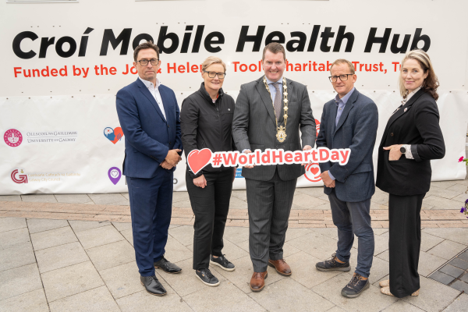

**News: Welcoming the Mending heARTS Programme**

A new programme of arts workshops for people living with heart conditions launched in Galway City on Sunday 29 September, as part of World Heart Day. Led by Galway City Council, in partnership with Galway County Council, Saolta Arts, and Croí - the heart and stroke charity, this project helps patients in their journey through cardiac care through participating in arts activity. [More information here.](https://www.creativeireland.gov.ie/en/news/mending-hearts-arts-and-health-project-launched-in-galway-on-world-heart-day/#:~:text=30%2F09%2F24-,'Mending%20heARTS'%20%2D%20Arts%20and%20Health%20Project%20Launched%20in%20Galway,part%20of%20World%20Heart%20Day.)

**_____________________________________________________________**

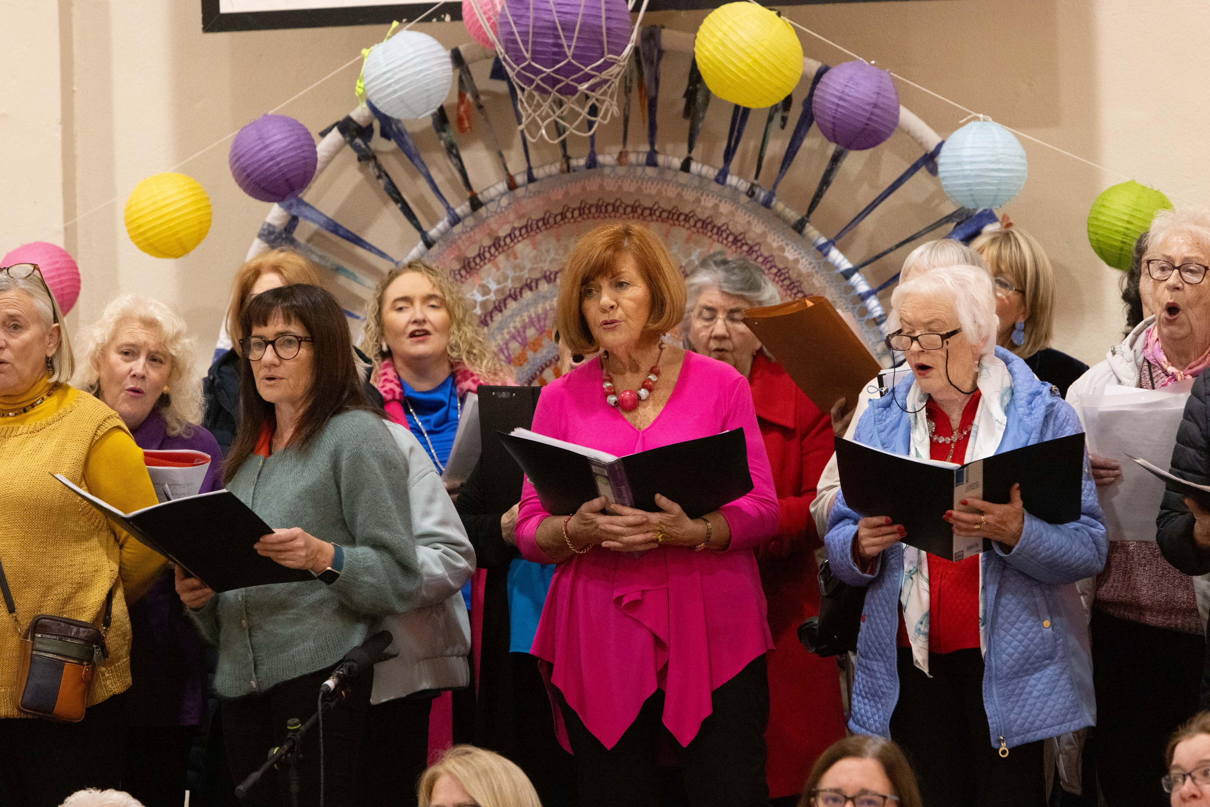Image credit: Aengus McMahon

**News: Success of New Community Arts Festival in East Galway City**

Communities in Galway City East celebrated the first Eastside Arts Festival on 11-12 October, showcasing local culture and creativity and celebrating the diversity. Visual art exhibitions are still on display at Ballybane Library and SCCUL Enterprise Centre. Supported through Creative Ireland.

Galway City Council is delighted to have supported the first Eastside Arts Festival, an exciting new, community-led festival for Galway City East. Funded through the Council’s Creative Ireland Programme, event took place at Ballybane Library, Ballybane Community Resource Centre, ARD Family Resource Centre, SCCUL Enterprise Centre, and other locations in Ballybane and Doughiska. [EastsideArtsFestival.ie](https://eastsideartsfestival.ie/)

**_____________________________________________________________**

### **Arts Council Festivals Investment Scheme (FIS) 2025 Closing Soon**

A reminder that the [Arts Council Funding Opportunity Festival Investment Scheme](https://www.artscouncil.ie/Funds/Festivals-Investment-Scheme/) 2025: Round 2 is open for applications until the 21st of November 2024. If you are applying for this grant and will be seeking a letter of support from the Arts Office, please reach out as soon as possible by emailing [arts@galwaycity.ie](mailto:arts@galwaycity.ie)

**_____________________________________________________________**

**Skylight 47**

*Skylight 47* poetry magazine will hold a launch event for its latest issue, Issue 19. The event will be hosted by Susan Millar DuMars, and poet Michael Dooley will launch the issue and perform a reading of his own work. He will be joined by selected contributors, who will read their published poems. All are welcome to this free event.

6.00 pm, 24 October 2025  
Galway City Library  
Information: [skylight47poetry.wordpress.com](https://eur04.safelinks.protection.outlook.com/?url=https%3A%2F%2Fscanner.topsec.com%2F%3Fd%3D1122%26r%3Dshow%26u%3Dhttp%253A%252F%252FSkylight47poetry.wordpress.com%26t%3D504c204b6f4691c9e89f458b5514fc9a289a052e&data=05%7C02%7Carts%40galwaycity.ie%7C8645bc8502ff4a6b18f108dcea30a54d%7Cd7a0f67a0cae4b21abdbb5186f6e07a9%7C0%7C0%7C638642741878351549%7CUnknown%7CTWFpbGZsb3d8eyJWIjoiMC4wLjAwMDAiLCJQIjoiV2luMzIiLCJBTiI6Ik1haWwiLCJXVCI6Mn0%3D%7C0%7C%7C%7C&sdata=P3vkiCQRhByLw7Ovum3VhfYRewAq09la8ee%2BhfAT8Ck%3D&reserved=0)

**_______________________________________________________________**

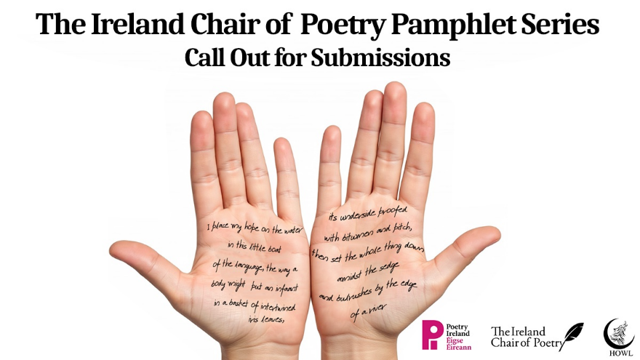

**Ireland Chair of Poetry Call for Submissions**

The Ireland Chair of Poetry Trust, in partnership with HOWL New Irish Writing, is delighted to announce a new project that will showcase the ubiquitous talent of Ireland's emerging poets.

Poets who have not yet published a pamphlet or collection are invited to submit a sample of their work of between twelve and twenty pages of poetry and a brief CV. Poems will be selected by Professor Paul Muldoon for inclusion in two pamphlets of The Ireland Chair of Poetry Pamphlet Series, which will be published by HOWL New Irish Writing in Spring 2025. [More information here.](http://irelandchairofpoetry.org/the-ireland-chair-of-poetry-pamphlet-series-call-out-for-submissions/)

_____________________________________________________

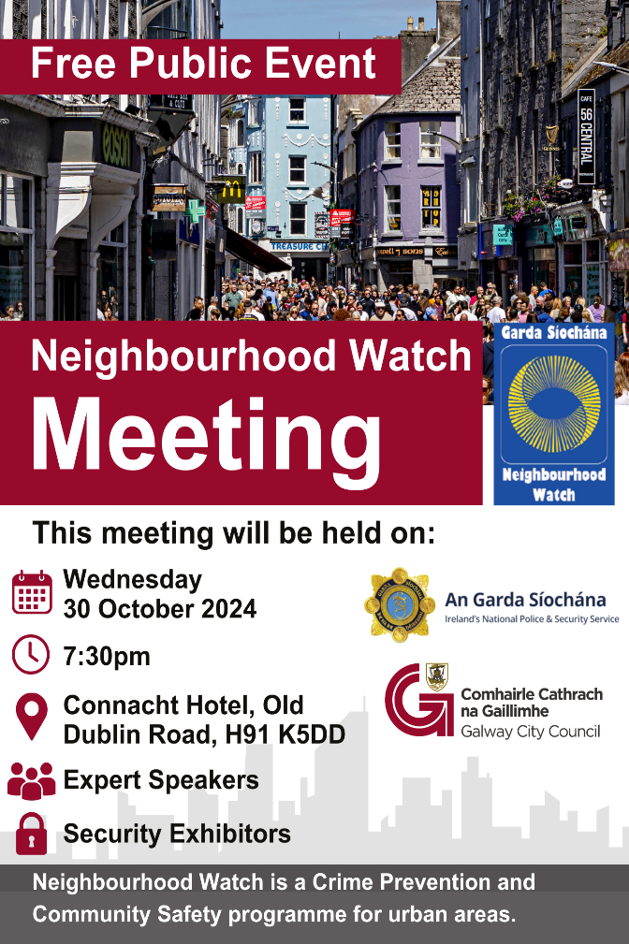

**Neighbourhood Watch Meeting with Galway City Council**

There will be a free public neighbourhood watch meeting on Wednesday 30 October at the Connaught Hotel. Everyone is welcome and no booking is required.

_____________________________________________________

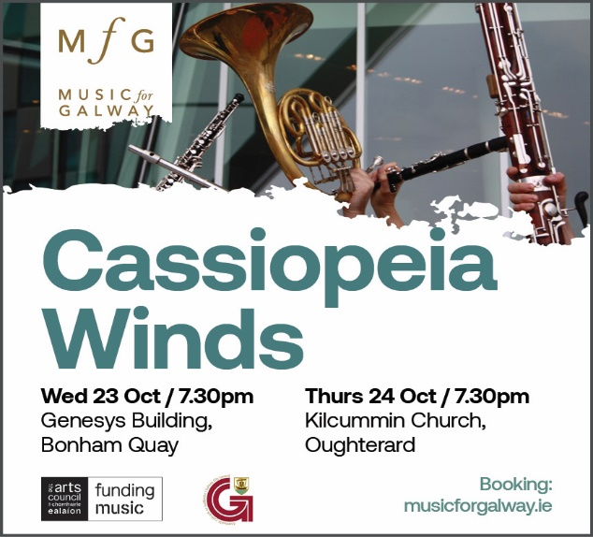

**Music for Galway**

[**Cassiopeia Winds**](https://eur04.safelinks.protection.outlook.com/?url=https%3A%2F%2Fscanner.topsec.com%2F%3Fd%3D1122%26r%3Dshow%26u%3Dhttps%253A%252F%252Fmusicforgalway.ie%252Fartsit-profile-cassiopeia-winds%252F%26t%3D8d608559a0d0836e0f7f08c48e2acd968c466817&data=05%7C02%7Carts%40galwaycity.ie%7C0417d30f6abd41e3b6f808dce85a84bc%7Cd7a0f67a0cae4b21abdbb5186f6e07a9%7C0%7C0%7C638640722732856913%7CUnknown%7CTWFpbGZsb3d8eyJWIjoiMC4wLjAwMDAiLCJQIjoiV2luMzIiLCJBTiI6Ik1haWwiLCJXVCI6Mn0%3D%7C0%7C%7C%7C&sdata=%2B5sC89XfwEMJEnfZvWYHrg0kBiPtWT9nPnkpAz6EQ%2FM%3D&reserved=0) is a quintet of Ireland’s finest wind players, sharing  
their passion for the superb wind quintet repertoire with audiences throughout Ireland. The group will perform in an intimate space on the top floor of the Bonham Quay development in Galway’s docks with spectacular views over the city and the bay on 23 October. [musicforgalway.ie/event](https://eur04.safelinks.protection.outlook.com/?url=https%3A%2F%2Fscanner.topsec.com%2F%3Fd%3D1122%26r%3Dshow%26u%3Dhttps%253A%252F%252Fmusicforgalway.ie%252Fevent%252Fconcert-cassiopeia%252F%26t%3De7b6e0504f38ff9abcf44efcd6e49649c131709e&data=05%7C02%7Carts%40galwaycity.ie%7C0417d30f6abd41e3b6f808dce85a84bc%7Cd7a0f67a0cae4b21abdbb5186f6e07a9%7C0%7C0%7C638640722732886795%7CUnknown%7CTWFpbGZsb3d8eyJWIjoiMC4wLjAwMDAiLCJQIjoiV2luMzIiLCJBTiI6Ik1haWwiLCJXVCI6Mn0%3D%7C0%7C%7C%7C&sdata=7sIth8z3njy359iBfdetpuBo5vvlbbdPwPL1TuPJugY%3D&reserved=0)

**_____________________________________________________________**

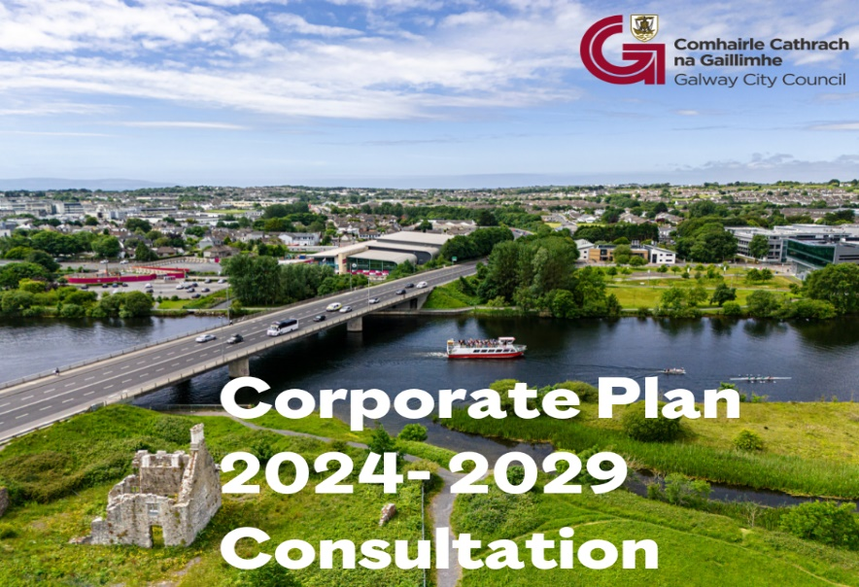

**Have your say on Galway City Council's Corporate Plan 2024-2029**

Galway City Council is preparing a new Corporate Plan that will set out a vision and mission statement for Galway City Council and we need your feedback! The Corporate Plan forms the core values that inform the work of the Council, its corporate goals and strategic priorities and how it delivers services for the new term of the Council. It is the Council’s strategic framework for action during the lifetime of the current Council, 2024-2029.

[Get more information about how you can give feedback on the plan here.](https://www.galwaycity.ie/news/4055/59/Have-your-say-on-Galway-City-Councils-Corporate-Plan-2024-2029/d,NewsDetail)

**_____________________________________________________________**

**La Na Cruite | Harp Day**

The international celebration of Ireland's iconic instrument, the harp is on 19 October 2024. Galway Harper Kathleen Loughnane is organising events throughout Galway County to celebrate the day. [More information: Harp Ireland](https://www.harpireland.ie/national-harp-day-overview/)

**________________________________________________________**

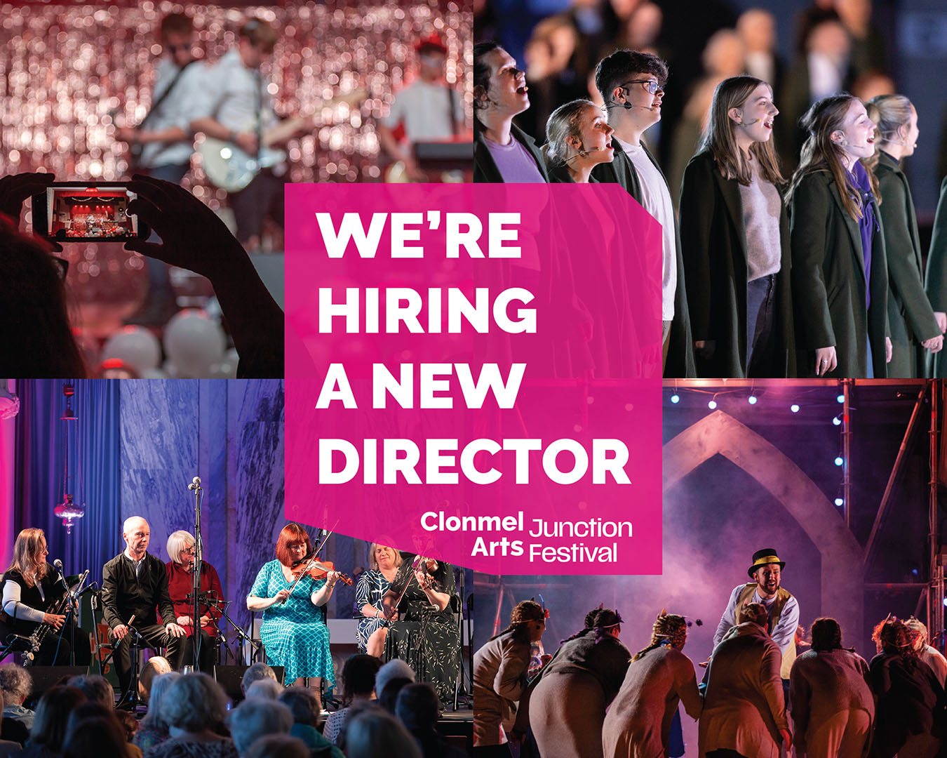

Clonmel Junction Arts Festival Seeks New Director

Do you want to lead this exciting festival? Click [here](https://eur04.safelinks.protection.outlook.com/?url=https%3A%2F%2Fscanner.topsec.com%2F%3Fd%3D1464%26r%3Dshow%26u%3Dhttps%253A%252F%252Fjunctionfestival.us2.list-manage.com%252Ftrack%252Fclick%253Fu%253D0524cfe7d7de5a4569498891b%2526id%253D099d2c3cc6%2526e%253D0a544945b6%26t%3Db9bfd6b23d92f00ad97da7bdfa80b4fb79f603e0&data=05%7C02%7Carts%40galwaycity.ie%7Cdc1d489eb9da494cd30b08dceceefbaf%7Cd7a0f67a0cae4b21abdbb5186f6e07a9%7C0%7C0%7C638645758380227406%7CUnknown%7CTWFpbGZsb3d8eyJWIjoiMC4wLjAwMDAiLCJQIjoiV2luMzIiLCJBTiI6Ik1haWwiLCJXVCI6Mn0%3D%7C0%7C%7C%7C&sdata=k2xawkfc6k%2BxVtSOPSA44zZd6r2FkYZvIoTd%2BnzjAnk%3D&reserved=0) for further details and a candidate pack.

**___________________________________________________**

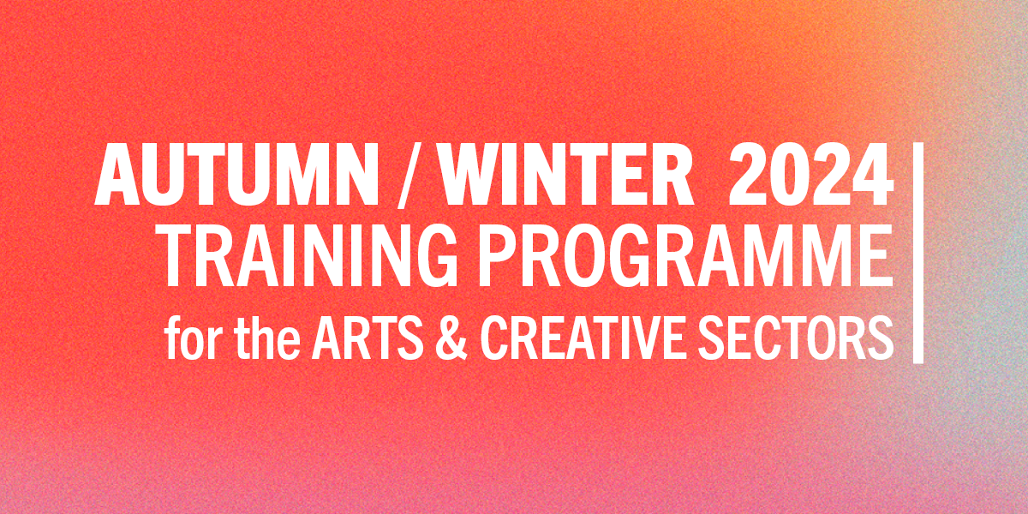

Safe to Create launches Autumn/Winter 2024 Training Programme

Safe to Create training for the arts & creative sectors. It features a range of online and in-person training opportunities to support artists, creatives and arts workers in addressing dignity issues in the workplace. Courses are either free, subsidised by Safe to Create or include the opportunity to apply for a bursary to participate. [Further information/Book your place](https://www.safetocreate.ie/news/safe-to-creates-autumn-winter-2024-programme-announced/)

**_________________________________________________________**

**Failte Ireland Invites Creative Events Listings**

Do you have a great event happening in Ireland this year? Promote it with Fáilte Ireland!

Advertise your upcoming events to [irelandwestinfo@failteireland.ie](mailto:irelandwestinfo@failteireland.ie) and

Register & add your events through the events portal linked to Discover Ireland.

www.FailteIrelandEvents.ie/

**_________________________________________________________**

**Promote Your Evening and NIght Time Events to Free Listings**

Do you have a great event happening from 6 pm? Promote it with This is Galway! These listings are a new initiative by Galway City Council Night-Time Economy. Simply email [Kate.Howard@galwaycity.ie](mailto:Kate.Howard@galwaycity.ie) with a summary of your event and receive a special code to access the events page, where you can add the details and promote your offering. Free to list! [More information.](https://thisisgalway.ie/nighttime/)

**_________________________________________________________**

**Send us your Listings & News**

We can share your posts! Email up to 50 words to [arts@galwaycity.ie](mailto:arts@galwaycity.ie) with a high-resolution landscape image. Images and text may be edited to fit.

**___________________________________________________________________**

**GCC Arts Office Social Media**

Facebook: [www.facebook.com/ArtsOfficeGalwayCity](https://scanner.topsec.com/?d=1122&r=show&u=https%3A%2F%2Fwww.facebook.com%2FArtsOfficeGalwayCity&t=a6b33347cd65717d4a93047cc8b1c9f7c5d8a4c9)

Instagram: [@artsofficegalwaycity](https://www.instagram.com/artsofficegalwaycity?utm_source=ig_web_button_share_sheet&igsh=ZDNlZDc0MzIxNw==)

X: [@cityartsgalway](https://x.com/CityArtsGalway?s=20)

**___________________________________________________________________**

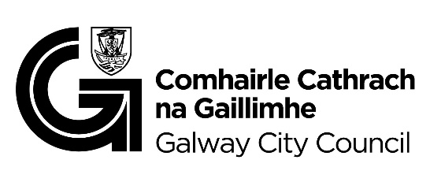

You are getting this email because you are on the Galway City Council Arts Office mailing list. Unsubscribe by emailing [arts@galwaycity.ie](mailto:arts@galwaycity.ie) and ask to be removed.