===Galway City Council Arts Newsletter Early November
Welcome to this fortnight’s newsletter. Below you will find Galway City Council Arts Office Content, External Content, News, Opportunities, and Listings/Events.
Happy reading, from the Galway City Arts Office team.
_____________________________________________________________

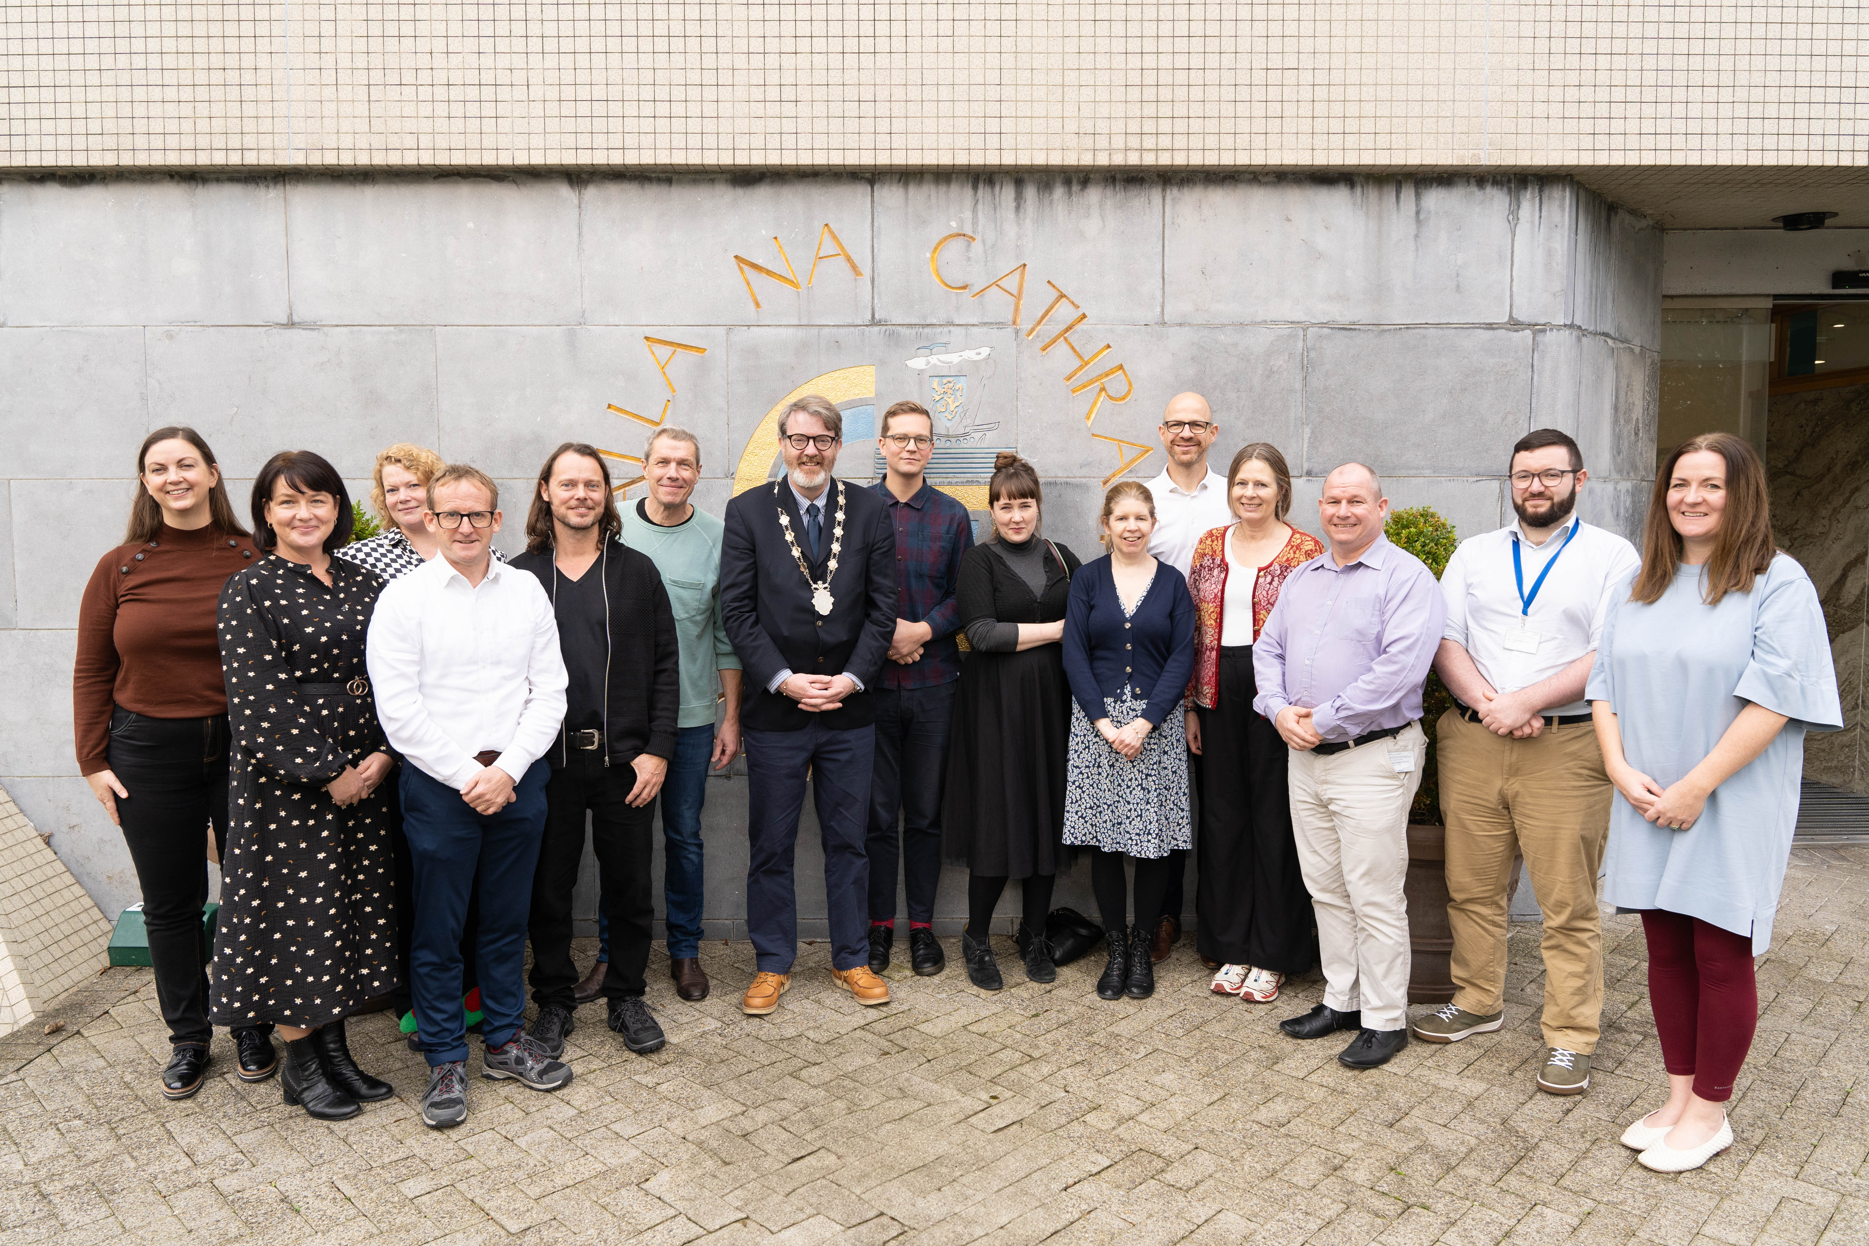

Recent visit from Aalborg Arts Committee

The Arts Office recently welcomed visitors from the Arts Committee of Aalborg, Denmark. Galway City is proud to be twinned with Aalborg.
The committee came to learn more about how we work, with a specific interest in the Green Transition, Public Art, and Community Arts. The visit provided a strong opportunity for shared learning for Galway City and Aalborg. We would like to extend warm thanks to all our colleagues in Galway who supported this visit. Special thanks to the teams at the Museum, Town Hall Theatre, Galway Arts Centre, Deanta and Centre for Creative Technologies UoG, Tulca, and Macnas.

You can find out more about the work of the Aalborg Arts Committee here.
_____________________________________________________________

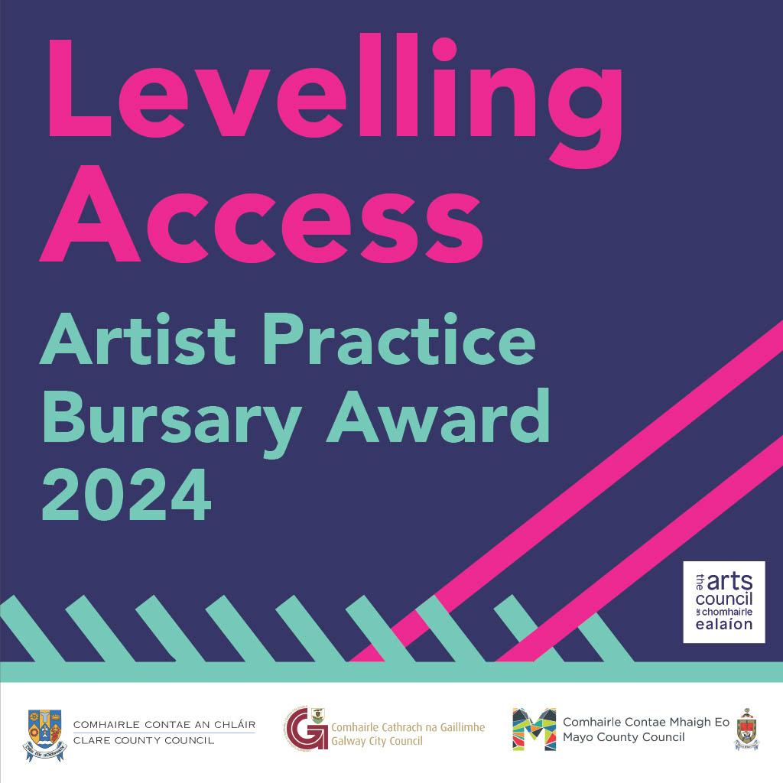

Closing Date for Leveling Access Artists Bursary Approaching

The Arts services of the three local authorities are now inviting applications for the Levelling Access Artists Practice Bursary from artists with disabilities, one in each local authority area. The bursary is open to professional artists with disabilities working in any art form and at any stage of their career, resident in Counties Clare, Mayo or Galway City.

The Bursary will support professional artists with disabilities to develop their practice; create new work or develop an artistic project with one award in each local authority area of €5000 plus specific access supports, resources and network opportunities.

Deadline for applications: 19th of November

More information here.
_____________________________________________________________
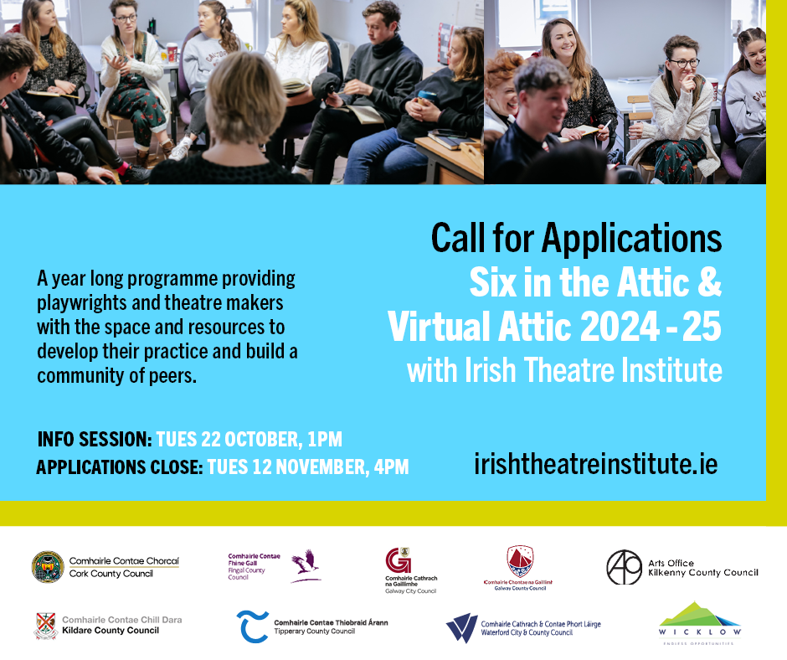

Six in the Attic applications close soon!

Galway City Council Arts Office is delighted to partner with the Irish Theatre Institute on the Six in the Attic (SITA) programme. This programme supports playwrights and theatre makers with resources, space, and peer networks. The 2024/25 programme, in partnership with nine local arts offices, offers virtual and in-person options. Twelve artists will be selected, including at least six from partner regions.

Applications close 12th of November

More information here.

_____________________________________________________________
Arts Council Festivals Investment Scheme (FIS) 2025 Opening Soon

A reminder that the Arts Council Funding Opportunity Festival Investment Scheme 2025: Round 2 is open for applications from the 22 October 2024. If you are applying for this grant and will be seeking a letter of support from the Arts Office, please reach out as soon as possible by emailing arts@galwaycity.ie

_____________________________________________________________
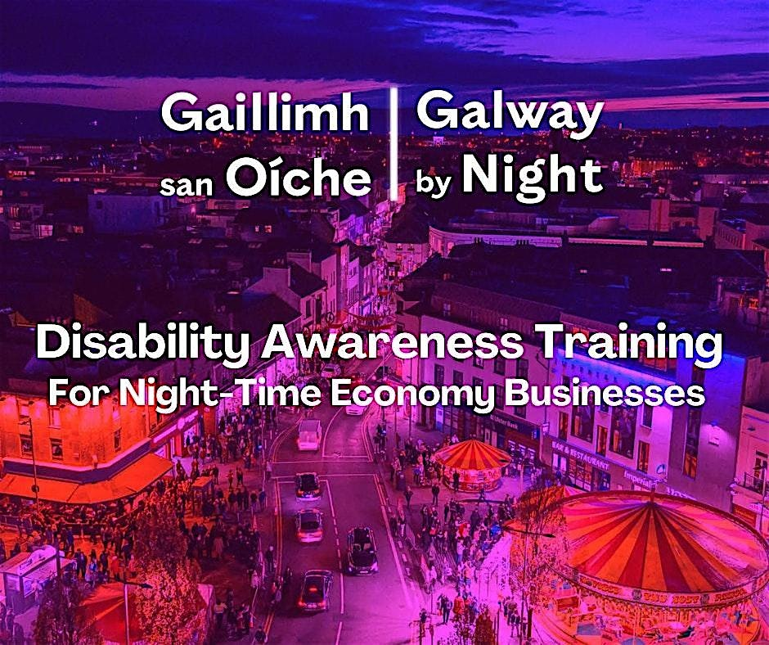

Night Out Access In

Calling all Galway City businesses and organisations in the Night-Time Economy including cultural venues, cultural organisations, and promoters. Make your organisation /venue more inclusive, with FREE Disability Awareness Training.

This initiative, part of the Galway City Council Night-Time Economy Action Plan 2024-2025, aims to create a more inclusive and welcoming environment for people with disabilities, ensuring everyone can enjoy Galway's vibrant nightlife. The initiative is in partnership with Access for All Galway City, Fáilte Ireland, Galway City Partnership, and the Disability Federation of Ireland.

More Information here.

_____________________________________________________________

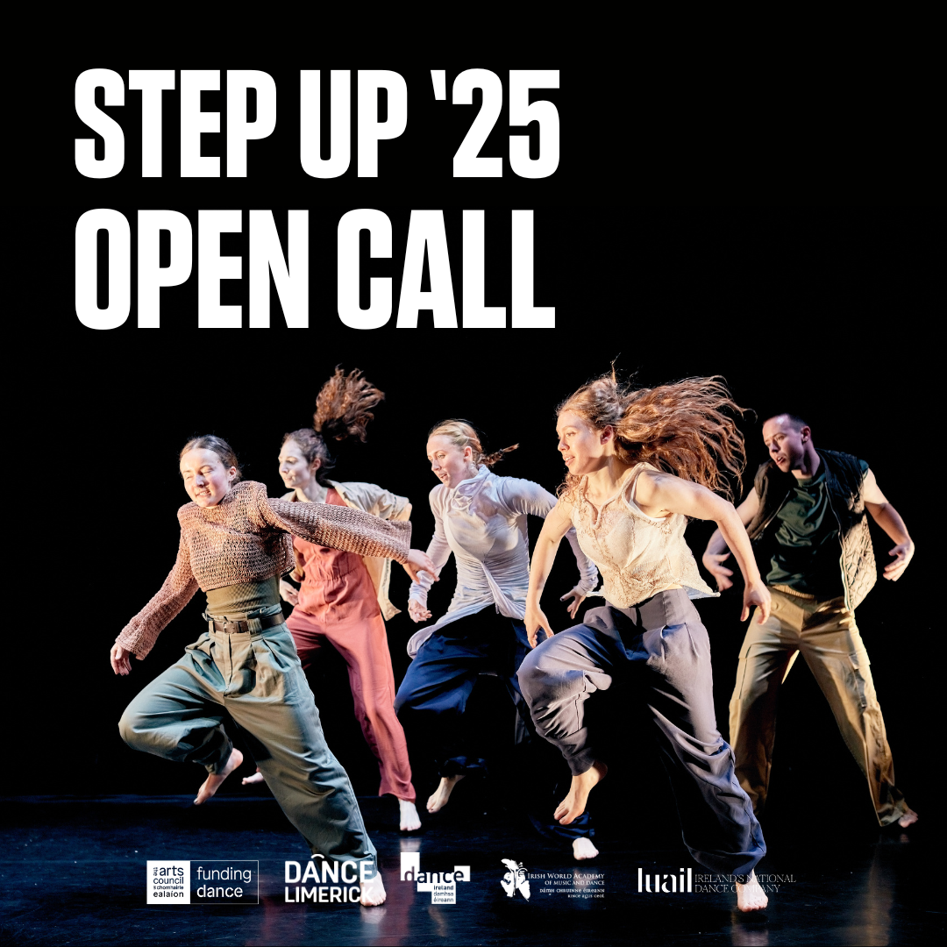

Open Call: Step Up Dance Project 2025

Step Up Dance Project seeks up to five recent dance graduates, born or residing in Ireland, for an 8-week professional development programme with Philip Connaughton and Luail. Application deadline: 25 November 2024, 12pm IST. Celebrating its 15th edition in 2025

More information here.

_____________________________________________________________
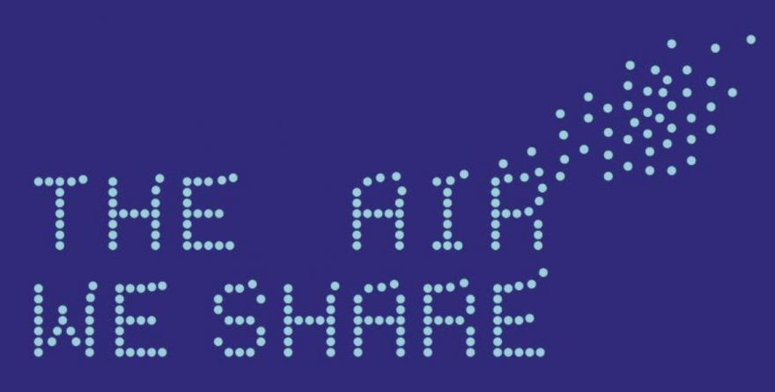

Making Your Own Air Quality Monitoring Unit

The Air We Share (TAWS), led by Galway City Council and University of Galway, addresses air quality through citizen science, art, and research. Air monitors in Westside Galway track pollution data for the community. A family workshop on low-cost air sensors runs November 16 during the Galway Science Festival.

More information here.

_________________________________________________________
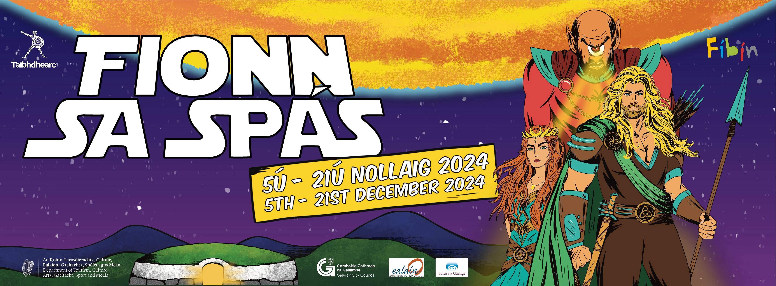

Christmas Pantomime 2024

Fionn is back at An Taibhdhearc to face his greatest-ever challenge. To prevent the onset of global freezing he must travel to outer space and battle an ancient foe!
Can he save the planet in time for Christmas or has the sun disappeared…. forever?! With the trusty Druid Bódhmall by his side, Fionn and crew must face fears of the great unknown and survive his biggest adventure yet!
Fionn sa Spás turns Irish myth to super-hero legend in this new space romp from Fíbín sa Taibhdhearc. It will be out of this world!
More information here.
_________________________________________________________
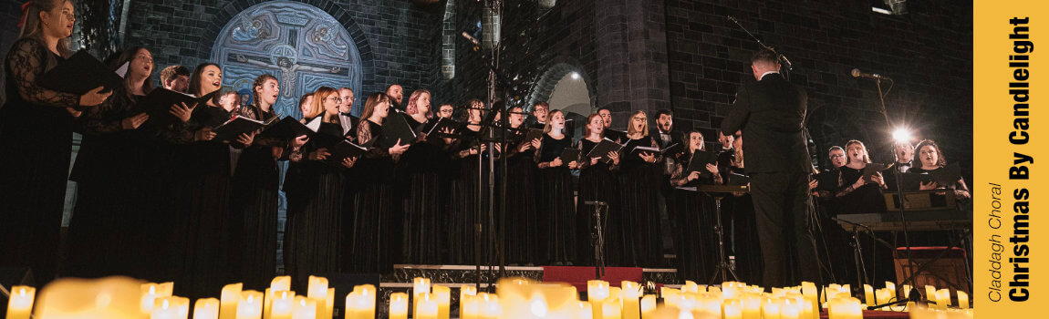

Christmas by Candlelight with Claddagh Choral

Join Claddagh Choral for an enchanting evening of music as they present "Christmas by Candlelight: A Choral Celebration" at the Town Hall Theatre on the 1st and 6th December. Set in the warm, intimate glow of candlelight, this year’s concerts promise to be a magical experience that captures the spirit of the season.
More information here.
_________________________________________________________
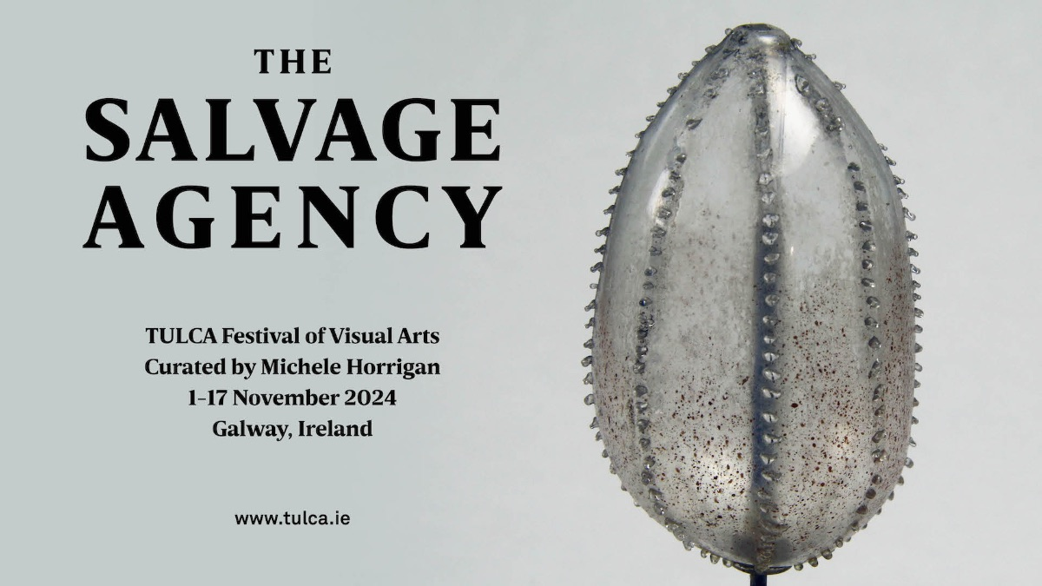

TULCA Festival Now Open

TULCA 2024 is now presented across multiple venues and locations in Galway until 17 November 2024. Established as the west of Ireland’s key annual showcase of contemporary art, TULCA continues to embrace Galway’s art institutions, cultural initiatives and public space together, presenting Irish and international artistic positions vital to our understanding of life today.
More information here.
_________________________________________________________

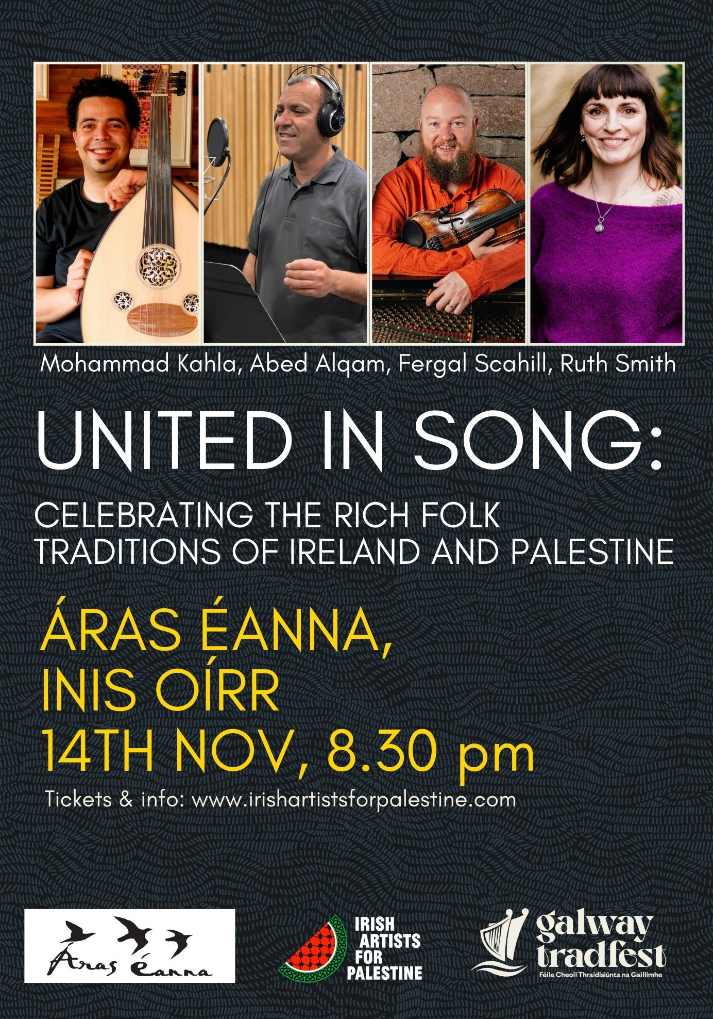

Fundraiser Concert for Palestine at Áras Éanna

Irish Artists for Palestine and Áras Éanna are proud to present the collaboration of Galway natives, Ruth Smith and Fergal Scahill along with a Palestinian duo Mohammed Kahla and Abed Alqam.
Galway’s Fergal Scahill is a skilled multi-instrumentalist and teacher, celebrated for his dynamic fiddle playing and his Tune a Day project, where he has recorded over 1,200 tunes since 2017. His career spans over two decades, touring more than 30 countries and releasing five solo projects, two albums with Freewheel, seven with We Banjo 3, and an album with Ryan Molloy titled One Day :: November Woods. Fergal is also deeply committed to music education, having taught at UL’s World Academy, Scoil Acla, Music Generation Waterford, and international camps in Canada, the U.S. and France. Fergal is set to release his second duo album, The Gannet’s Dive, with Ryan Molloy, Winter 2024.
More information about Irish Artists for Palestine here.
Link for Tickets.
_________________________________________________________
Send us your Listings & News
We can share your posts! Email up to 50 words to arts@galwaycity.ie with a high-resolution landscape image. Images and text may be edited to fit.
___________________________________________________________________
GCC Arts Office Social Media
Facebook: www.facebook.com/ArtsOfficeGalwayCity
Instagram: @artsofficegalwaycity
X: @cityartsgalway
___________________________________________________________________
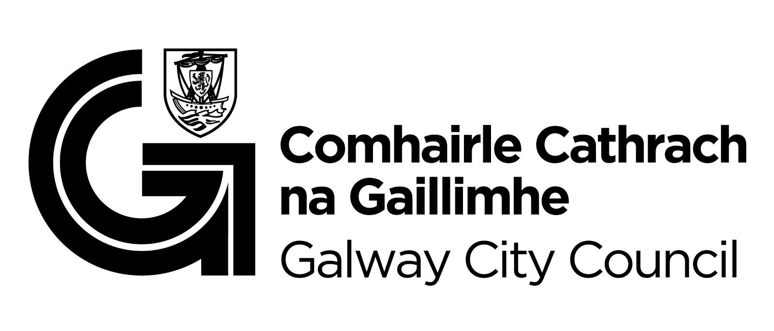

You are getting this email because you are on the Galway City Council Arts Office mailing list. Unsubscribe by emailing arts@galwaycity.ie and ask to be removed.

